**What is the equation of the parabola?**

**Vertex Form & General Form – FOM 11**

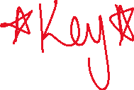

1. **Complete the below table by writing the equation in BOTH vertex form and general form.**

|  |  |  |
| --- | --- | --- |
| **Graph** | **Equation in Vertex Form** | **Equation in General Form** |
|  |  |  |
|  |  |  |
|  |  |  |
|  |  |  |
|  |  |  |
|  |  |  |
|  |  |  |
|  |  |  |
|  |  |  |
|  |  |  |
|  |  |  |