Environmental Sciences 11/12
Water Unit Review
Name: _________________________
Learning Goal
- I can explain bio-indicators of a healthy water system
- I can explain the health factors that contribute to healthy oceans
- I can explain the health factors that contribute to healthy freshwater systems
Learning Goal #1: I can explain bio-indicators of a healthy water system
- Draw the water cycle and label all the important vocabulary words.
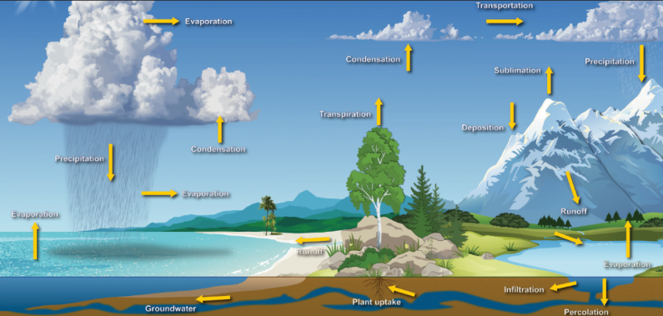
Make sure that you know the following words:
- Condensation
- Evaporation
- Sublimation
- Precipitation
- transpiration

- What is an aquifer? Are there any aquifers in the Okanagan? What is happening with the Ogallala Aquifer in the US? How can we deal with this?
Confined vs unconfined aquifers Okanagan Water Basin
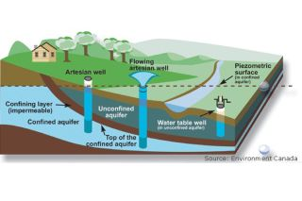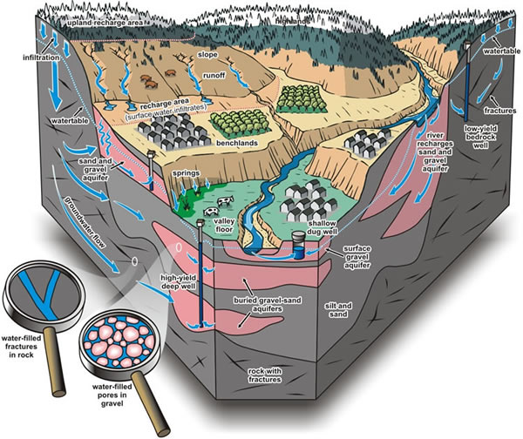
High Plains Aquifer (also known as Ogallala Aquifer) is in Central USA. Largest Aquifer in North America. Greatly depleted and water is coming out faster than the water cycle can replace and refill. This is impacting the farming of wheat, agriculture in general in USA.
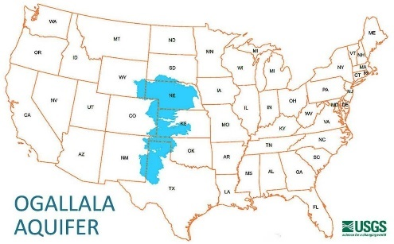
- What was happening in with the population of Alaskan Sea Lions and why? Is this indicating a healthy system? Why or why not?
Eastern population slight increase in population
Western population dramatic decrease due to the change in herring population. Currently changed to eating pollock, which is a low fat fish. Mothers can not make high fat milk with a primary diet of pollock
Pollock fishing was originally blamed and banned. Turns out it was not competition with fisherman, but the wrong diet
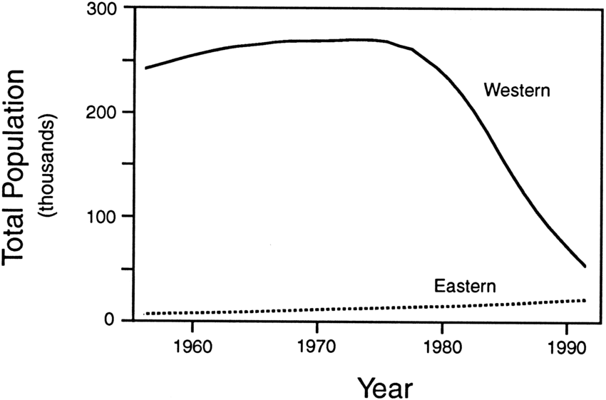

- What is a trophic cascade that might happen in a water system? Why? What might cause this?
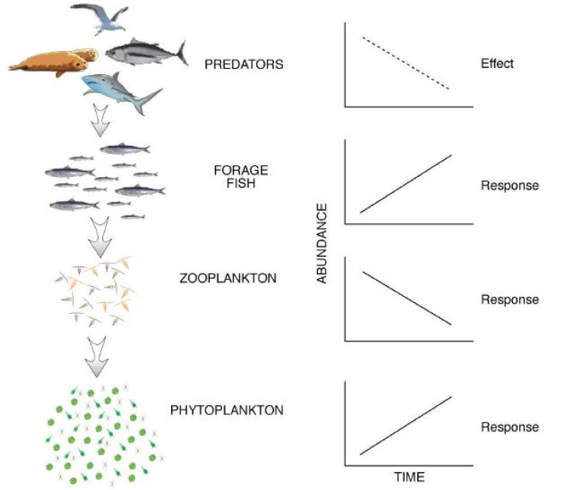
- Why is sewage treatment an issue that impacts our water health?
Sewage untreated will increase the phosphorous in the water. Increased Ph will cause an algae bloom, which can cause the process of eutrophication. Sewage needs to be treated and the water put back into our lakes need to be free of added carbon, nitrogen and phosphorous. Lake Okanagan is very slow turning lake, therefore extra nutrients will be trapped in the lake for a very long time. That makes it extra important that the water re-entering the lake is clean with no added nutrient contaminants.

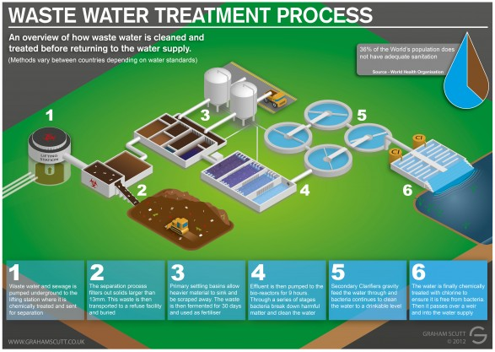

- What is causing ocean acidification? What are the consequences of it? What can be done? What is being done?
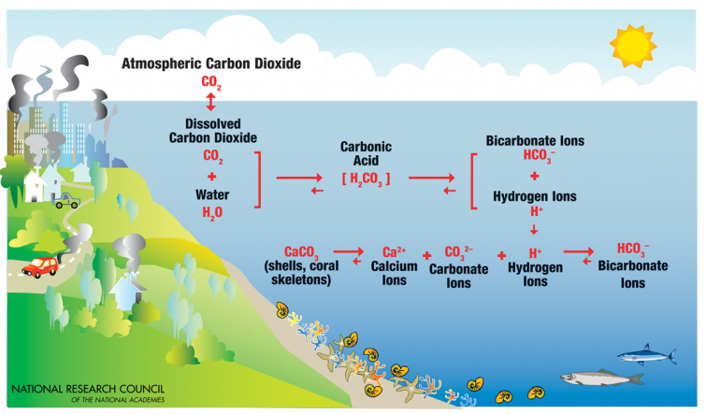
Ocean acidification is causing bivalve larvae to not be able to create their shells, which puts them at risk for damage and infection while they develop. This lack of bivalves is impacting ocean ecosystems as well as aquaculture

Learning Goal #2: I can explain the health factors that contribute to healthy oceans
- How much of the earth’s surface is covered in ocean water? What does this mean for our water consumption?
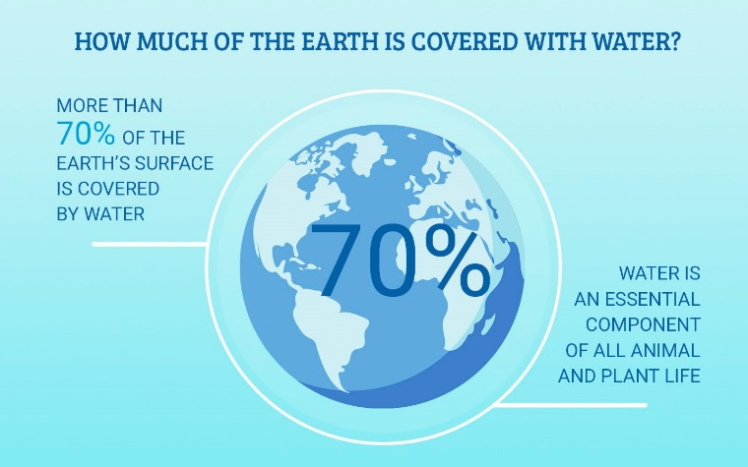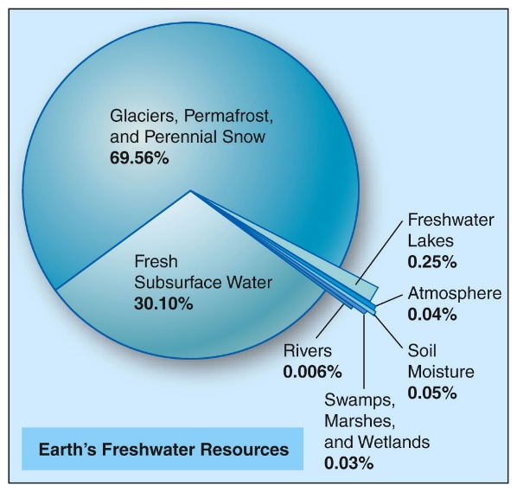
- How is ocean acidification impacting aquaculture in BC? Why? What are aqua culturists needing to do?
- Ocean acidification is causing bivalve larvae to not be able to create their shells, which puts them at risk for damage and infection while they develop. This lack of bivalves is impacting ocean ecosystems as well as aquaculture. Some aquaculture companies are growing their larva inside tanks, instead of using ocean water. This allows them to alter and pH of the water if needed

- What are the issues with overfishing? Use some of the statistics that show how overfishing is impacting our fish population.

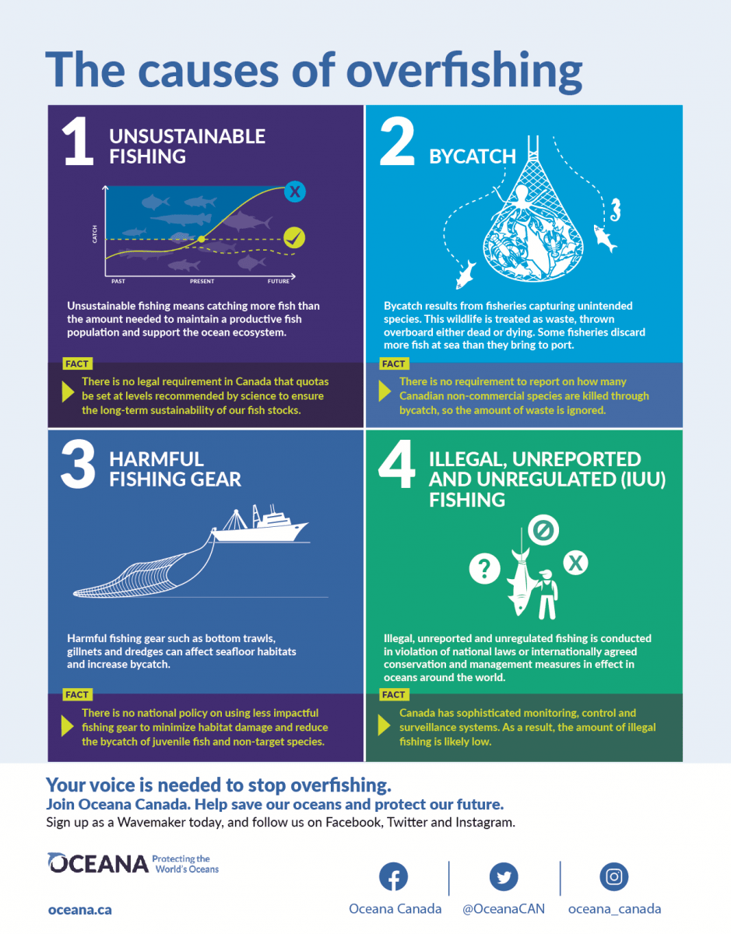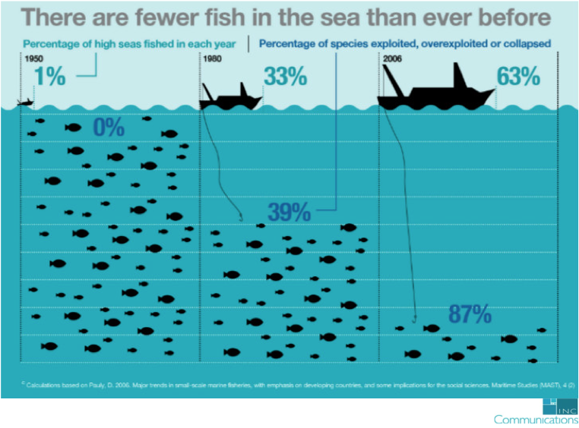

- What is bycatch? What is the largest catch species that causes bycatch? What are the statistics on this? What could be done?
For every 1kg of shrimp caught there is 3 – 5kg of bycatch
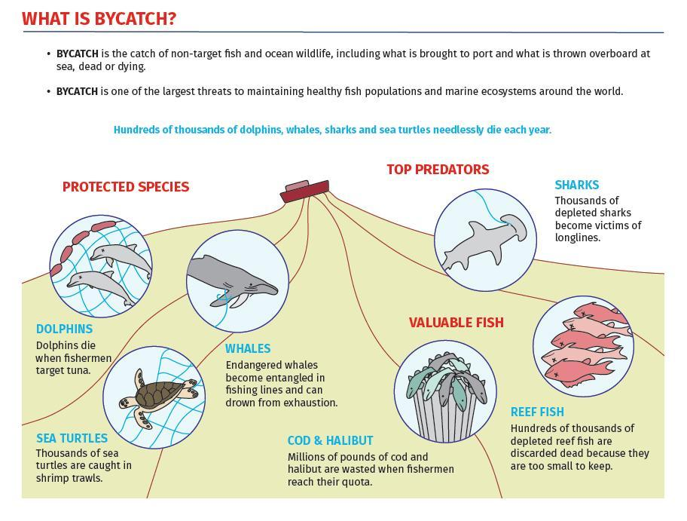
- What are some of the issues around salmon farming? What is being done? Give an example of some proactive actions that are trying to solve this issue.
Salmon fish farms farm Atlantic salmon in Pacific waters. They are a larger fish which gives farmers a larger mass, which means a larger profit. Atlantic salmon are carnivors and will eat the smaller Pacific salmon. With high populations they will have fungi and sea lice. SLICE is an antibiotic that they use to prevent sea lice, and this is causing tumours in our pacific salmon fish. The salmon fry are being harmed

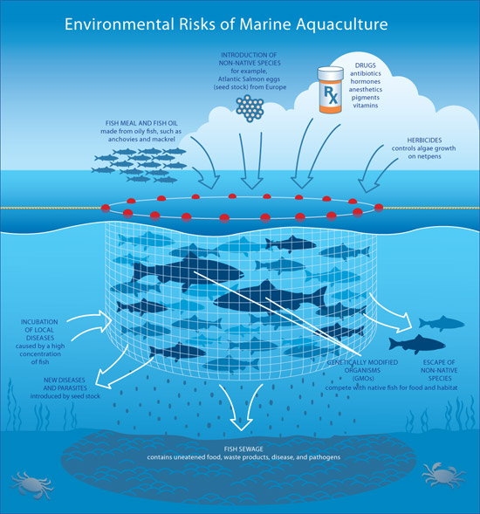

Learning Goal #3: I can explain the health factors that contribute to healthy freshwater systems
- How is water consumption tied to population? Is it always? What are some countries that have low water use per capita? What are some countries that have high use per capita? Use the below graphic.
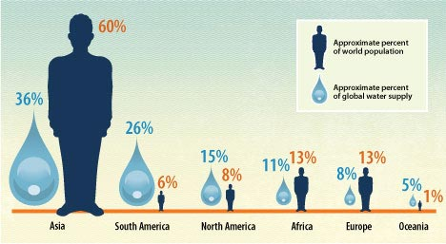
What is the population vs consumption? What is our responsibility to the global water supply?

- How is farming and agriculture tied to water use?
Farming uses a great deal of water. Do they need to use treated water to water trees and crops? How do you twin a system? Cost vs gain. Use of aquifers (like the Ogallala aquifer in USA)
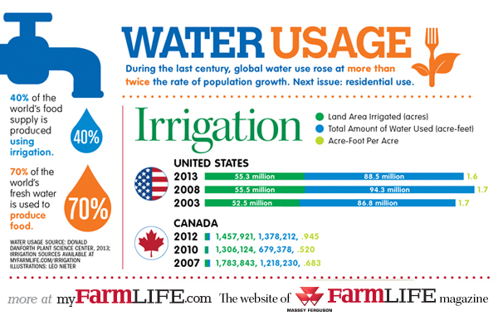
- If we as a community decided to reduce our water use by reducing our show time, reducing our use of a dish washer, and sticking to lawn watering restrictions, would that impact our overall global water use? Why or why not? What needs to change?
Reusing grey water (dishwashing water) to water our plants. Minimal grass watering. Low shower watering time.
- What are some of the statistics we use to find the health of a fresh water system? Why?
Turbidity – murkiness of the water. High particulate matter will increase temperature
Temperature – higher temperature does not hold on to oxygen
Dissolved oxygen – oxygen available for aquatic fish and animals
pH – acidic and alkaline (basic) levels. Neutral is pH = 7

- How does temperature impact freshwater systems and organisms?
High temperature will impact the oxygen of the water which will impact the sustainability of wildlife. Lead to a “dead” water system

- How does pH impact freshwater systems and organisms?
pH is the amount of hydrogen ions in the water. An acidic or alkaline pH will change the ability of the organisms to form exoskeletons (shells) which can cause them not to develop properly.

- How does turbidity impact freshwater systems and organisms?
Turbid water is very murky. It has lots of particulate matter (soil) in it. This will hold on to heat, which will then cause oxygen to leave the water system. Turbid water can also harm spawning sites and damage eggs

- How does dissolved oxygen impact freshwater systems and organisms?
Too little oxygen will impact the success of aquatic animals. Cyclical breakdown, as if no oxygen then no animals, which means lowered carbon dioxide which means no algae.

- What is mercury poisoning in our fish? Why is it happening?
