Environmental Sciences 12
Water-Bacteria Lab Report

Big Question:
If counted, will more types of bacteria colonies be observed in stagnant water from Adams Bird Sanctuary in comparison to stagnant water from Dale Meadows?

Background Research:
- What are the main bacteria found in stagnant water?
Many varying classes of microbes are able to thrive and reproduce in stagnant water. Bacteria being the most common. Anaerobic bacteria are frequently found in stagnant water, specifically legionella. Stagnant water is the perfect home for these bacteria, which requires a humid and moisture filled environment to survive. Other bacteria that are frequently found in stagnant water is E. coli, a type of fecal coliform bacteria. E. coli can live outside of its host for a long time so it can be considered as an indicator organism and are typically found in the human or animal gut. Stagnant water can also be home to Campylobacter (jejuni) bacteria, a gram negative, spirally curved microaerophilic bacterium that contributes frequently to surface water contamination. Salmonella, a genus bacillus gram negative bacteria can also be expected in stagnant bodies of water. This is likely because they are hardy bacteria and can survive up to several months in water.

- How does bacteria get into stagnant water?
Legionella occurs naturally in freshwater environments but is generally harmless as it is often found in low quantities. Legionella grows best in warm water but can also survive low temperatures. They can multiply effectively in moist areas such as stagnant water. After a stagnant water source has been infected with legionella it can spread in small droplets that enter the human body through respiration. E. Coli may be found in stagnant water bodies due to contamination with compromised feces from infected animals or humans. Waste has been known to enter the water through different methods, including but not limited to; animal defecation, sewage overflows, sewage systems that are not working properly, polluted storm runoff and agricultural runoff. Campylobacter is also spread through contamination with feces. Both wild and domesticated animals are known transmitters of campylobacter into stagnant water bodies. Another bacteria that is spread through water contaminated by feces containing bacteria is salmonella. It has been found that salmonella can survive up to five years in sterile water and can multiply effectively in a broad range of temperatures.

- How does farming (fertilizers?) affect bacteria growth in stagnant water?
Concentrated Animal Feeding operations (CAFQ’s or factory farms) generate millions of gallons of animal waste yearly. Animal waste is typically stored in pits or open ponds (lagoons). These waste contaminants are prone to leakages and possible ruptures due to storm conditions. This can be devastating to both nearby surface water and groundwater sources. Animal waste is often high is bacteria and contaminants such as nitrates, nitrogen, phosphorus, heavy metals, and ammonia that can be dangerous in an ecosystem. Farmers often spread huge amounts of manure onto farm fields to fertilize their crops and dispose of the waste. Chicken manure is especially high in phosphorus, nitrogen, and ammonia. When dissolved in water ammonia is highly toxic to fish and can be converted chemically into harmful nitrates as a result of bacterial action. Animal waste contains a high level of bacteria and pathogens that cause human disease. Many disease-causing bacteria can be spread through contaminated fecal matter. Pathogens survive after being spread throughout the farm fields, seeping into ground water, or being transported to surface water as a result of runoff.
Nitrogen and phosphorus are two of the main macronutrients in fertilizer. This is because they contain nutrients that promote plant growth. The rates at which they are applied to cropland are far higher than what the plants need, or what the soil can absorb and retain. The excess leeches into surface and groundwater, causing algal blooms and nitrate contamination.

- How would drinking stagnant water affect humans?
When stagnant water is left untreated and used for human consumption there are a number of illnesses that can be contracted and spread to the human population.
Legionella: When water containing legionella bacteria is consumed or inhaled it can cause a serious type of pneumonia called legionnaires disease. The symptoms of legionnaires disease consist of; high fever, chills, cough, difficulty breathing, headache, soreness in muscles, pain or discomfort in joints, chest pain, fatigue, nausea, and diarrhea. Legionella bacteria can also cause Pontiac fever, a less serious disease in comparison to legionella. If Pontiac fever has been contracted, symptoms that can be expected are fever, chills, headache, muscle aches, loss of appetite, tiredness, and occasional diarrhea.
E. Coli: E. Coli is contracted when water sources that have been contaminated with feces from an infected animal/human are ingested. The symptoms of e. coli vary depending on the individual. Symptoms frequently include severe stomach cramps, diarrhea (often bloody) and vomiting. Some people may also develop a fever, which isn’t often very high (less than 101 degrees Fahrenheit)
Campylobacter: When water that has been contaminated with fecal matter containing campylobacter bacteria is used for human consumption it is likely that the individual will contract a campylobacter infection, a type of stomach flu (gastroenteritis). The most common symptoms to be expected are diarrhea, vomiting, stomach cramping and fever.
Salmonella: Salmonella can be contracted when an untreated water source is used for consumption. Specifically, when the water source contains fecal matter infected with the salmonella bacteria. Symptoms such as diarrhea, fever and stomach cramps usually begin 6 hours-6 days after infection and last 4-7 days.

- How does temperature affect bacteria growth in stagnant water?
The growth rates of bacteria in stagnant water are the highest at optimal growth temperature. The lowest temperature at which the bacteria can survive, and replicate is considered its minimum growth temperature, and the highest temperature at which growth is still achievable is its maximum growth temperature. Bacteria live in all bodies of water and thrive in varying temperature and weather conditions. However, warmer conditions are largely the most effective in creating the perfect environment for bacteria to thrive in. They may even grow and reproduce to potentially dangerous levels. The “danger zone” for bacterial growth ranges between 41-135 degrees Fahrenheit. Though some bacteria thrive in extreme heat or cold it is typical that water above 149 degrees Fahrenheit may kill or inactivate bacteria by using the extreme heat to damage the structural components. This essentially disrupts essential life processes. Cold water temperatures don’t necessarily kill bacteria, but rather stop or slow the growth of bacteria. This means that reproduction won’t be quick, but it also won’t stop completely.

Hypothesis:
If the bacteria colonies are observed in stagnant water from Adams Bird Sanctuary in comparison to stagnant water from dale meadows, then it will be found that more varying bacteria colonies will be found in the stagnant water from dale meadows. This is because of increased bacteria due to infected fecal matter transported from the nearby farms to this stagnant water body as a result of runoff, therefore further contaminating the water.

Variables:
Independent Variables:
- Stagnant water from Adams Bird Sanctuary
- Stagnant water from Dale Meadows
Dependent Variables:
- Number of varying bacteria colonies.
Control Variable:
- Test with distilled water

Safety:
When conducting experiments in the lab it is essential that you wear closed toed shoes, safety goggles, and tie back long hair. Chemicals and stains used during labs can be very damaging to your eyes pr skin, so it is very important that you know the location of the eye wash station and the shower in case your eyes, body or clothes encounter a stain (eyes) or damaging chemical. The Bunsen burner is a fire hazard, especially when long hair or loose clothing is in close proximity. You must know the location of the fire blanket, extinguisher, alarm, and exit route and protocols in case of fire. You also have the option to wear plastic gloves and lab coats should you wish to protect your hands and clothes from the stain and other potentially damaging product. It is also essential that you use all equipment correctly, in the manner that you are instructed. Being aware of what is going on around you is a must. You are responsible for making sure your peers are aware when you are using the Bunsen burner, hot plate, chemicals, or stains near them. Horseplay and running will not be tolerated in the lab. Labelling of your agar plates is a key part of conducting this experiment. If you don’t do so its possible that your results wont be viable. It is important that you wash your hands and all equipment before, during and after your experiment to avoid contamination of samples that may compromise your results. This means keeping your equipment and hands clean and free of contaminates at all times. At the end of your lab, improper disposal of products and chemicals is not an option. If you aren’t sure the correct way to do so, consult with your peers or preferably a teacher. Some covid specific rules are also in place. These rules include making sure you are wearing your mask at all times in the lab and sanitizing or washing your hands regularly. It is also recommended that you social distance from your peers to keep them, and yourself, safe. You should be sanitizing/wiping your workspace and other touch points before and after contact to prevent the spread of the virus.

Procedure:
- Collect stagnant water samples from Dale Meadows and Adams Bird Sanctuary
- Feed bacteria with aquarium plants and allow adequate time and conditions for them to grow and reproduce
- Make agar (collect and clean all equipment prior):
- Add 2.8 grams nutrient agar in 200ml of distilled water
- Boil mixture on hot plate and stir until it becomes clear
- Remove from hot plate and tent with aluminum foil to avoid contamination
- Once cooled, fill 4 (labeled) petri dishes ¾ full of agar
- Refrigerate until set
- Inoculate plates
- Drag Q tip with water sample from edge to edge on all (3) agar plates (distilled water, stagnant ABS, stagnant DM)
- Allow time for colonies to grow and develop
- Take photos of completed agar plates
- Count all colonies and individual bacteria (record all results)
- Gram stain
- (2 drops) water on slide mixed with bacteria sample
- Heat fix (pass over Bunsen burner 3 times)
- Crystal Violet (1 min)
- Wash with water
- Gram’s iodine (1 min)
- Alcohol wash (5 seconds)
- Wash with water
- Safranin (1 min)
- Wash with water
- Observe under microscope using oil immersion lens

Observations:

Agar Plates:
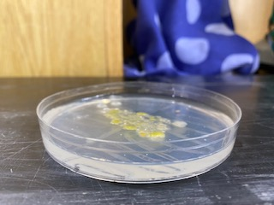
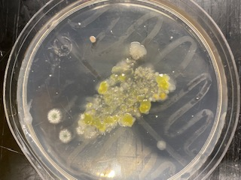
Stagnant water from Dale Meadows

This is the completed agar plate of stagnant water from dale meadows. As you can see the bacteria is all clumped in the middle of the plate, this is due to personal error (listed in the sources of error). We counted 160 individual bacteria, which may not be completely accurate. This Included 3 different kinds of bacteria, and 1 type of mold. The bacteria we observed were (1) yellow, circular, raised, undulate (2) cream, circular, flat, entire (3) pink, circular, flat, entire. As you can see, we also observed some mold, which we observed under a microscope (pictured below) rather than doing a gram stain.

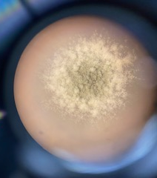
Mold observed on the Dale Meadows agar plate.
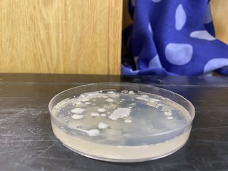
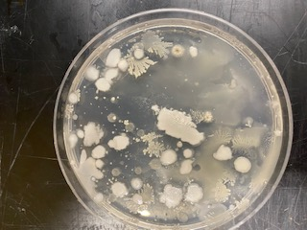
Control Variable: Distilled Water

The is the completed control agar plate of distilled water. This plate happened to be the most successful of the 3 plates, as you can see the bacteria is spread throughout the plate which made it significantly easier to count and observe. We were able to observe 2 different colony types and a total of 174 individual bacteria. The types of bacteria that we observed were (1) cream, circular, flat, entire (2) cream, filamentous, flat, filiform.
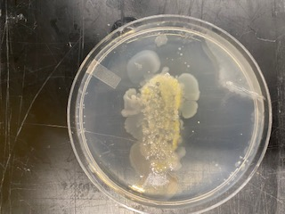
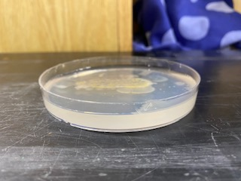
Stagnant water from Adams Bird Sanctuary

This is the completed agar plate of stagnant water from Adams Bird Sanctuary. As stated in the sources of error section, we incorrectly inoculated our plates, causing the bacteria to clump together and overproduce in the middle of the plate. This made it extremely difficult to count the individual bacteria and we couldn’t come up with an exact number. However, we were able to observe 2 different types of colonies. The colonies we observed were (1) yellow, circular, flat, entire (2) cream, circular, flat, entire.

Gram Stains:
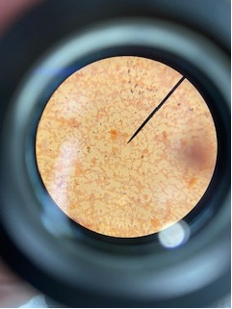
This is the gram stain of the yellow, circular, flat, entire bacteria found in the agar plate of stagnant water from Adams Bird Sanctuary and the agar plate of stagnant water from Dale Meadows. As you can see the bacteria appears gram neutral as very few of them appear purple in colour. Due to the shape and arrangement, these bacteria are most likely staphylococci.

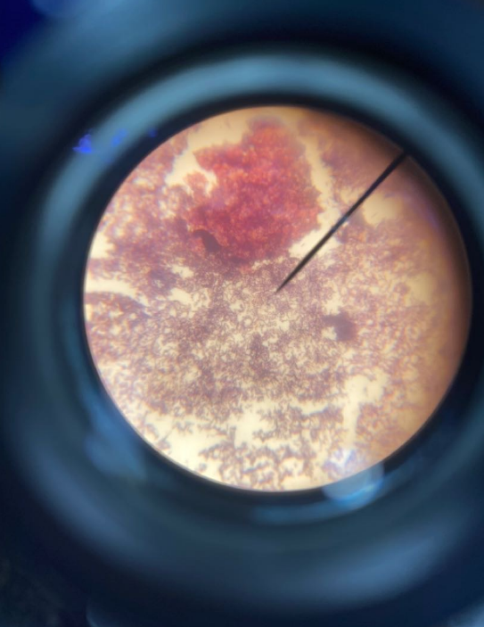
This is the gram stain of the cream, circular, flat, entire bacteria that we observed in all three agar plates. As you can see the bacteria appears purple which means the bacteria are gram positive. The picture obtained and the burnt agar included in the slide make it difficult to determine what type of bacteria we are observing.

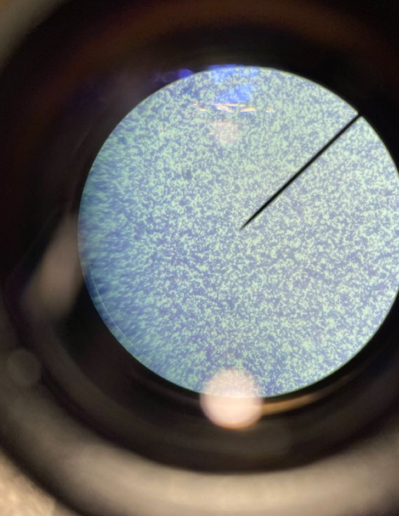
This is the gram stain of the pink, circular, flat, entire bacteria that we observed in the agar plate of stagnant water from dale meadows. As you can see the bacteria appear purple-ish in colour, meaning they are also gram positive. The picture obtained is not clear enough to observe and accurately determine the type of bacteria.

Data Table/Graphs:
Water Location | Colony Count | Number of Colony Types
Control-Distilled Water | 174 | 2
Stagnant Adams Bird Sanctuary | Inconclusive | 2
Stagnant Dale Meadows | 160 | 3 (+mold)

Conclusion:
After observing bacteria colonies is stagnant water from Adams Bird Sanctuary in comparison to stagnant water from Dale Meadows it was found that the stagnant water from Dale Meadows contained more bacteria colonies. These findings were conclusive with the hypothesis.

Sources of error:
There were a number of errors made throughout this experiment that need to be accounted for. It is important to recognize that in order to get accurate results many more trials would need to be conducted, but due to time and access to resources this was not a possibility. The first error occurred at the beginning of the experiment, when waiting for the bacteria to grow and reproduce our samples were not kept at a regulated temperature which could have affected the bacterial growth and varied our overall results. Next time, ideally, I will keep my samples in a controlled environment at an optimal bacterial growth temperature. The next error occurred when making the agar plates. The distilled water we used had preexisting bacteria in the waterspout which likely contaminated our plates and the distilled water control variable test. This could have varied our results. Next time, I will make sure I am using bacteria free distilled water to avoid contamination. When inoculating our plates, we did not spread the q tip from edge to edge resulting in an inconclusive count of the bacteria colonies in the stagnant water from Adams Bird Sanctuary. The bacteria clumped in the middle in 2 out 3 plates. The only successful of the 3 was the distilled water. However, we were able to count 160 individual bacteria in the stagnant water from dale meadows which is most likely inaccurate due to the extremely close proximity of the bacteria on the plate. This error made it very difficult to count the individual bacterium and therefore we could not accurately observe, record, and report out on all of our data. Next time I will make sure to spread from edge to edge to avoid clumping and get more accurate data. During the gram staining we accidentally included some agar on some of the slides, which burnt during the heat fixing. This made it difficult to observe the colonies under the microscope. In the future I will make sure to be extra cautious when adding the bacteria to the slides in order to avoid burnt agar spoiling the sample. The final mistake that was made in this experiment occurred when gram staining the pink bacteria from the stagnant dale meadows agar plate. We put too much water on the slide which made the water to bacteria ratio unbalanced. This made the gram stain less effective and more difficult to observe the data. When gram staining we did not keep track of the bacteria that we were staining, this made it very difficult to distinguish between them and accurately observe and compare them.

Discussion:
I found this lab report very interesting and informative. I believe the background research I attained is very important for the average person to know, as it could prevent them from consuming stagnant water and potentially putting their lives at risk. The research I conducted on the specific types of diseases and illnesses that can be contracted from stagnant water was especially shocking to me, I think that everyone should be aware of the risks and consequences of consuming these bacteria. I found it especially interesting that there was preexisting bacteria in the distilled water. This prompted me to believe that we need to be extremely careful with the water we are putting into our bodies as you cannot fully trust that it is safe to ingest and free of harmful bacteria.

Areas of Further Study:
With more time and resources there are plenty of other experiments I would like to conduct in this field. The first of which is, how would stagnant water samples collected from drastically different temperatures compare in terms of types of bacteria colonies? I think it would be interesting to see how hot vs cold temperatures affect bacteria growth and whether they are more (or less) dangerous to consume then the water samples that we tested in this experiment. I would also like to compare stagnant water from drastically different destinations to measure and observe how different species and wildlife contribute to bacteria growth in stagnant water. I think it would be interesting to see how the stagnant water from different locations vary in terms of types of bacteria colonies. Do some places grow more dangerous or harmful bacteria then others? Do certain species cause this? I would also like to test running salt water in comparison to running freshwater to compare the number and types of bacteria colonies produced. I think it would be very interesting to compare these two and observe how salt in water affects bacteria growth. Would it increase? Would it decrease? How do the different species found in these bodies of water contribute to the results?

Bibliography:
CDC, July 1st 2015- https://www.cdc.gov/healthywater/drinking/private/wells/disease/e_coli.html
Frontiers in Public Health, May 30th 2018-https://www.ncbi.nlm.nih.gov/pmc/articles/PMC5989457/#:~:text=Salmonella%20may%20survive%20in%20an,phosphate%20buffered%20solution%20(85).
Mika, Facty Staff, March 2nd 2021-https://facty.com/ailments/body/10-symptoms-of-legionnaires-disease/3/
H. B. D. Halkman, A. K. Halkman, 2014- https://www.sciencedirect.com/topics/pharmacology-toxicology-and-pharmaceutical-science/indicator-organism
https://courses.lumenlearning.com/microbiology/chapter/temperature-and-microbial-growth/
https://foodprint.org/issues/how-industrial-agriculture-affects-our-water/

