Inductive & Deductive Reasoning
FOM 11
Name: _______________________________

Learning Goals | Novice | Apprentice | Expert
I can use inductive reasoning, conjectures, and counterexamples
I can use deductive reasoning, conjectures, and counterexamples
I can determine, explain, verify, identify and correct a strategy to solve a puzzle.

- Emma works part-time at a bakery shop in Saskatoon. Today, the baker made 20 apple pies, 20 cherry pies, and 20 bumbleberry pies. Which is a conjecture that Emma most likely to make from this evidence? ________________________________________________________________________________________________________________________________________________________________________________________________________________________________________________________________________________________________________________________________________________________________________

- Debbie gathered the following evidence.

4(33) = 132 5(33) = 165 6(33) = 198

What is a conjecture, if any, that Debbie most likely to make from this evidence?
________________________________________________________________________________________________________________________________________________________________________________________________________________________________________________________________________________________________________________________________________________________________________

- What is a conjecture that you can make about the sum of two even integers and one odd integer? List three examples.

________________________________________________________________________________________________________________________________________________________________________________________________________________________________________________________________________________________________________________________________________________________________________

Examples:

- Nadine claims that whenever you add an odd integer to the square of an odd integer, the result is an odd number. Is her conjecture reasonable? Yes No

Briefly justify your decision.

_____________________________________________________________________________________________________________________________________________________________________________________________________________________________________________________________________________________________________________________________________________________________________________________________________________________

- What conjecture could you make about the product of three odd integers? Use inductive reasoning to justify your conjecture.

Conjecture:
__________________________________________________________________________________________________________________________________________________________________

Justification:

- The square of an even integer is added to the square of an odd integer. Develop a conjecture about whether the sum is odd or even. Provide inductive and deductive evidence to support your conjecture.

Conjecture | Inductive Reasoning | Deductive Reasoning

- All birds have backbones. Birds are the only animals that have feathers. Rosie is not a bird. What can be deduced about Rosie?
I. Rosie has a backbone.
II. Rosie does not have feathers.
Explain your thinking: ________________________________________________________________________________________________________________________________________________
a. | Neither I nor II
b. | I only
c. | I and II
d. | II only

- Hali is a fitness instructor. People who take Hali’s exercise class regularly soon become very fit. Regular exercise makes people feel happy. Joshua takes Hali’s exercise class regularly. What can be deduced about Joshua?
1. Joshua is very fit.
2. Joshua feels happy.
Explain your thinking: ________________________________________________________________________________________________________________________________________________
a. | Choice 2 only
b. | Choice 1 only
c. | Neither Choice 1 nor Choice 2
d. | Choice 1 and Choice 2

- Use both deductive reasoning and inductive reasoning to show that the sum of three even integers is even.

Inductive Reasoning | Deductive Reasoning

- Use both inductive reasoning and deductive reasoning to show that the sum of two odd integers is even.

Inductive Reasoning | Deductive Reasoning

- Use both inductive reasoning and deductive reasoning to show that that the product of an odd integer and an odd integer is always odd.

Inductive Reasoning | Deductive Reasoning

- Make a conjecture about what will happen when you subtract two consecutive odd numbers. Prove with both inductive and deductive reasoning

Conjecture | Inductive Reasoning | Deductive Reasoning

- Try the following number trick with 2 (or more) different numbers. Make a conjecture about the trick, then prove.

Conjecture: ___________________________________________________________________________________________________________________________________________________________________________________________________________________________________________________

 | Inductive Reasoning | Deductive Reasoning
Choose a number.
Multiply by 3.
Add 5.
Multiply by 2.
Subtract 10.
Divide by 6.

- Austin made the following conjecture: As you travel farther south, the climate gets hotter.

Do you agree or disagree? Agree Disagree

Briefly justify your decision with a counterexample if possible. ____________________________________________________________________________________________________________________________________________________________________________________________________________________________________________________________________________________________________________________________________________________________________________________________________________________________________

- Sarah made the following conjecture: The square of a number is always greater than the number. Show three counter examples.

- Attila made the following conjecture:
The difference between two numbers always lies between the two numbers.
Is the following equation a counterexample to this conjecture? Why or why not.

6 – 2 = 4

______________________________________________________________________________________________________________________________________________________________________________________________________________________________________________________________________________

- Look at the below pattern:
1 • 6 + 1 = 7 • 1
2 • 6 + 2 = 7 • 2
3 • 6 + 3 = 7 • 3
4 • 6 + 4 = 7 • 4
Do you think the pattern will continue? Justify your decision with a counterexample if possible.

______________________________________________________________________________________________________________________________________________________________________________________________________________________________________________________________________________

- What number should go in the grey square in this Sudoku puzzle?
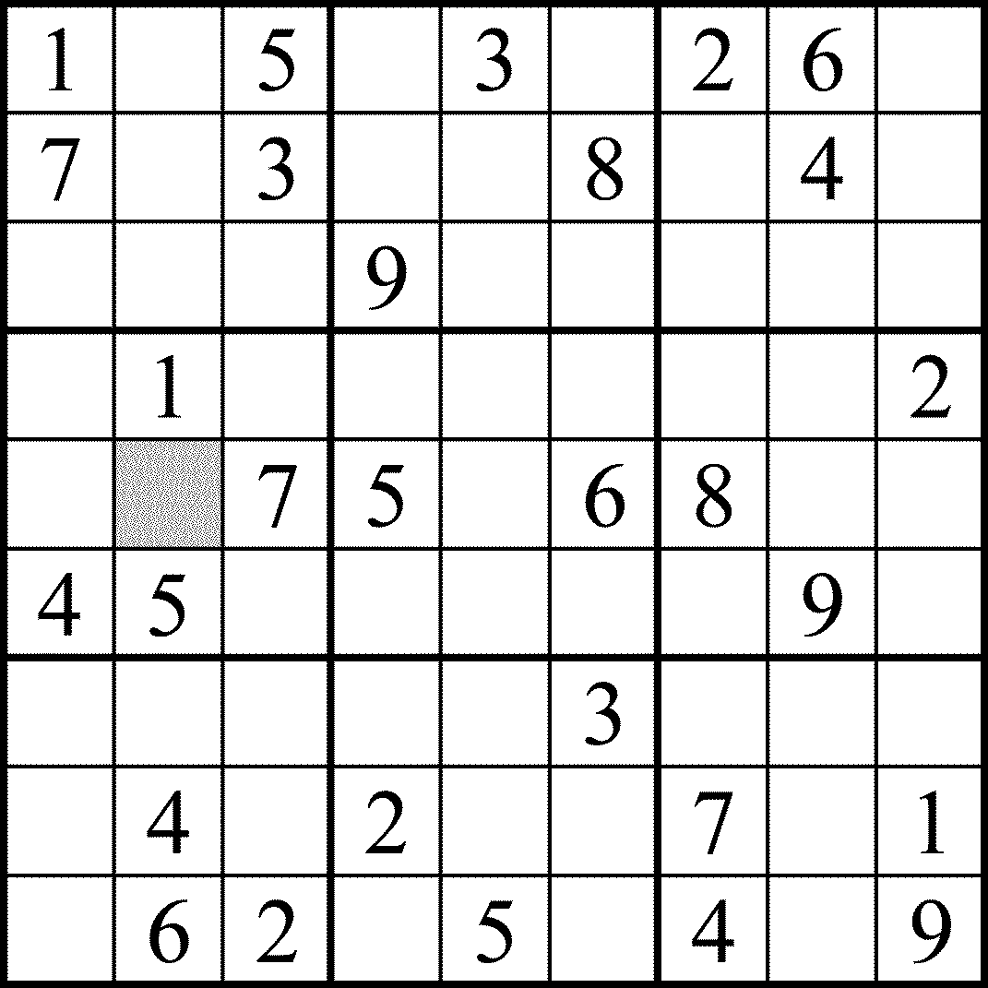

- Solve this KenKen puzzle using only the numbers 1 to 4. Do not repeat a number in any row or column. The darkly outlined sets of squares are cages. The numbers in each cage must combine in any order to produce the target number, using the operation shown. A number may be repeated in a cage as long as it is not in the same row or column.

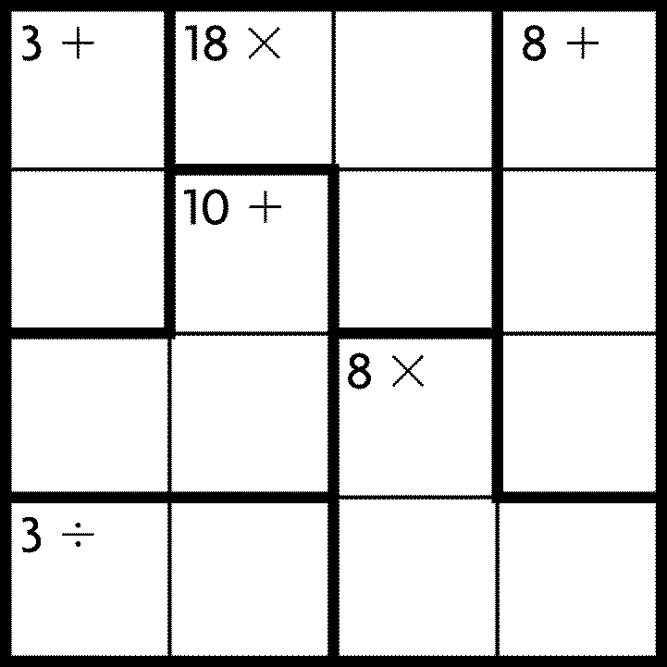

Futoshiki Puzzle
- Complete the grid such that every row and column contains the numbers 1 to the size of the grid.
- The arrows on the grid are less-than and greater-than signs. e.g. 1 < 4, 3 < 5, 2 > 1.

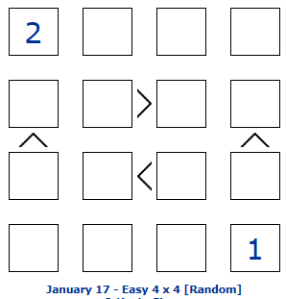

Neighbours
- Complete the grid such that every row and column contains every number exactly once.
- The symbols on the grid indicate neighbours (e.g. 1 >< 2, 3 >< 4, 2 >< 1).
- Rule 1 - a symbol between = the numbers are neighbours.
- Rule 2 - NOT a symbol between = the numbers are NOT neighbours.

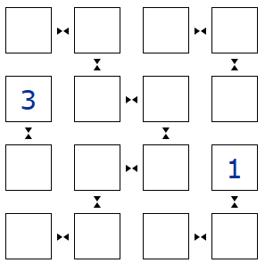

Slitherlink
- Join the dots to create a single continuous loop.
- The numbers indicate how many of the four surrounding sections contain a line.
- The loop never crosses itself and any given dot can only have a maximum of two lines passing through it.

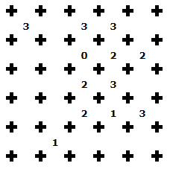

3-in-a-Row 1
- Fill the grid with Blue and White squares.
- A 3-In-A-Row (or column) of the same colour is not allowed.
- Each row and column has an equal number of Blue and White squares.

