Environmental Sciences 12
Take Action Final Project

#1  What ACTIONS can you do that will positively impact our Summerland Secondary environmental understanding? | #2  What ACTIONS can you do that will positively impact our Summerland communities environmental understanding?  OR
 | 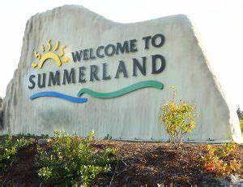
- What needs to improve in our Summerland Secondary school to help our students and staff have more understanding of our environmental issues?  - How can we change our behaviours in our school to help the environment?  - Who would you need to talk to about this project?  - What would be your goal with this project? | - What would our Summerland community benefit from that would help our environment?  - Who would you need permission from?  - What would be your goal with this?

Project Timing
Please have this project completed and written up for submitting by Wednesday, June 22nd at 3pm.

How to Get Started
Week #1 June 6 - 12
- Choose a partner and a project topic
- What do you want to do/change either in our SSS school or our Summerland community with respect to bettering our environment
- Complete your project proposal and submit to Mrs. Becker by Thursday, June 9th

Week #2 June 13 - 19
- Talk to the people who can help you get approval for this project
- Start building, making appointments, making phone calls, etc
- Take a photo of each step so that you can include it in your write up

Week #3 June 20 - 23
- Complete the project (keep taking photos of the finished product)
- Write up what you did (see guiding questions below)
  - What did you do?
  - Include photos and a brief description of what you did
  - Why did you do this? What was your motivation? What is your goal for an environmental shadow?
  - How do you think this will improve our Summerland environmental understanding?
  - How will this impact us immediately? How will this impact us in 5 years? How will this impact us in 10 years?

Marking Criteria

Learning Goal | Beginning  1 | Developing  2 | Proficient  3 | Sophisticated  4
I can show how human activities can impact global climate systems |  |  | - I can ask insightful questions that expand our knowledge about the environment  - I can connect my project to my learning about the environment  - I can connect my project to statistics and data
I can provide evidence of sustainable living |  |  | - I have explained in my project journal how my project connects to sustainable living and sustainable practices
I can collaboratively plan and follow through on a project |  |  | - I worked collaboratively with my partner  - I advocated for my project  - I connected to the community members that I needed to in order to take action on my project  - I finished and followed through with all aspects of my project plan

