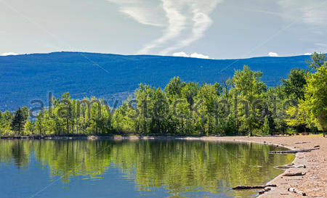
Environmental Sciences 11/12
Sunoka Story Trail Project Species Project

Your organism: ______________________________________
Due: Wednesday, October 6th

Parts of the Project
- Choose an organism that is along the Sunoka walking trail (visible or hidden)
- Create a PDF or webpage that is visibly appealing that will educate people about the plant, animal, insect, fungus
- Include photos, information, sounds, Okanagan Syilx language words and stories
- What is this organism’s niche?
- What other organisms in the area is this connected to (eat, shelter, connections)
- How do we protect this organism?

Information to include about your organisms
Learning Goal  Curricular Competency | Details
Societal Impact | - Current situation with population  - What is going to happen to the ecosystem if this continues  - Factors involved with decline  - Trophic cascades (who else does this organism impact?)  - Organisms niche in the ecosystem  - Is this a red/blue listed species?  - Is this an invasive species?
Analyzing Data | - Current population of organism  - Historical population organism  - Graph of provincial and local numbers  - Map of boundary of area
Evaluating Situation | - What are we currently doing to help (organizations, etc)  - What more needs to be done  - What can we do as a community?
Reflection | - What can people’s role be in order to keep this organism healthy? (personally and as a part of our Okanagan community)
Communication | - Strong use of scientific language  - Did the information on your PDF/website make sense? Easy to follow? No spelling errors?  - Was able to answer questions confidently.

We will then create a QR code that will link people on the trail directly to your PDF/website. These QR codes will be connected to a log and directly linked on a website so that people can look things up and learn more about our Sunoka environment.

Make connections between Syilx ways of knowing and western ways of knowing.

Create a visually appealing product.

