Statistics Unit Review
Name: _________________________

Learning Goal | Novice | Apprentice | Expert
I can calculate the measures of central tendency and standard deviation
I can use normal distribution to find patterns in a population
I can use z-scores to describe my data

Learning Goal #1: I can calculate the measures of central tendency and standard deviation
Novice
For the following groups of numbers, calculate the mean, median and mode for each.

- 18, 24, 17, 21, 24, 16, 29, 18

Mean
Median
Mode

- 75, 87, 49, 68, 75, 84, 98

Mean
Median
Mode

- Brian was comparison shopping for DVD players. He decided he wanted to purchase a DVD player that was in the middle of the price ranges. The prices he was quoted include the following: $59.99, $219.99, $79.99, $84.99, $159.99, $109.99, $35.99. Which DVD player did Brian select?

- Below is the class data for the Unit #1 test. Organize your data in a frequency table.
92, 92, 90, 91, 92, 95, 92, 89, 87, 88, 90, 86, 90, 91, 86, 86, 90, 90, 87, 92, 95, 90, 91, 86, 87, 91, 86, 87

Apprenticeship
- Chad recently launched a new website. In the past six days, he has recorded the following number of daily hits: 37, 29, 37, 56, 45, 38. He is hoping at week’s end to have an average number of 40 hits per day. To achieve this, how many hits must he have on the final day of the week?

- Joe and Bill were competing against each other to see who could collect the most bottle caps. If Joe averaged 320 and Bill averaged 340, what did each one collect in December if they collected the following amounts in the previous months.

 | Joe | Bill
Jan | 300 | 413
Feb | 412 | 286
Mar | 207 | 395
Apr | 283 | 250
May | 601 | 174
June | 114 | 228
July | 319 | 370
Aug | 299 | 419
Sept | 403 | 450
Oct | 317 | 684
Nov | 354 | 207

Expert
- You want to find the mean and standard deviation of the swimming speed for the 100m front stroke of the top 8 Orca swimmers.
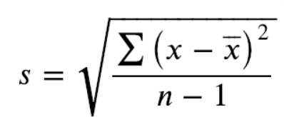
35.2, 33.5, 45.1, 30.9, 45.3, 23.3, 33.2, 44.3

- You look up the calories in the Tim Horton’s donuts. Calculate the mean and standard deviation of the calories in their donuts.

220, 300, 375, 250, 325

Learning Goal #2: I can use normal distribution to find patterns in a population
Novice
- Draw a normal distribution curve. Put the percentages of population that will fit into each standard deviation. Label the mean.

- A bowhead whale is one of the longest living animals. The mean life expectancy of a bowhead whale is 200 years with a standard deviation of 7. What is the range that we would expect approximately 68% of the bowhead population to live?

- On a math test, the class mean was 75% with a standard deviation of 3%. Susan gets 81% on the test. What percentile does she fall in?

- You collect speed skaters times and calculate the race mean to be 123 seconds with a standard of 4 seconds. Draw a normal distribution with this data and label what the x axis will be up to 3 standard deviations.

- The ages of members of a seniors curling club are normally distributed, with a mean of 63 years and a standard deviation of 4 years. What percent of the curlers are in each of the following age groups?
  - Between 55 and 63 years old?
  - Between 67 and 75 years old?
  - Older than 75?

Apprentice
- What is the mean and standard deviation of the below normal distribution?
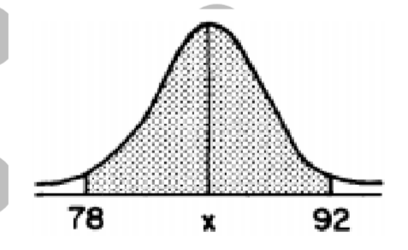

- At a high school in the US, 2500 students took their SAT’s. The scores were normally distributed with a mean of 64 and a standard deviation of 6. What percentage of scores are between 52 and 70?

- The average annual salary at a BC company is $46,700 with a standard deviation of $3,000. What percent of employees make above $49,700?

Expert
- The line at a concert has an average waiting time of 25 minutes, with a standard deviation of 4 minutes. If there are 2000 people in line, how many people expect to wait for less than 21 minutes?

- A manufacturer offers a warranty on its coffee makers. The coffee makers have a mean lifespan of 4.5 years, with a standard deviation of 0.7 years. For how long should the coffee maker be covered by the warranty, if the manufacturer wants to repair no more than 2.5% of the coffee makers sold?

- Tiegan is organizing her movie collection. She decides to record the length of each movie, in minutes. Determine the mean and standard deviation. Create a frequency table and graph the distribution of the data. Label the distribution.
91 | 129 | 95 | 96 | 96 | 90 | 101 | 87 | 100 | 90
86 | 78 | 105 | 99 | 81 | 106 | 101 | 122 | 91 | 102
89 | 125 | 162 | 155 | 89 | 89 | 180 | 94 | 84 | 99
73 | 100 | 99 | 100 | 117 | 135 | 100 | 89 | 87 | 110
125 | 103 | 94 | 99 | 98 | 102 | 96 | 88 | 154 | 144

Learning Goal #3: I can use z-scores and confidence intervals to describe my data
Novice
- The speeds of motorists passing a particular point on the Coquihalla Highway are normally distributed with mean 115 km/h and a standard deviation of 14km/h. If 64% of the motorists are driving at, or above the posted speed limit, what is the posted speed limit?

- In order to determine the mean mass of baseballs produced at a factory, sampling is done and the following statement is made by the company. The mean mass of baseballs produced at our factory is 150.6 grams ± 1.1 grams. The results are accurate 18 out of 20 times.
  - What is your confidence interval?

  - How would you write this as a confidence interval?

  - How would you write this as a margin of error?

  - What is your confidence level?

  - What is the percent change that the mean mass could be outside of the confidence interval?

X | X - μ | Z-score
10
11.2
15
17.2
14.9
11.5
- You are a biologist looking at the length of painted turtles in a specific population. There are only 6 turtles remaining in this specific pond population. The lengths are: 10cm, 11.2 cm, 15cm, 17.2 cm, 14.9cm, 11.5 cm. Find the z-scores for each data point (use desmos to find mean and standard deviation first).

- Before applying to law school, students need to take an exam called the LSAT. Before applying to medical school, students need to take an exam called the MCAT. Here are some summary statistics for each exam:
LSAT μ = 151, σ = 10
MCAT μ = 25.1, σ = 6.4
Jackie took both exams. She scored 172 on the LSAT and 27 on the MCAT. Which exam did she do relatively better on?

Apprentice
- A recent survey shows that Canadian high school students spend an average of 1.5 hours per day accessing the internet and an average of 1.75 hours per day being physically active. The results are considered accurate to within 0.2 hours 24 times out of 25.
  - Interpret what this is saying using confidence intervals: _______________________________________________________________________________________________________________________________________________________________________________________________________________________________________________________________________________________________________________________

