FOM 11
Quadratics Unit Review #2
Unit Test (online): June 17/18th (must write by 3pm on 18th)
Name: _____________________________
Learning Goals | Novice  1/2 | Apprentice  3/4 | Expert  5/6
I can use technology to graph parabolas and find important points of the graph
I can formulate the equation of a parabola in multiple forms (factor form, vertex form, and general form)
I can translate a general form equation into both factor and vertex form in order to graph
I can use quadratics to understand situational use of parabolas

Learning Goal #1: I can use technology to graph parabolas and find important points on the graph
YOU ARE TO USE THE DESMOS APP FOR EACH QUESTION IN THIS LEARNING GOAL
Novice
Graph the following equation into desmos. Use the graph to find the below data:  f(x) = x² + 5x - 2  axis of symmetry: _________________________  y-intercept: __________________________  x-intercept(s): _________________________  Domain: _____________________________  Range: _______________________________ | Graph the following equation into desmos. Use the graph to find the below data:  f(x) = 4(x - 1)(x + 2)  axis of symmetry: __________________________  y-intercept: ___________________________  x-intercept(s): _________________________  Domain: _____________________________  Range: _______________________________
Graph the following equation into desmos. Use the graph to find the below data:  f(x) = -$\frac{1}{3}$x² – 5x + 1  axis of symmetry: _________________________  y-intercept: __________________________  x-intercept(s): _________________________  Domain: _____________________________  Range: _______________________________ | Graph the following equation into desmos. Use the graph to find the below data:  f(x) = -2(x – 5)² – 5  axis of symmetry: _________________________  y-intercept: __________________________  x-intercept(s): _________________________  Domain: _____________________________  Range: _______________________________

Learning Goal #2: I can communicate the characteristics of a quadratic function
You may NOT use Desmos for this learning goal. PUT YOUR PHONE AWAY!

What are the three forms of a quadratic function? How do you represent these functions? What data can you get from each of these forms? | For the below graphs, identify the axis of symmetry and the co-ordinates of the vertex.  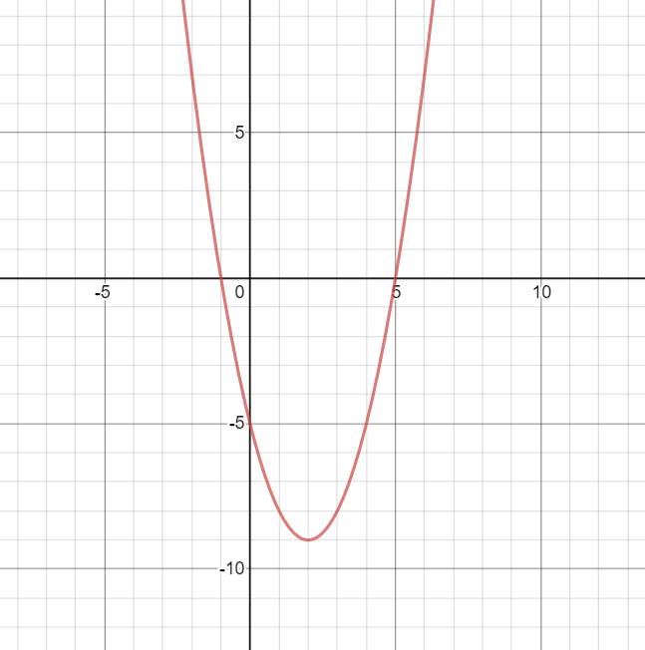  Axis of symmetry: _________________  Vertex: __________________________  Value of a = ______________________  Domain: ________________________  Range: __________________________  Equation in vertex form: ________________________  Equation in Factor Form: ________________________
For the below graphs, identify the axis of symmetry and the co-ordinates of the vertex.  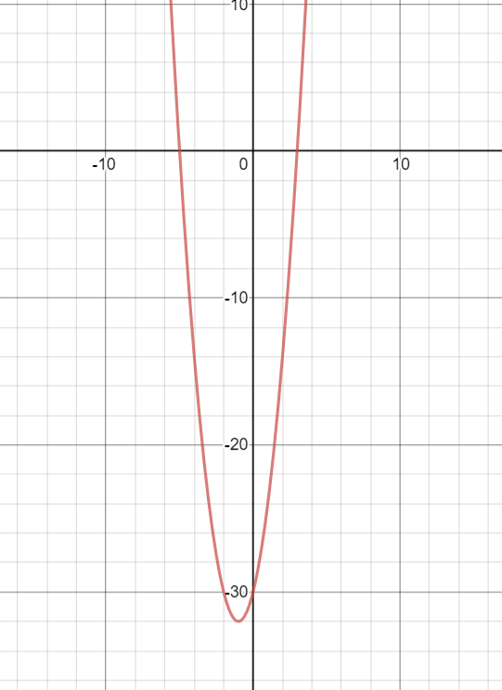  Axis of symmetry: _________________  Vertex: __________________________  Value of a: _______________________  Domain: _________________________  Range: _____________________ | For the below graphs, identify the axis of symmetry and the co-ordinates of the vertex.  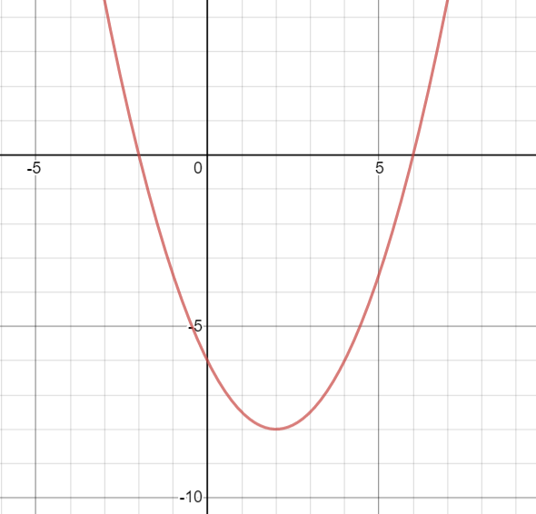  Axis of symmetry: _________________  Vertex: __________________________  Value of a: _______________________  Domain: _________________________  Range: __________________________
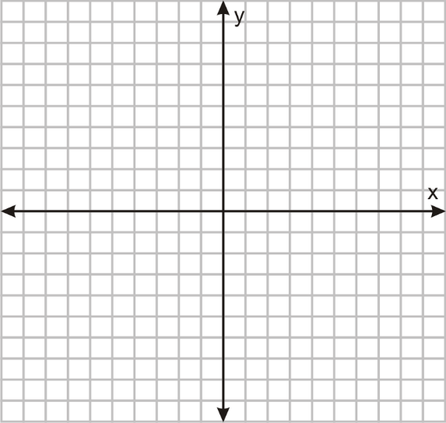
Use a table of values to graph the below function:
y = -$\frac{1}{2}$x² - 3

Apprentice
What is the equation of the below parabola in vertex form?  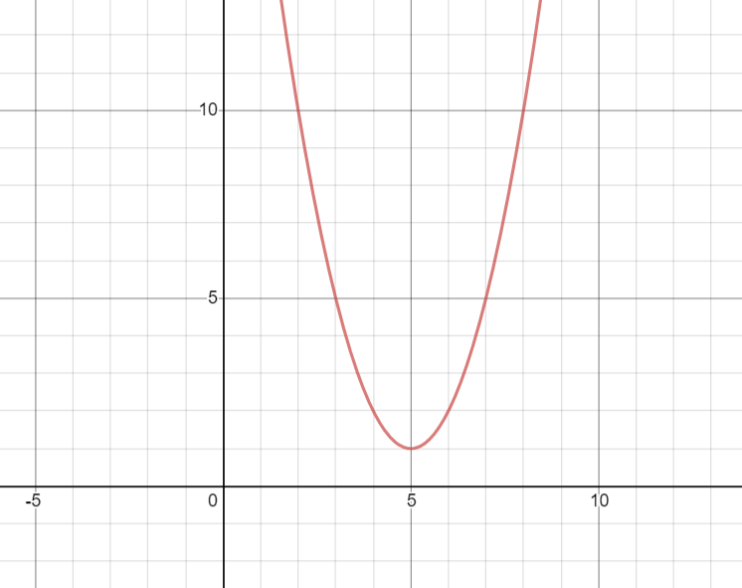 | What is the equation of the below parabola in vertex form?  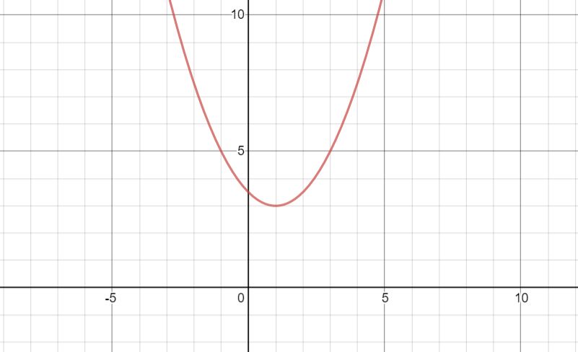
What is the equation of the below parabola in factor form?  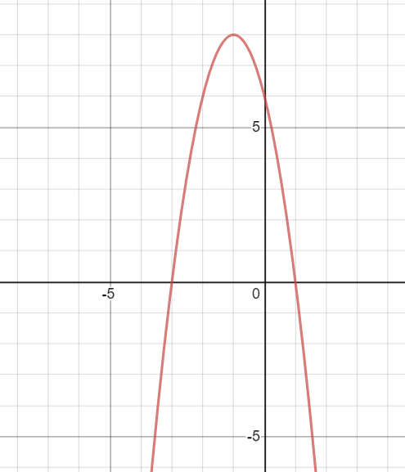 | What is the equation of the below parabola in factor form?  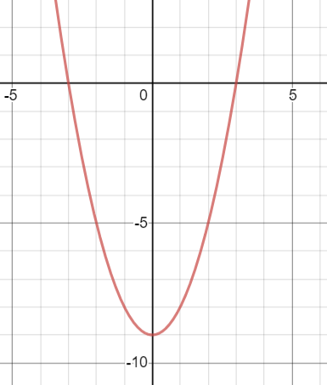

Expert
Graph the following equation (without using a table of values): f(x) = 2(x - 3)² + 1  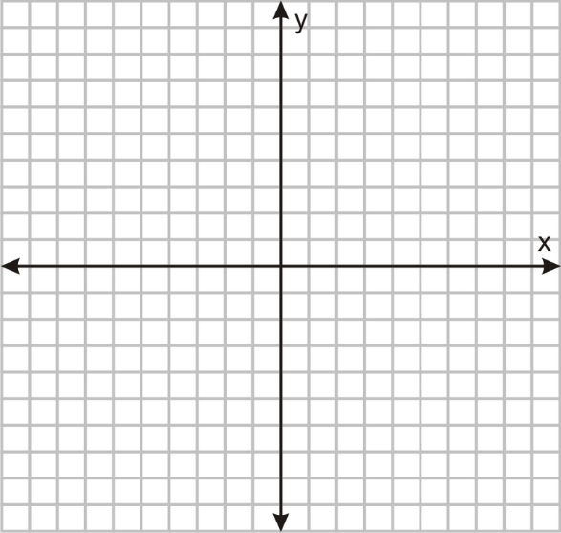 | Graph the following equation (without using a table of values): f(x) = - $\frac{1}{2}$(x – 4)(x + 2)  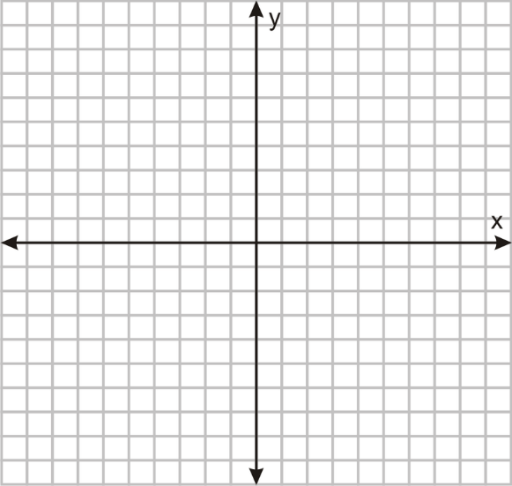
Graph the following equation (without using a table of values): f(x) = -$\frac{1}{2}$ (x - 1)² + 3  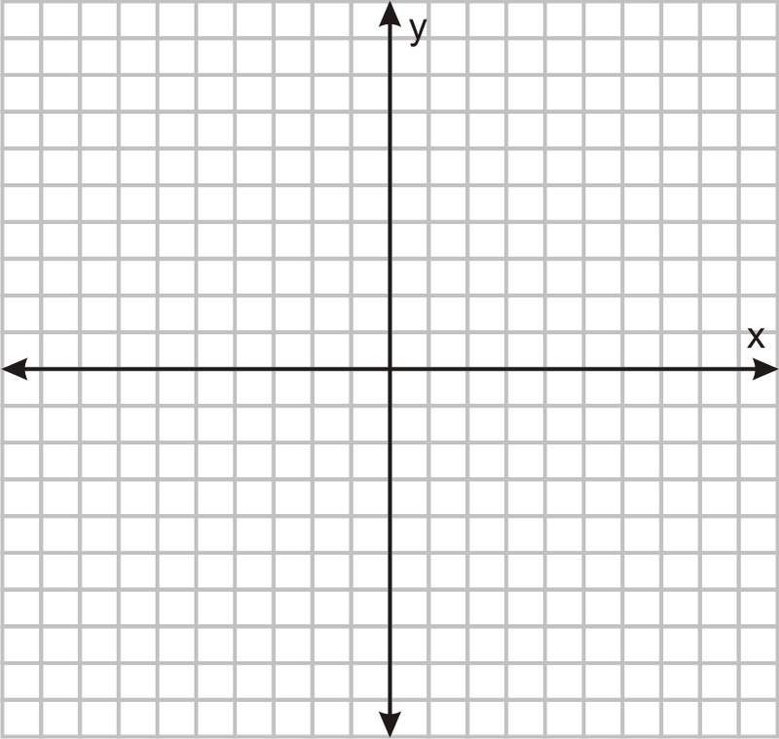 | Graph the following equation (without using a table of values): f(x) = 2(x + 3)² - 5

Learning Goal #3: I can translate general form equations into both factor form and vertex form in order to graph without using a table of values

Change the below equation into factor form and then graph the parabola: y = x² – 4x – 5  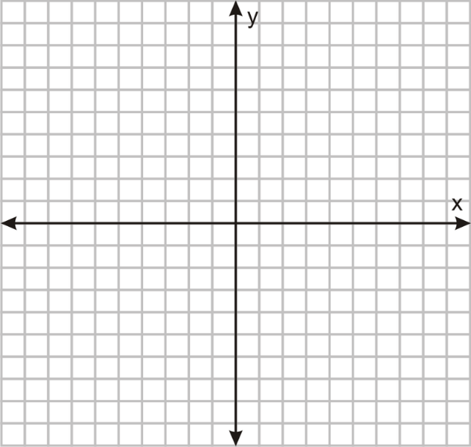 | Change the below equation into factor form and then graph the parabola : y = x² - x - 6  Graph the below parabola  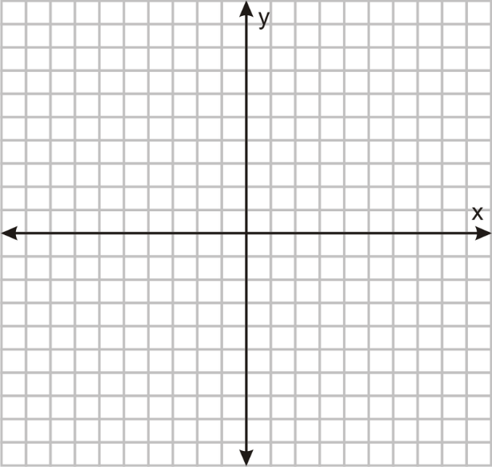
Change the below equation into vertex form and then graph the parabola: y = x² + 4x + 1 | Change the below equation into vertex form and then graph the parabola: y = x² + 8x + 11

Learning Goal #4: I can use quadratics to solve situations problems

A skateboarder was recorded in frame by frame analysis and placed in one pictures as shown. The below function shows the skateboarders height above the ground, y, measured in metres, to the time, x, in seconds is:
y = -1.9x² + 56x + 1

Graph the function using desmos.
- What is the skateboarder’s maximum height, to the nearest tenth of a metre?

- How many seconds does the skateboard “hang” in the air until he lands (to the nearest hundredth of a second)?

A grad committee is selling tickets to a pasta dinner fundraiser. They usually sell tickets for $50. At this price, they will sell 275 tickets. Looking at previous years sales they are aware that they will sell 10 fewer tickets for each price increase of $2. What function models the potential earnings, if x represents the number of price increases in dollars?

- Using desmos, what is the maximum revenue for the grad council?

- If they are wanting to earn the maximum revenue, how much should they sell the tickets for?

- If they use this highest price ticket, how many tickets can they expect to sell?

Expert
At the Canada Day celebration in Summerland, a firework is projected vertically into the air and reaches a maximum height of 100m. The path of the firework is parabolic and lands 30 m from the launch site.

- Determine the equation that models the height of the firework as a function of the horizontal distance travelled.

- Use Desmos to graph the parabola. How high is the firework after travelling the horizontal distance of 10m?

John sells boxes of apples for $25. At this price, he can sell 20 boxes every week. He wants to increase his earnings, but, from his research, he knows that he will sell 1 fewer boxes per week for each price increase of $2.

- What is the maximum amount that John can make?

- What should John charge for his box of apples if he wants to earn the maximum amount of money?

- If he charges the amount of money that he would need to earn the highest amount, how many boxes of apples would he sell in a week?

