FOM 11
Quadratics Review #1 Online
Name: _____________________________
Learning Goals | Novice  1/2 | Apprentice  3/4 | Expert  5/6
I can communicate the characteristics of a quadratic function
I can create a quadratic equation of a graph in various formats (vertex, factor, and general form

Novice
What are the three forms of a quadratic function? How do you represent these functions? What data can you get from each of these forms? | For the below graphs, identify the axis of symmetry and the co-ordinates of the vertex.  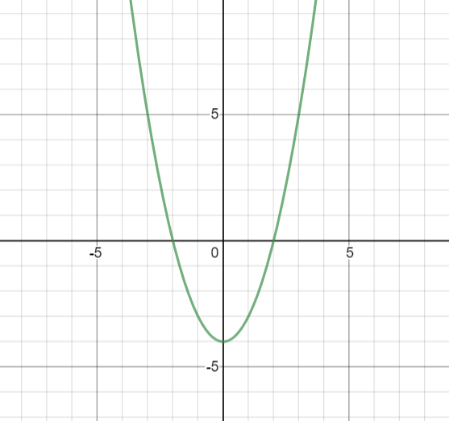  Axis of symmetry: _________________  Vertex: __________________________  Value of a = ______________________  Domain: ________________________  Range: __________________________
For the below graph, identify the axis of symmetry and the co-ordinates of the vertex.  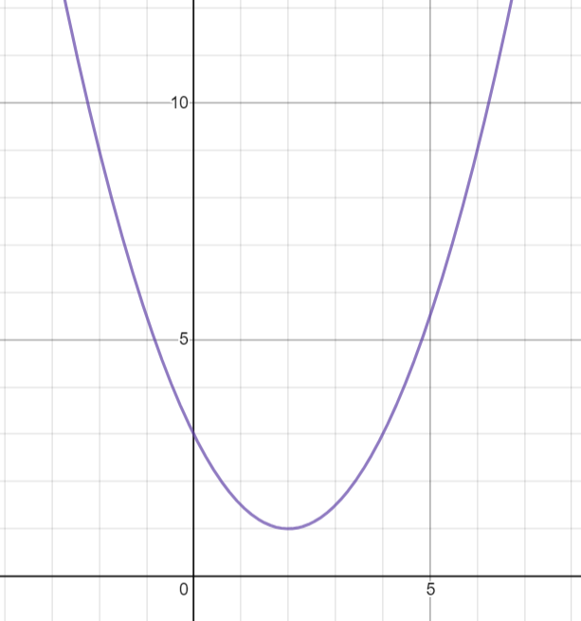  Axis of symmetry: _________________  Vertex: __________________________  Value of a: _______________________  Domain: _________________________  Range: __________________________ | For the below graphs, identify the axis of symmetry and the co-ordinates of the vertex.  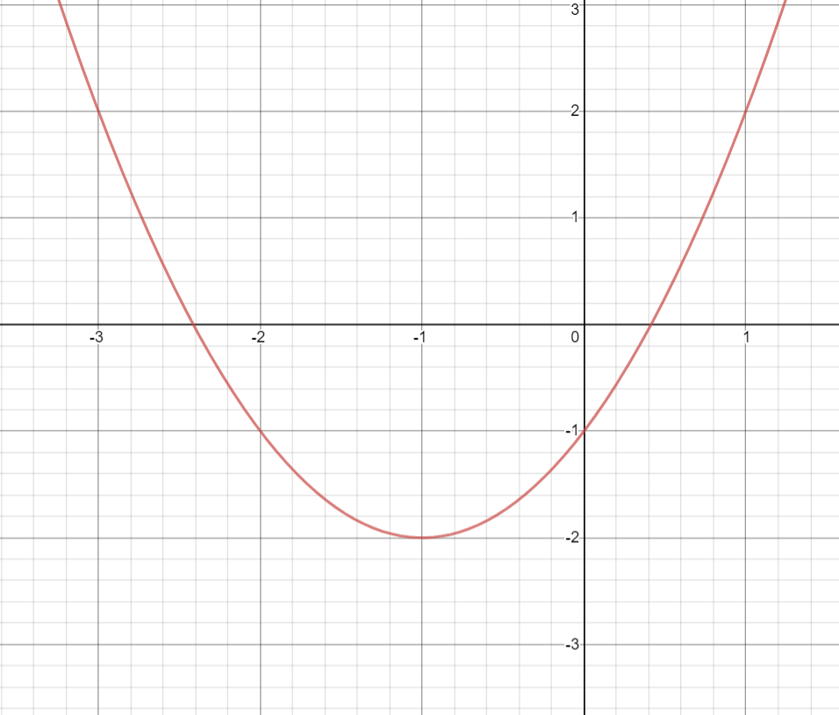  Axis of symmetry: _________________  Vertex: __________________________  a-value: _________________________  Domain: _________________________  Range: ___________________________
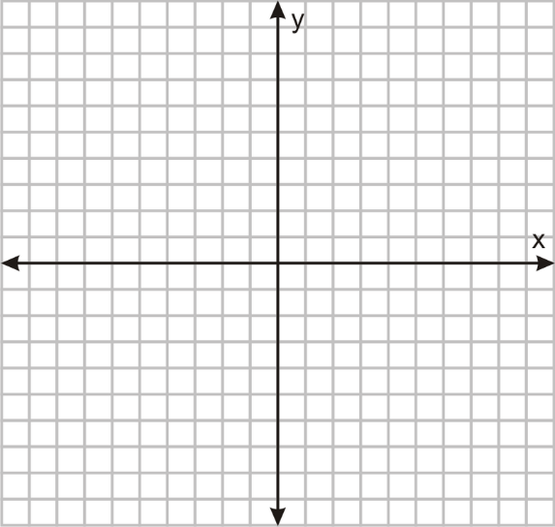
Graph the below quadratic:
y = - (x – 1)² + 3

Graph the below quadratic:
y = (x – 1)(x + 3)

Apprentice
What is the equation of the below parabola in vertex form?  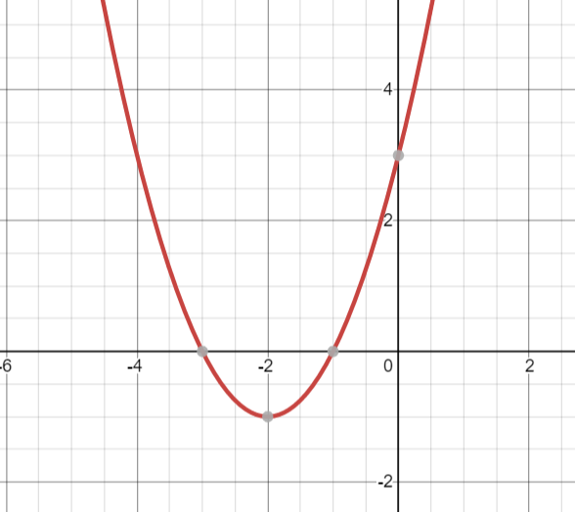  Vertex Form: _________________________  General form: ________________________ | What is the equation of the below parabola in vertex form?  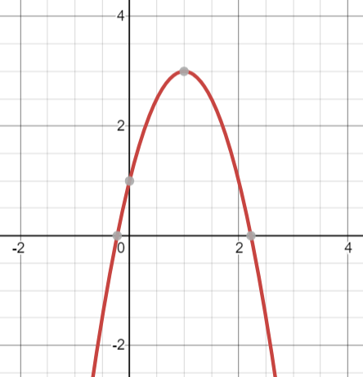  Vertex Form: _________________________  General form: ________________________
What is the equation of the below parabola in factor form?  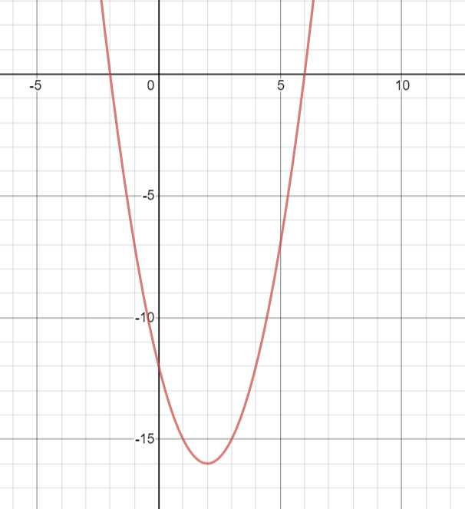  Factor Form: _________________________  General form: ________________________ | What is the equation of the below parabola in factor form?  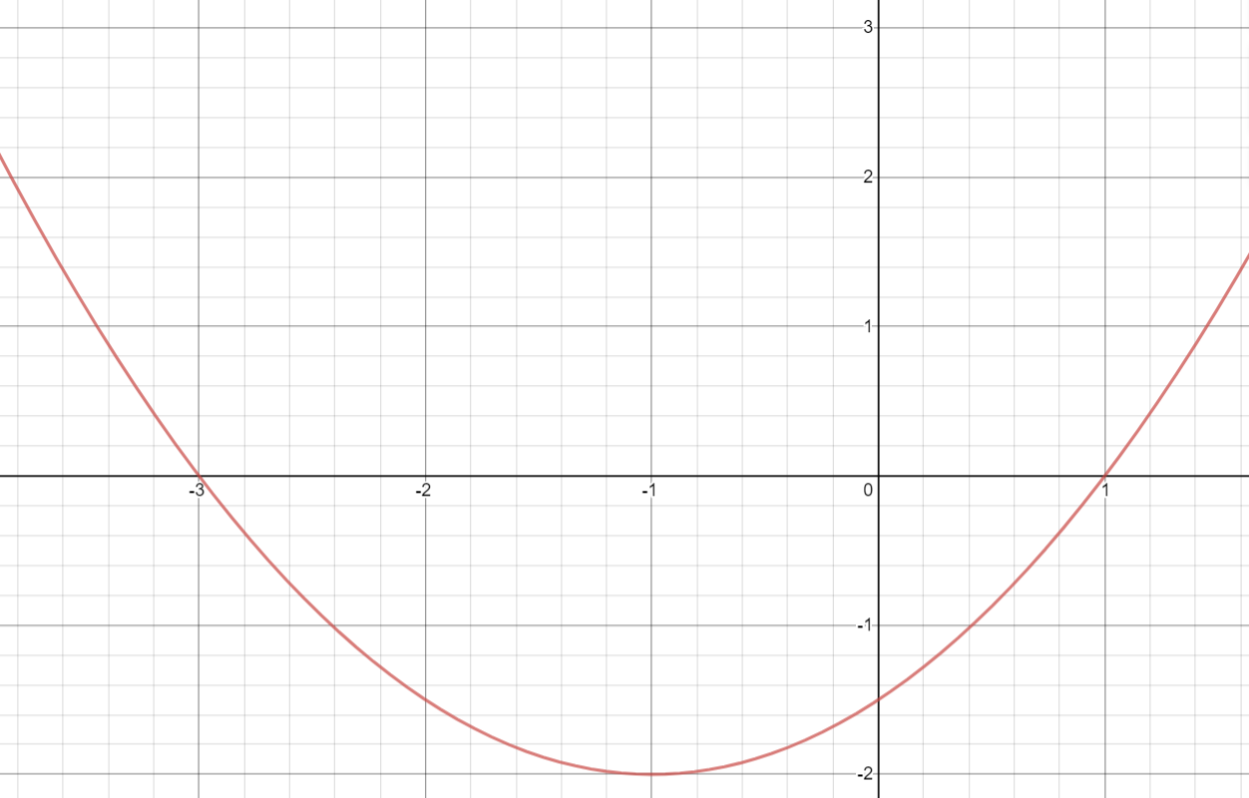  Factor Form: _________________________  General form: ________________________
Graph the below quadratic:  y = $\frac{1}{2}$(x – 2)(x + 4) | Graph the below quadratic:  y = 2(x – 1)² - 5

Expert
Graph the following equation (without using a table of values): f(x) = -2(x - 1)² + 8  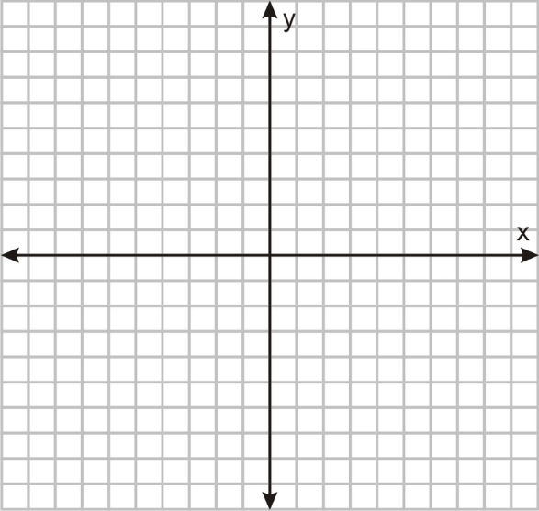 | Graph the following equation (without using a table of values): f(x) = -$\frac{1}{2}$(x – 2)(x + 4)  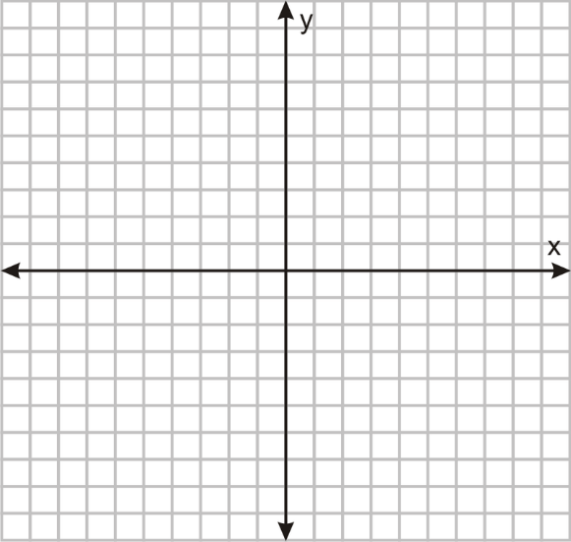
What is the equation in general form? (CHOOSE which other form to use to access general form)  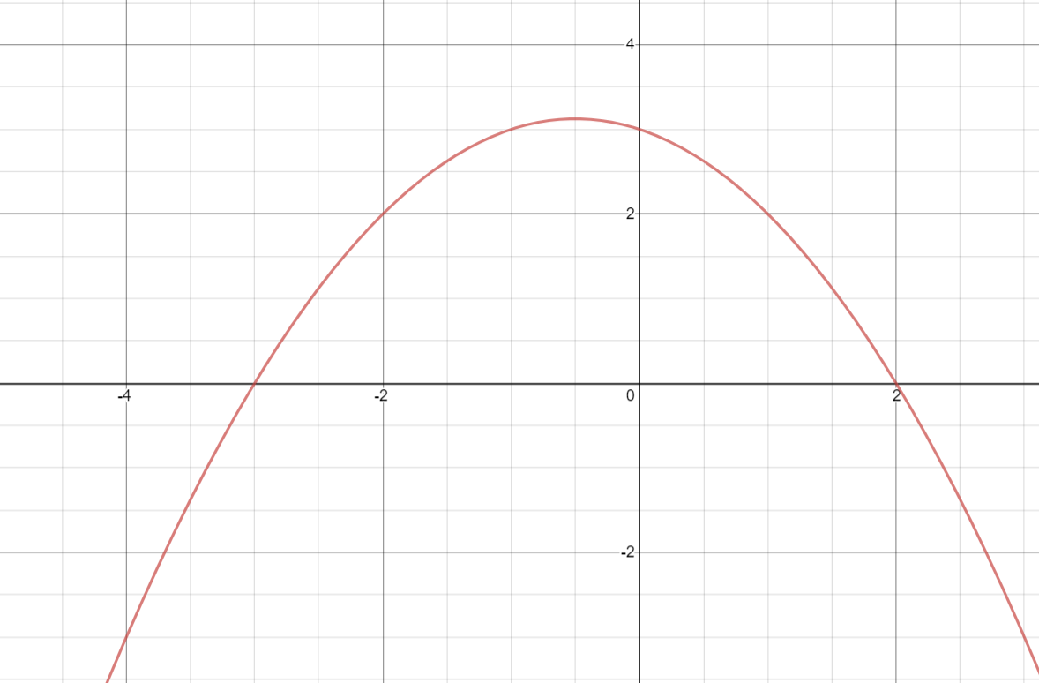  General Form: ________________________________ | What is the equation in general form? (CHOOSE which other form to use to access general form)  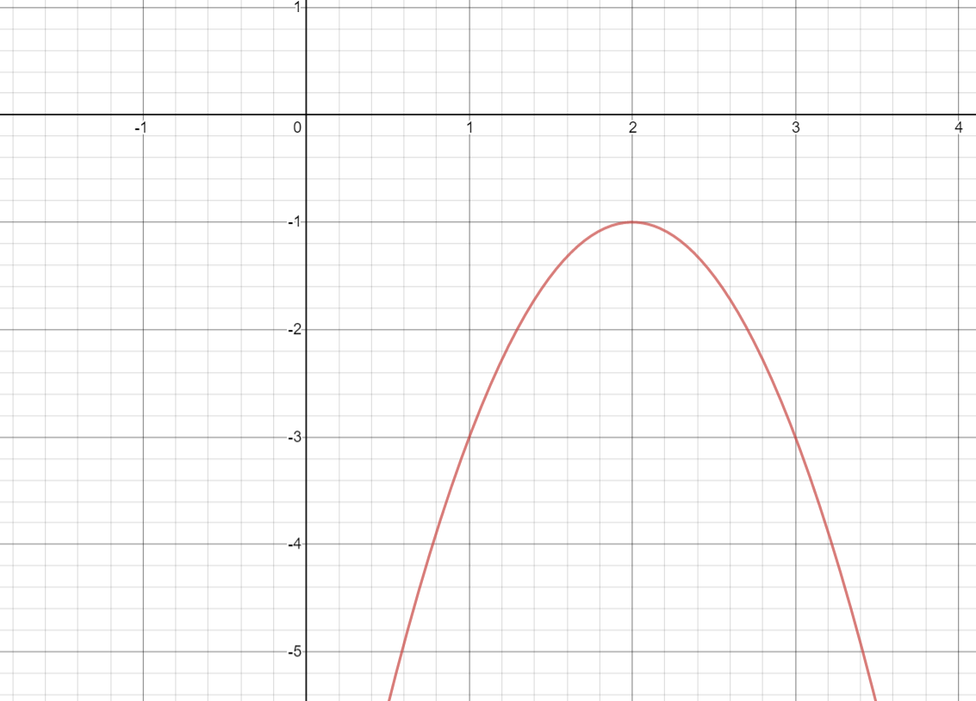  General Form: ________________________________

