Angles, Triangles, and Parallel Lines
PRACTICE Test
Name: _____________________________

Learning Goal | Novice | Apprentice | Expert
I can find missing angles using geometry concepts

I can use tools such as a protractor and a compass to draw and measure angles

Learning Goal #1: I can find missing angles using geometry

Novice
Write the vocab word that matches the below picture. Include whether they are equal or supplementary:

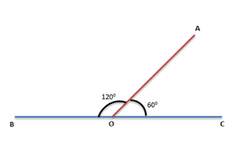 = __________________________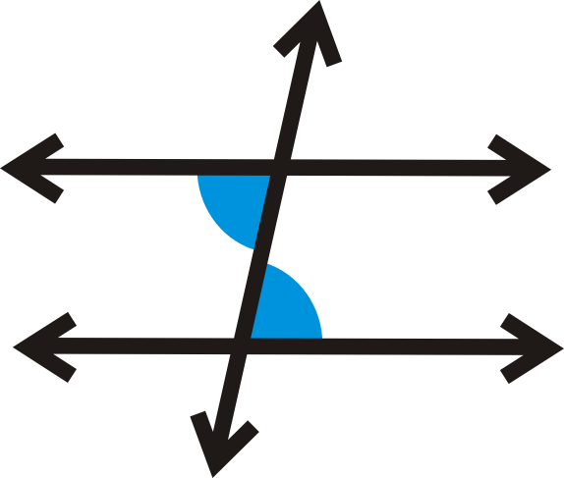 = ______________________________

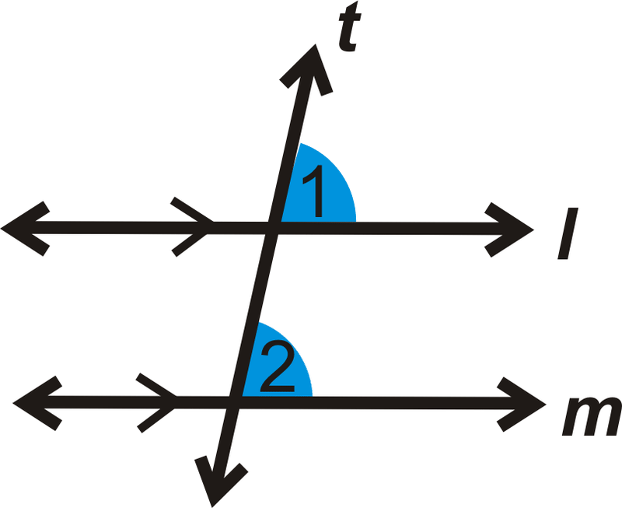 = _________________________ 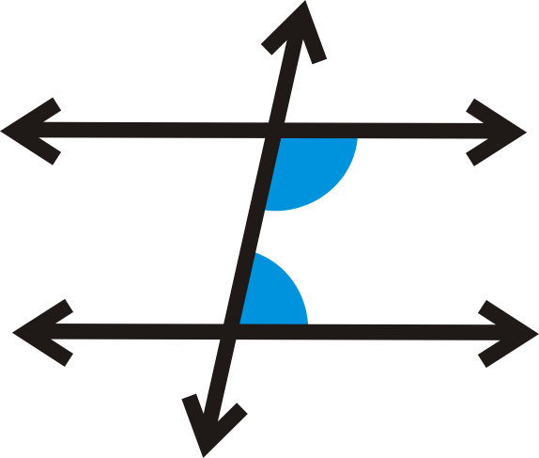= ______________________________

What is the sum of the interior angles in the below shapes?  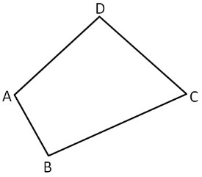 | What is the name for the below triangle? Also list one characteristic of the triangle.  Name: ___________________  Characteristic:_______________________________________________  Name: ___________________  Characteristic:_______________________________________________
Complete the interior angles of the below polygon:  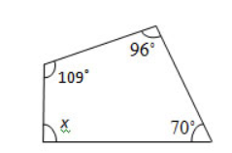 | Complete the interior angles of the below triangle:  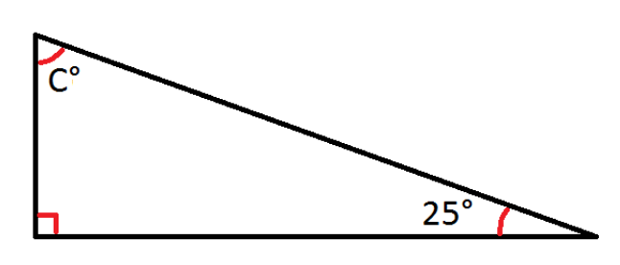
Complete the below chart with labelling the vocab word for the KIND OF ANGLE and then adding a real world example of where you might see this type of angle:
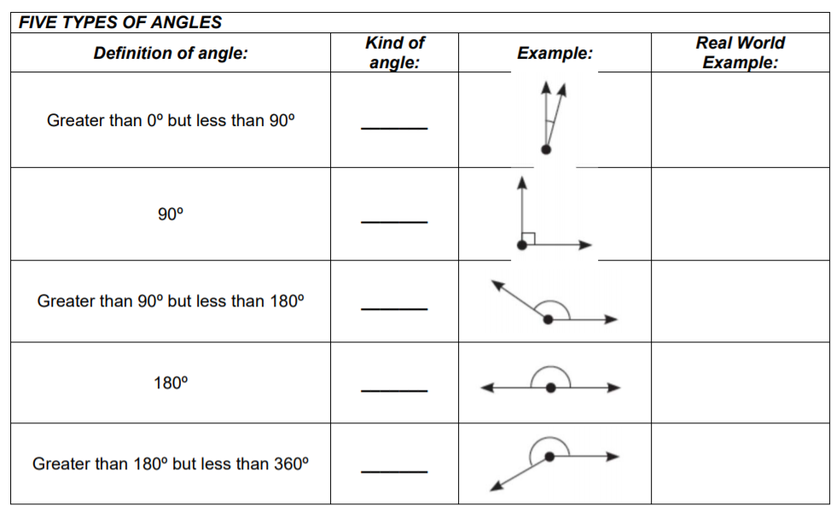

Apprentice
What is angle a, b, and c?  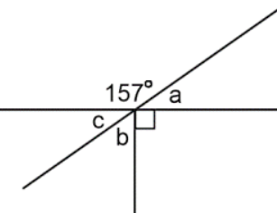 | Find the missing angle x:  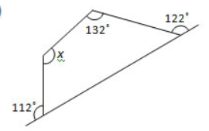
Find missing angles A, B, C, D, and F:  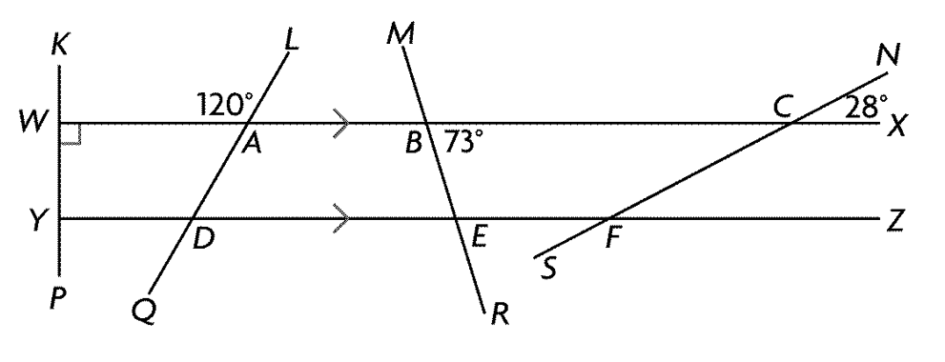 | What is angle DCE?  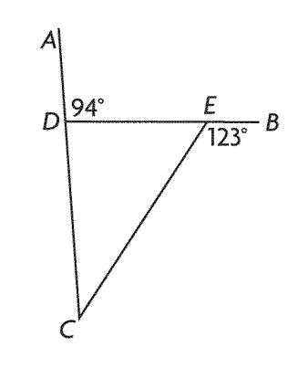
If angle f is 85º and c is 25º, what is a, b, e, and g?  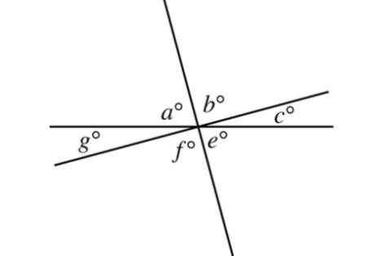 | Each interior angle of a regular convex polygon measures 144°. How many sides does the polygon have?
Determine Find the sum of the measures of the interior angles of this polygon. | Determine Find the sum of the measures of the interior angles of this polygon.  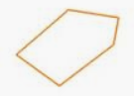
Complete the below table:

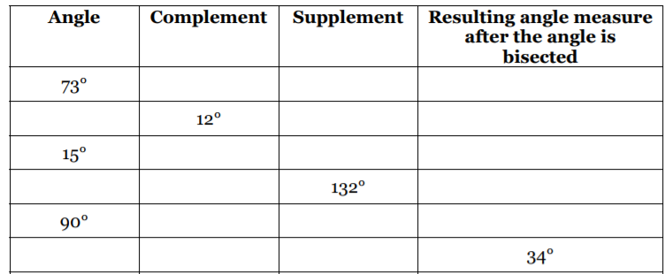

Expert
Determine the value of x  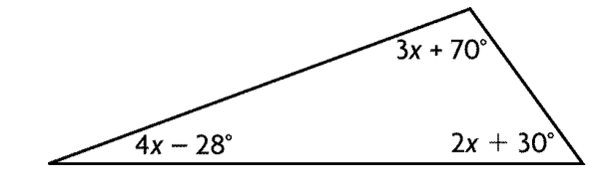 | Determine all the interior angles (not just solving for x…solve for the angle).  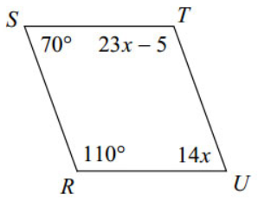
Determine the measure of angle S0R  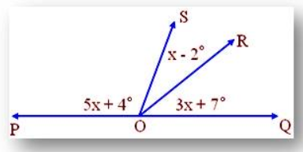 | Determine the value of x  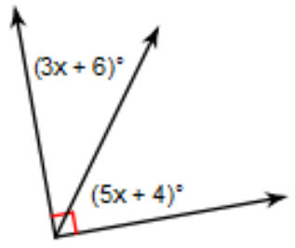
Determine Determine the value of angle x  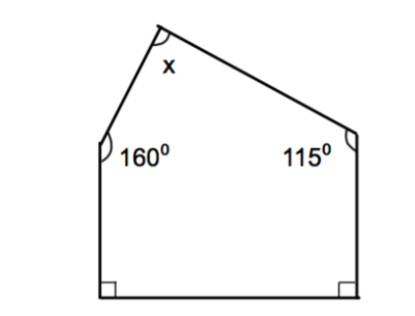 | Determine the value of angle y  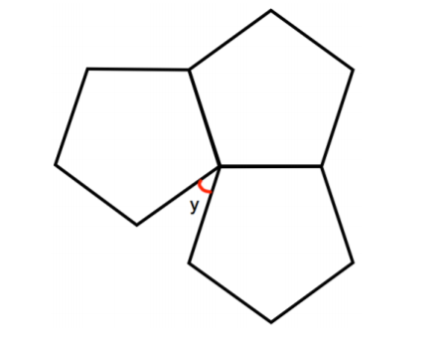
Determine  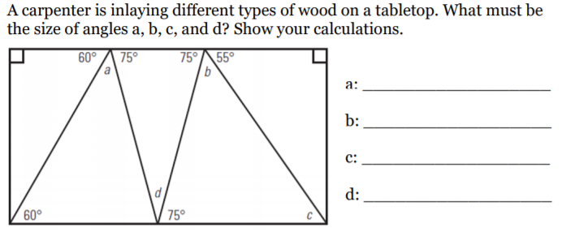 | Each interi Each interior angle of a regular convex polygon measures 150°. How many sides does the polygon have?

Learning Goal #2: I can use tools such as a protractor and a compass to draw angles
Novice
What is the below angle?  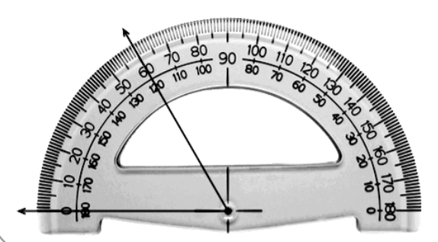 | What is the below angle?  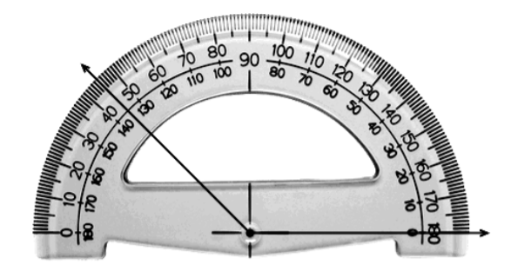
What is this angle classified as? What is the exact value of the angle?  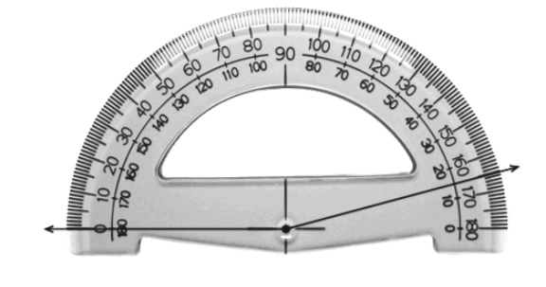 | What is this angle classified as? What is the exact value of the angle?  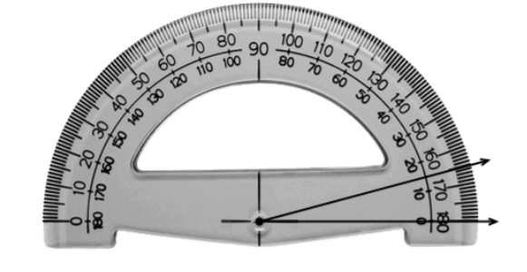

Apprentice
Use a protractor to draw an angle of 23º | Use a protractor to find the below angle  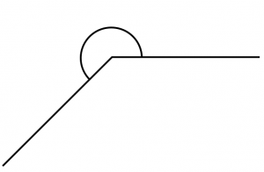
Use a protractor to find the below angle.  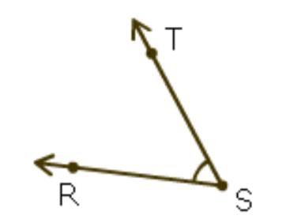 | Use a protractor to find the below angle:  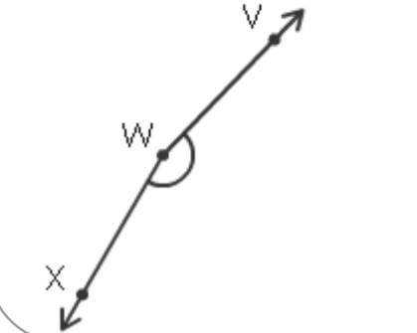

Expert
Using a compass, draw a 90º angle | Using a compass, draw a 60º angle
Using a compass, draw a 30º angle | Using a compass, draw a 120º angle

