Foundations of Math 11
Name: _________________________________________
Practice Final Exam
Part B Technology Section (Desmos and TVM)

GOOD LUCK
Learning Goals  Final Exam Review Booklet | My STUDY PRIORITY
- I can calculate simple and complex interest
- I can explain an calculate loan payments and investments
- I can use technology to graph a parabola and find important data points
- I can find the intersection points of two non-linear graphs
- I can graph the solution to a system of linear inequalities
- I can use optimization to solve for different situations
- I can solve systems of equations with linear inequalities
- I can calculate the measures of central tendency and standard deviation

Learning Goal #1: I can calculate simple and compound interest
Use your TVM Calculator for this learning goal.
- You have invested $2000.00 into a Royal Bank Saving account. It is compounded monthly at a rate of 1.1% per annum. How much will you have in your bank account if you left it in there for 5 years? Use your TVM Solver. Show what values you would add to the various parts below (not everything needs to be filled, only what is necessary for this scenario):

Present Value
Payment
Future Value
Annual Rate %
Periods
Compounding
Mode

- When you were born your parents decided to put away some money into a high interest RESP that you can cash when you turn 18 to use for post-secondary. The goal was for you to have $30,000. The RESP rate was 8.1% per annum, compounded monthly. How much money should your parents put into the RESP when you are born?

Present Value
Payment
Future Value
Annual Rate %
Periods
Compounding
Mode

Learning Goal #2: I can calculate loan and leasing payments
- Frank needs to borrow $5,000 in order to pay for Okanagan College. His bank gives him a student loan at 3.95% per annum compounded monthly. His plan is to pay back all the money within 4 years of graduation. What will his monthly payment be?

Present Value
Payment
Future Value
Annual Rate %
Periods
Compounding
Mode

- You decide to buy a new Kia. The sale price is $28,900. Kia’s leasing deal is 1.99% per annum compounded monthly for 48 months, with a down payment of $4000. The residual value is $12,498.40.
- What is the monthly payment?
Present Value
Payment
Future Value
Annual Rate %
Periods
Compounding
Mode
- What is the final cost of the vehicle?

Learning Goal #3: I can use technology to graph parabolas and find important points on the graph
YOU ARE TO USE THE DESMOS APP FOR EACH QUESTION IN THIS LEARNING GOAL
Graph the following equation into desmos. Use the graph to find the below data:
f(x) = -2x² + 3x - 4

axis of symmetry: _________________________
y-intercept: __________________________
x-intercept(s): _________________________
Domain: _____________________________
Range: _______________________________

You got a new pair of ski’s for Christmas and take them up Apex to do some terrain park jumps. Your friend videos your jumps and you graph one of the largest. Desmos gives you the following equation for the jump:

y = - $\frac{1}{2}$(x - 6)(x + 2)
- How tall was obstacle you jumped (in meters)?

- What was your highest point in your jump?

- How many seconds were you in the air before you hit the snow?

Rui is a professional deep water free diver.
His altitude (in meters relative to sea level), x seconds after diving, is modeled by:
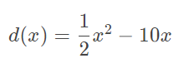
How many seconds after diving will Rui reach his lowest altitude?

Learning Goal #4: I can find the intersection points of two non-linear graphs
Use DESMOS to find the solution to the system of non-linear equalities.
Graph the following and state a solution to the system.  y = (x + 2)(x – 3)  y = $3x$  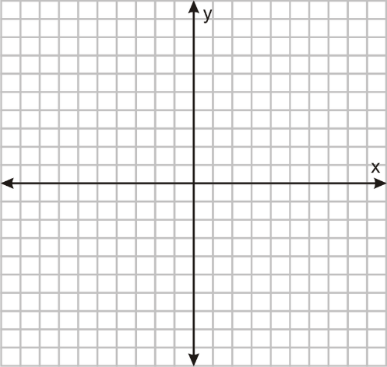  Solution : ____________________ | Graph the following and state a solution to the system.  y = $\frac{1}{2}$(x + 2)² - 5  y = $3x$  Solution : ____________________

Learning Goal #5: I can graph the solution to a system of linear inequalities (for optimization)
Use DESMOS to find the solution to the system of non-linear equalities.
- The staff in a cafeteria are making two kinds of muffins, lemon and chocolate. A maximum of 300 muffins are needed. Based on previous demand, there should be at least four times as many lemon as chocolate muffins. Define the variables and write a system of inequalities that models his solution.

Variables
_____ = ____________________________________________________________________________
_____ = ____________________________________________________________________________

Constraints

Three possible solutions

- A company does custom paint jobs on cars and trucks. Due to the size of the workshop, the company can paint a maximum of 8 cars and 5 trucks in one day. The total output for the shop cannot exceed 10 vehicles in one day. The company earns $400 for a truck paint job and $250 for a car paint job. How many of each should they book to earn the greatest profit in one day?
Define your variables:

Complete the constraint and restriction chart
Constraints | Restrictions

What is your objective function?
Objective function:

Graph using desmos. What are your test co-ordinates for your maximum and minimum?

Minimum and maximum test window.

What combination of cars and trucks will result in the maximum profit? What is the maximum profit? (make a full sentence). ___________________________________________________________________________________________________________________________________________________________________________________________________________________________________________________________________________________________________
Learning Goals #6: I can calculate the measures of central tendency and standard deviation
- Below are two sets of full class data from their course marks. Using Desmos, find their Mean, Median, and Mode, along with standard deviation.
Block 3 – Biology 12 | Block 4 – Biology 12
89%, 73%, 62%, 60%, 78%, 89%, 77%, 50%, 53%, 81%, 98%, 78%, 64%, 52%, 64%, 63%, 55%, 78%, 78%, 89%, 54%, 80%, 64%, 67% | 90%, 93%, 98%, 97%, 100%, 100%, 97%, 98%, 90%, 91%, 98%, 50%, 51%, 52%, 54%, 43%, 45%, 58%, 48%, 59%, 54%, 60%, 44%, 57%
Mean:  Median:  Mode:  Standard Deviation: | Mean:  Median:  Mode:  Standard Deviation:

Summarize how this data describes the class results. _______________________________________________________________________________________________________________________________________________________________________________________________________________________________________________________________________________________________________________________________________________________________________________________________________________________________________________________________________________________________________________________________________________________________________________________________________________________________________

- Wasim and Mushtaq are two Cricket players in Australia. The data shows the number of runs scored by both players in various innings.
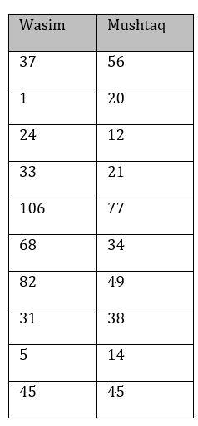
  - On average, who is the better player? Why?

  - Which player is more consistent? Why?

