**Foundations of Math 11**

Name: _________________________________________

**PRACTICE FINAL**

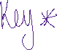

**Part A: Calculator Section**

**GOOD LUCK ☺**

|  |  |  |
| --- | --- | --- |
| **Learning Goals**  **Final Exam Review Booklet** | **My STUDY PRIORITY** |  |
| 1. I can find missing angles using geometry |  |  |
| 1. I can calculate simple and complex interest |  |  |
| 1. I can explain and calculate loan payments and investments |  |  |
| 1. I can use technology to graph a parabola and find important data points |  |  |
| 1. I can graph a parabola using general, vertex, and factor forms |  |  |
| 1. I can find the intersection points of two non-linear graphs |  |  |
| 1. I can use optimization to solve for different situations |  |  |
| 1. I can calculate the measures of central tendency and standard deviation |  |  |
| 1. I can use confidence intervals, z-score, and distributions to explain data |  |  |
| 1. I can use scale factor to find proportional dimensions, area, and volume |  |  |
|  |  |  |

**Learning Goal #1: I can find missing angles using geometry**

|  |  |  |  |  |  |  |  |  |  |  |  |  |  |  |  |  |  |  |  |
| --- | --- | --- | --- | --- | --- | --- | --- | --- | --- | --- | --- | --- | --- | --- | --- | --- | --- | --- | --- |
| Complete the chart below:   |  |  |  | | --- | --- | --- | | Vocab Word | Diagram | Are the angles “equal” or “Add to 180º” | | Supplementary angles |  |  | | Complimentary Angles |  |  | | Alternate Interior Angles |  |  | | Corresponding Angles |  |  | |  |  |  | | |
| The below lines are parallel. Solve for x. | Draw and label vertically opposite angles in a diagram. Make sure there are appropriate angle values included.  Draw and label same side interior angles in a diagram. Make sure there are appropriate angle values included. |
| Find angles a, b, c, and d. Place your justification into the table below:   |  |  |  | | --- | --- | --- | | Angle | Value | Reason | | d |  |  | | |
| Find angle DAC. Be sure to show your work: | |

**Learning Goal #2: I can calculate simple and compound interest**

1. You have saved $4000 from your summer job and are planning on putting it in your back account. You put it in your Credit Union account, which is a simple interest account at 4.1% per year. You leave the funds in your account for three years.
   1. Calculate the simple interest on your investment.

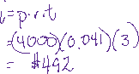

* 1. At the end of the three years, how much do you have in your account? Do NOT use your TVM calculator (please show formula and use a regular calculator).

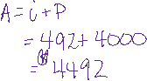

1. Jack has invested $10,000 in a 10 year bond, compounded semi-annually at a rate of 2.3% per annum. Determine the interest earned at the end of the 10 year period. Do NOT use your TVM calculator (please show formula and use a regular calculator).

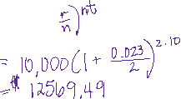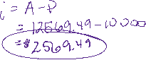

1. You have invested $1000.00 from your summer earnings into a 5 year Mutual Fund investment, It is compounded quarterly at a rate of 3.12% per annum. Determine HOW YOU WOULD SET UP THIS PROBLEM. Do not solve, just add the values and words in the correct spot.

|  |  |  |
| --- | --- | --- |
| Present Value |  |  |
| Payment |  |  |
| Future Value |  |  |
| Annual Rate % |  |  |
| Periods |  |  |
| Compounding |  |  |
| Mode |  |  |

1. Estimate how many years it would take for an investment of $1000 to grow to $8000 if the annual interest rate was 7.2%

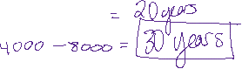

**Learning Goal #3: I can use technology to graph parabolas and find important points on the graph**

|  |  |
| --- | --- |
| Using the below quadratic equation, find the below characteristics of the graph:  **f(x) = (x – 2)2 + 5**  Vertex: _______________________  Axis of symmetry: _________________________  Domain: _____________________________  Range: _______________________________ | Graph the following equation into desmos. Use the graph to find the below data:  **f(x) = -2(x - 2)(x + 4)**  axis of symmetry: __________________________  x-intercept(s): _________________________  Domain: _____________________________  Range: _______________________________ |
| You head to Mexico on a vacation and enjoy some lovely cliff jumping. Your brother took photos of your best jump. You use desmos to over lay a parabola on your photo and find the equation to your jump. ‘y’ represents the height in (m) and ‘x’ represents the time (sec):  y= -0.4x2+12x+12  What ***characteristics of the graph*** could help you find the following information.   1. How tall was the cliff that you jumped from?  1. What was your highest point in your jump? 2. How many seconds were you in the air before you hit the water? | |

**Learning Goal #4: I can communicate the characteristics of a quadratic function**

|  |  |  |
| --- | --- | --- |
| For the below graphs, identify the axis of symmetry and the co-ordinates of the vertex.    Equation in Factor Form: ________________________  Equation in General Form: ________________________ | For the below graphs, identify the axis of symmetry and the co-ordinates of the vertex.    Axis of symmetry: _________________  Vertex: __________________________  Value of a = ______________________  Domain: ________________________  Range: __________________________  Equation in Vertex Form: ________________________  Equation in General Form: __________________________ | |
| Change the below equation into factor form and then graph the parabola: y = x2 - 4x – 5  Factor Form: ____________________________________  Image result for cartesian plane | | What is the y-intercept and x-intercept(s) of the below form? f(x) = 2x2 - 4x - 6  y-intercept: ____________________________  x-intercept(s): _________________________  Graph the below parabola  Image result for cartesian plane |

**Learning Goal #5: I can graph the non-linear system of equality**

|  |  |
| --- | --- |
| **Graph the following and state a solution to the system.**  y = (x + 1)2 - 2  y = -2  Image result for cartesian plane | **Graph the following and state a solution to the system.**  y = (x – 1)(x + 3)  y = x - 3  Image result for cartesian plane |

**Learning Goal #6: I can graph the solution to a system of linear inequalities**

|  |  |
| --- | --- |
| Graph the inequality: y > -3x + 2    Image result for cartesian plane | Inequality equation: ________________________  Image result for linear inequalities |
| Graph the following inequality:  y < x + 4  10 by 10 grid | Graph the following inequality:  -3y ≤ 9x + 12  10 by 10 grid |

**Learning Goal #7: I can solve use my graphing skills to solve for optimizing situations**

A company makes two types of fishing rods on different assembly lines: trout rod and a fly fishing rod. When both assembly lines are running at full capacity, a maximum of 100 rods can be made in a day. The demand for trout rods is greater than the demand for fly fishing rods, so the company makes at least 4 times more trout rods than fly rods each day. What combinations of rods should the company make each day?

State your variables and systems of inequalities. Graph the inequalities and state two possible solutions to the systems.

*Variables*

_____ = ____________________________________________________________________________

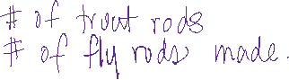

_____ = ____________________________________________________________________________

*Constraints*

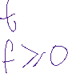

*What are the equations that you would put into DESMOS?*



**Learning Goal #8: I can calculate the measures of central tendency and standard deviation**

1. Calculate the mean, median, and mode of the below data:
   1. 32.1, 44.5, 33.9, 34.3, 32.1, 50.1, 44.5,



|  |  |
| --- | --- |
| Mean |  |
| Median |  |
| Mode |  |



1. Create a **frequency chart** and a **histogram** for the resting heart rate for your PE class.

56, 45, 67, 98, 100, 52, 72, 68, 80, 81, 79, 77, 54, 51, 78, 60, 59, 67, 78, 90, 91, 101, 42, 67, 73, 87, 78, 94, 95, 52,

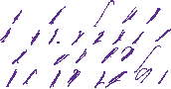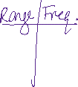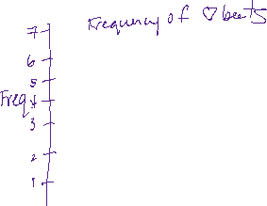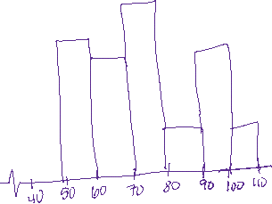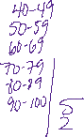

1. You want to find the mean and standard deviation of the running times for the SSS 100 m dash.

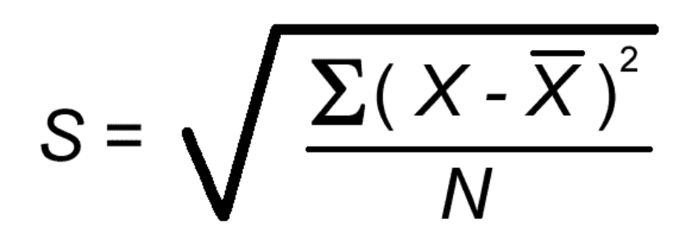



100 m dash times for a sample of SSS students:

15.2 s, 17.5 s, 21.2 s, 16.9 s, 15.4 s

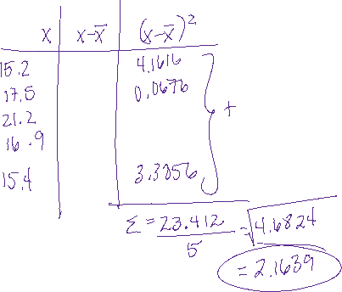

**Learning Goals #9: I can use confidence intervals, z-scores, and distributions to explain data**

1. On a biology test, the class mean was 79% with a standard deviation of 4%. Jake gets 71% on the test. What percentile does he fall in? Use the normal distribution curve to SHOW your understanding of the situation.

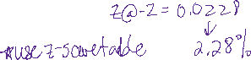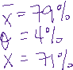

1. You are looking into buying a new cell phone plan and are on the phone with Telus. There is an average wait time of 32 minutes, with a standard deviation of 5 minutes. If there are 43 people on hold, how many people can expect to wait more than 42 minutes?

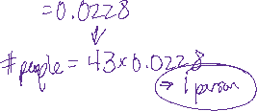

1. Assume the cholesterol levels of adult Canadian women can be described by a normal model with a mean of 188 mg/dL and a standard deviation of 24. If there are 485,340 females over the age of 65 in British Columbia, how many of them will have high cholesterol over 236 mg/dL?

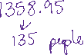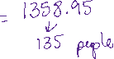

1. A 100-watt light bulb has an average brightness of 1640 lumens, with a standard deviation of 62 lumens. If Rona has just purchased a lot of 5000 bulbs, how many of them will be below 1516 lumens? Show your thinking.

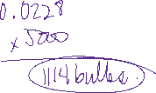

**Learning Goals #10: I can use scale factors to find new dimensions, area, and volume**

1. A photograph is 12 cm by 25 cm. A copy is made using a scale factor of 75%. What are the dimensions of the copy?

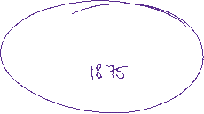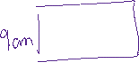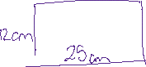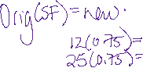

1. The Calgary Tower was built in 1968 and had a height of 190.8 m. For a school project, Kevin is to make a scale model of the tower. If Kevin uses a linear scale factor of 0.0001, determine the height of the model to the nearest hundredth of an inch. (1m = 39.3 inches)

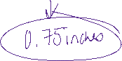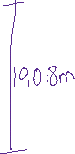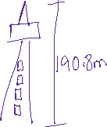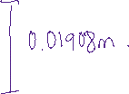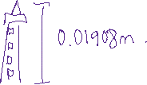





# Z-Scores



# Equation of a Line



Quadratic Formula



**Quadratic Function Equations**

 or *y = a(x – m)(x – n) or y= ax2 + bx + c*

**Scale Factor**

*SF = new $÷$ old*

*Original (SF) = New*