**Parabolas**

**Expansion and Compression**

**FOM 11**

Name: ____________________________

Find the key features of each parabola, then graph.

1. y = x2 (basic parabola)

|  |  |
| --- | --- |
| Characteristic | Value |
| Vertex |  |
| Axis of Symmetry |  |
| y-intercept |  |
| x-intercept(s) |  |
| Domain |  |
| Range |  |
| Maximum or minimum |  |

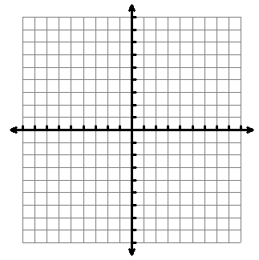

2. y = 2(x + 1)2 - 2

|  |  |
| --- | --- |
| Characteristic | Value |
| Expansion or Compression? |  |
| Vertex |  |
| Axis of Symmetry |  |
| Domain |  |
| Range |  |
| Maximum or minimum |  |
| y-intercept |  |
| x-intercept(s) |  |



3. y = - (x - 2)2 + 4



|  |  |
| --- | --- |
| Characteristic | Value |
| Expansion or Compression? |  |
| Vertex |  |
| Axis of Symmetry |  |
| Domain |  |
| Range |  |
| Maximum or minimum |  |



4.  y = -2(x – 1)2 + 3

|  |  |
| --- | --- |
| Characteristic | Value |
| Expansion or Compression? |  |
| Vertex |  |
| Axis of Symmetry |  |
| Domain |  |
| Range |  |
| Maximum or minimum |  |



|  |  |
| --- | --- |
| Characteristic | Value |
| Expansion or Compression? |  |
| Vertex |  |
| Axis of Symmetry |  |
| y-intercept |  |
| x-intercept(s) |  |
| Domain |  |
| Range |  |
| Maximum or minimum |  |

5. y = (x + 2)2



6. y = -3(x – 2)2 + 5

|  |  |
| --- | --- |
| Characteristic | Value |
| Expansion or Compression? |  |
| Vertex |  |
| Axis of Symmetry |  |
| Domain |  |
| Range |  |
| Maximum or minimum |  |

