**FOM 11**

**Optimization Practice Worksheet**

**May 5th, 2020**

Name: ___________________________________



**GOAL:** Create models to represent optimization problems.

Use Desmos app when needed to complete the scenarios using systems of inequalities.

1. **EXPLORE:**



• A florist is ordering bracken fern and baby’s breath for bouquets and centrepieces.



• No more than 100 stems of baby’s breath will be ordered.



• More than 100 stems of bracken fern will be ordered.



• The florist has space to store no more than 250 stems, in total.



• Is each of the following a combination she can order? Explain.

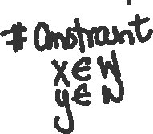

1. A toy company manufactures two types of toy vehicles: racing cars and sport-utility vehicles.

• Because the supply of materials is limited, no more than 40 racing cars and 60 sport-utility vehicles can be made each day.

• However, the company can make 70 or more vehicles, in total, each day.

• It costs $8 to make a racing car and $12 to make a sport-utility vehicle.

There are many possible combinations of racing cars and sport-utility vehicles that could be made. The company wants to know what combinations will result in the minimum and maximum costs, and what those costs will be. Follow the below steps to work through the inequality.

|  |  |
| --- | --- |
| 1. Define your two variables |  |
| 1. What is an inequality that would represent the total number of racing cars that can be made? |  |
| 1. What is an inequality that would represent the total number of sport-utility vehicles that can be made? |  |
| 1. What is an inequality that would represent the total number of vehicles that can be made? |  |
| 1. What type of number restrictions is this question dealing with? |  |
| 1. Graph all your inequalities overlapping on DESMOS |  |
| 1. What are the options that would maximize or minimize the situation? |  |
| 1. What is the optimization equation (OBJECTIVE FUNCTION)? |  |
| 1. Substitute your inequality options.(all corners of your overlap) |  |
| 1. The best answer is… |  |
| 1. Write your answer in a sentence… |  |



1. Three teams are travelling to a basketball tournament in cars and minivans.



• Each team has no more than 2 coaches and 14 athletes.



• Each car can take 4 team members, and each minivan can take 6 team members.

• No more than 4 minivans and 12 cars are available.

The school wants to know the combination of cars and minivans that will require the minimum and maximum number of vehicles.

|  |  |
| --- | --- |
| 1. Define your two variables |  |
| 1. What is an inequality that would represent the total number of minivans available? |  |
| 1. What is an inequality that would represent the total number of cars available? |  |
| 1. What is an inequality that would represent the total number of people that can travel in the cars |  |
| 1. What type of number restrictions is this question dealing with? |  |
| 1. Graph all your inequalities overlapping on DESMOS |  |
| 1. What are the options that would maximize and minimize the situation? |  |
| 1. What is the optimization equation (OBJECTIVE FUNCTION)? |  |
| 1. Substitute your inequality options.(all corners of your overlap) |  |
| 1. The best answer is… |  |
| 1. Write your answer in a sentence… |  |

1. A refinery produces oil and gas.

• At least 2 L of gasoline is produced for each litre of heating oil.

• The refinery can produce up to 9 million litres of heating oil and 6 million litres of gasoline each day.

• Gasoline is projected to sell for $1.10 per litre. Heating oil is projected to sell for $1.75 per litre.

The company needs to determine the daily combination of gas and heating oil that must be produced to maximize revenue. Use Desmos to find the best combination.

|  |  |
| --- | --- |
| 1. Define your two variables |  |
| 1. What is an inequality that would represent constraint of the amount of gasoline produced when compared to the amount of heating oil? |  |
| 1. What is an inequality that would represent the amount of gasoline produced? |  |
| 1. What is an inequality that would represent the amount of heating oil produced |  |
| 1. What type of number restrictions is this question dealing with? |  |
| 1. Graph all your inequalities overlapping on DESMOS |  |
| 1. What are the options that would maximize the situation? |  |
| 1. What is the optimization equation (OBJECTIVE FUNCTION)? |  |
| 1. Substitute your inequality options.(all corners of your overlap) |  |
| 1. The best answer is… |  |
| 1. Write your answer in a sentence… |  |

1. A doctor advises a patient to take vitamin supplements to provide at least 35 mg of Vitamin C, but no more than 600 mg of calcium. Each brand A pill contains 100 mg of calcium and 5 mg of Vitamin C. Each brand B pill contains 150 mg of calcium and 10 mg of Vitamin C. Each brand A pill costs 4₵, and brand B costs 9₵.
2. Suppose the patient takes x brand A pills and y brand B pills every day. Write an expression to represent the daily cost of taking these pills.

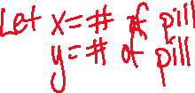

1. Write a system of inequalities to represent the constraints in this problem.

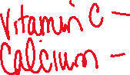

1. Use desmos to graph the system.

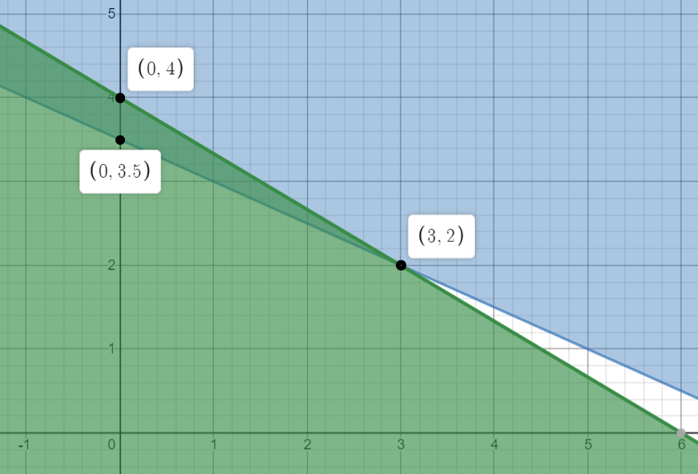



1. How many of each type of pill should the patient take daily to minimize the cost of taking vitamins?

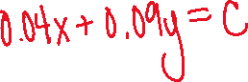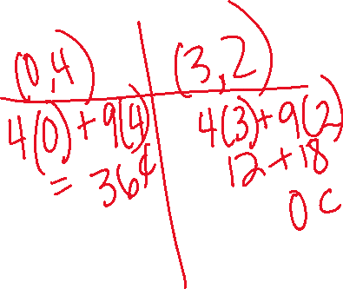

1. A parking lot has 900 m2 available to park vehicles. On average cars need 9 m2 and buses need 36 m2 for parking. No more than 70 vehicles can be parked in the lot at one time. The charge to park cars is $6 a day and to park buses is $20 a day. Determine the maximum revenue that could be collected in one day. Set up and organize your own solution.

