**Graphing and System of Linear Inequalities**

**Unit Review – May 2020**

Name: ________________________________

|  |  |  |  |
| --- | --- | --- | --- |
| **Learning Goals** | **Novice** | **Apprentice** | **Expert** |
| I can represent an inequality on a number line and a cartesian plane |  |  |  |
| I can graph the solution to a system of linear inequalities |  |  |  |
| I can create/model the inequalities given a situation. |  |  |  |

**Learning Goal #1: I can represent an inequality on a number line and a cartesian plane**

1. Write a sentence showing how you would SAY the below inequalities:
   1. x ≤ 7: ___________________________________________________________________
   2. -3 ≥ y: ___________________________________________________________________
   3. 5 > x: ____________________________________________________________________
   4. 3 < x: ____________________________________________________________________
2. Represent the below inequalities on a numberline:
   1. x < 5

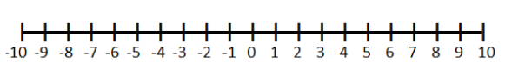

* 1. y ≤ (-5)



1. 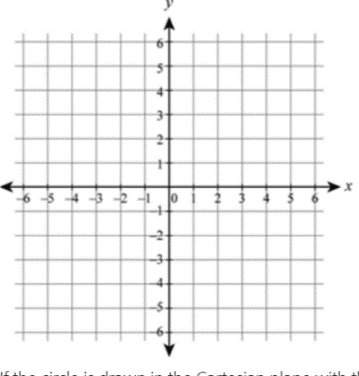Graph the following inequality:
   1. y > 3x + 1



* 1. y > - x +5
  2. 3x + 5y ≤ 10
  3. 5y – 2x ≥ 5

**Learning Goal #2: I can graph the solution to a system of linear inequalities**

1. What are the equations of the below inequalities?

|  |  |
| --- | --- |
| Inequality equation: ________________________ | Inequality equation: ________________________ |
| Inequality equation: ________________________ | Inequality equation: ________________________ |
| Inequality equation: ________________________ | Inequality equation: ________________________ |

1. For which inequality is (0, 9) a possible solution?



1. What is the boundary line for the inequality $2x+2y<16$?



1. How would you graph the solution set for the linear inequality $y+2x≤2$?



1. Graph the system of linear inequalities $y+2x<9$

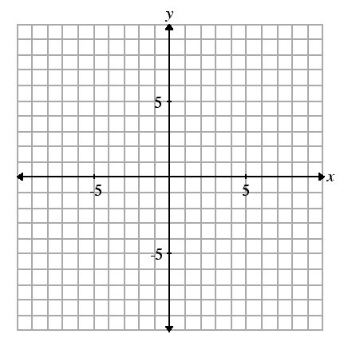 $y>x$ then identify the point of intersection that satisfies the system of linear inequalities.



1. Graph the following linear inequalities and systems of inequalities. *(*

a) b)

2x – 5y > 15 3y ≤ -2x + 12





c)  d) 





1. Graph the solution set for the system of inequalities:

$y<x+4$

$$3x+2y≥2$$

**Learning Goal #3: I can find an inequality based on a situation**

1. A vending machine sells juice & pop.

* The machine holds, at most, 300 cans.
* Sales from the vending machine show that at least 3 cans of juice are sold for each can of pop.
* Each can of juice has a profit of $1 and each can of pop has a profit of $1.25.

List the inequalities that could be used to determine the maximum profit from the vending machine. Graph the two inequalities using DESMOS and suggest how the vending machine should be stocked and justify your answer.

|  |  |
| --- | --- |
| Define your variables: | What are your inequalities and constraints? |
| Graph the inequalities on DESMOS and state your test ordered pairs | Show your Objective Function and state your answer. |

1. Write a system of linear inequalities to represent the following situations**. Use DESMOS to graph the inequalities.** Make sure to define each variable with sufficient detail.

A farmer has a field of 70 acres in which he plants potatoes and corn. The seed for potatoes costs $20/acre, the seed for corn costs $60/acre and the farmer has set aside $3000 to spend on seed. The profit per acre of potatoes is $150 and the profit for corn is $50 an acre. Find the optimal solution for the farmer.

|  |  |
| --- | --- |
| Define your variables: | What are your inequalities and constraints? |
| Graph the inequalities on DESMOS and state your test ordered pairs | Show your Objective Function and state your answer. |