Biology 12
Your Heart & Pulse Rate
Name: _______________________________

Big Question: How does your heart rate reaction to exercise? Both muscle building and cardio exercise and recovery?

Part 1: Heart sounds
a. Listen to your heart beat using a stethoscope. Notice the familiar lub-DUBB sound of the heart beat.
b. Describe the source of the first heart sound called the lub.
c. Describe the source of the second heart sound called the DUBB.
d. Describe a heart murmur.

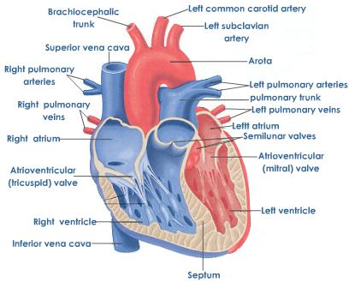

Part 2: Your pulse in various non-aerobic positions
- Make a copy of the below data table in your lab
Body Position  (2 minutes of position prior to recording data) | Trial 1 | Trial 2 | Average
Lying Down
Sitting
Peak Heart Rate
(just after standing up)
Standing Up (after 1 minute standing)

- Using your carotid pulse (the pulse from the artery to your brain), measure your resting heart rate in beats per minute (bpm). Use a 30 sec count and multiply by 2 to get bpm. Record this number.
- Using your radial pulse, measure your resting heart rate in bpm. Use a 30 sec count and multiply by 2 to get bpm. Record this number.
- Describe how a pulse is an accurate measurement of heart rate.
- Define cardiac output.
- Normal pulse (heart rate) is approximately 70 bpm. Some of the effects of prolonged (long term) exercise are:
  - The cardiac (heart) muscle actually grows in size and strength
  - The athlete will have a higher red blood cell count
  - The arteries will maintain their elasticity.

Part 3: Your pulse in response to exercise
- What is your MAX HEART RATE?
220 – age = ________________

Target heart rate:
- For muscular endurance zone -- 60% of max:

- For upper aerobic zone 80% of max:

- Make a copy of the below data table in your lab (each step add 2 minutes)
Type of exercise | 2 minutes (10 sec x 6) | 4 minutes (10 sec x 6) | 6 minutes (10 sec x 6) | 8 minutes (10 sec x 6)
Muscular
Push ups – 20
Squats – 20
Cardio
Running stairs
Jumping jacks

- Using your carotid pulse (the pulse from the artery to your brain), measure your heart rate at 2 minutes. 4 minutes, 6 minutes, and 8 minutes when you do muscular and cardio exercise
- What trend did you see?

Part 4: Your pulse recovering from exercise
- Make a copy of the below data table in your lab
Type of exercise | Heart Rate (bpm)
Pre-exercise (resting)
After 8 minutes cardio
1 minute after resting
2 minutes after resting
3 minutes after resting
4 minutes after resting
5 minutes after resting

- Using your carotid pulse (the pulse from the artery to your brain), measure your heart rate prior to starting cardio exercise. Then participate in “intense cardio” exercise. At the end of a 5 minute workout measure your heart rate.
- You are to then measure your recovery rate. Measure your heart rate at 1 minutes, 2 minutes, 3 minutes, 4 minutes, and 5 minutes
- If your heart rate has not yet returned to your pre-exercise rate, continue monitoring your heart rate until it returns to normal

Questions:
- How did your heart rate change after moving from a standing position to a reclining position? Why does this occur?
- Why would athletes need to exercise longer and harder before their heart rates were at the maximum value?
- There are multiple variations of what exercise physiologists refer to as TARGET HEART RATE ZONES. Find an example from the internet. Using your own data from the exercise tests that we have done in class, what zone did you fall into?
- What does the recovery rate tell you about your heart health? Why is this important? How can you work on this?
- What is the best way to improve the overall efficiency of the heart. There may be multiple answers to this question depending on opinion, but try and relate your answer to the information from above.

