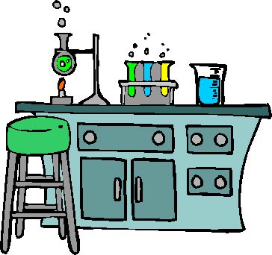
Get To Know The Lab

Name: _________________________

- What is the word in the 250 mL beaker drawer? ____________________________
  - Sketch what a beaker looks like:

  - When would you use a beaker? ____________________________________________________________________________________________________________________________________________________________

- What is the word in the 500 mL beaker drawer? _____________________________
- What is the word on the shelf with the graduated cylinders? ______________________
  - Sketch what a graduated cylinder looks like:

  - When would you use a graduated cylinder? ____________________________________________________________________________________________________________________________________________________________

- What is the word on the shelf with the ring stands? ___________________________
- What is the word in the drawer with the Bunsen burner flints? _________________________
- What is the word in the cupboard with the dissecting equipment? _____________________________
  - Sketch and label the three types of dissecting tools in the cupboard:

- What is the word under the goggle bin? __________________________________
- What is the word under the scoopula beaker? ____________________________
  - Sketch what a scoopula looks like:

  - When would you use a scoopula? ____________________________________________________________________________________________________________________________________________________________
- What is the word in the hotplate cupboard? ___________________________________
  - Sketch a hotplate:

  - When would you use a hotplate? ______________________________________________________________________________
______________________________________________________________________________

- In each of the Biology cubbies, there are two microscopes. One is a compound and the other is a stereoscope. Decide which is which. Sketch them below in the appropriate spot:
  - What would you use a compound microscope for? ____________________________________________________________________________________________________________________________________________________________
  - What would you use a stereoscope for? ____________________________________________________________________________________________________________________________________________________________

Compound Microscope | Dissecting Scope

- What is the word in the drawer with the beaker and test tube cleaners? _________________________
  - Sketch what a beaker cleaner looks like:

  - What are the five steps needed EACH TIME you use any glassware in a lab?
    - ______________________________________________
    - ______________________________________________
    - ______________________________________________
    - ______________________________________________
    - ______________________________________________

