Biology 12

Food Inquiry Lab

Big question:
How do levels of lipids and protein vary in cooked chicken vs. uncooked chicken?

Background Research:
Macromolecules are essential building blocks in our bodies; they are necessary for our body to function. There are four main macromolecules: proteins, carbohydrates, lipids and nucleic acids. For my lab I will be testing the quantity of lipids and proteins in cooked chicken versus uncooked chicken.

Protein is a macromolecule which is essential to building structure for the body. It is commonly found in animal products (such as chicken), nuts and legumes. Amino acids are the monomers of protein, they contain a carboxyl group, amine group, and a R group. Each gram of protein contains 4 calories, and proteins make up 15% of a human's body weight. There are 10 essential amino acids that we must eat and 10 non essential that our body makes. The formation of proteins occurs when the amino acids link up and create a primary structure that is connected by hydrogen bonds. From there the strand begins to change shape and either forms an Alpha helix or a Beta pleated sheet connected by hydrogen bonds, called the secondary structure. After that, the protein forms when the R groups of the amino acids begin to react to one another. Four different interactions can occur: a hydrogen bond, hydrophobic interaction, ionic bond and disulfide bridge. This is called the tertiary structure, when multiple tertiary structures come together and fold into each other it is called a quaternary structure. This is the last stage and has the same bonds as a tertiary structure. Lipids are a macromolecule that function as an energy reserve, they make up a key part of the cell membrane, and the myelin sheath they also provide insulation. A monomer of a lipid is a fatty acid and glycerol. A polymer of a lipid is a triglyceride. There are two types of fatty acids: saturated and unsaturated fats. Saturated fats are solid at room temperature, all single bonds and stackable. They are usually animal fats. Unsaturated fats are liquid at room temperature and have at least one double bond which causes a kink in the chain. They are usually plant fats. There are lipids that are bad for you like trans fats, which clog up your vessels with plaque. But, there are also lipids that are good for you like omega 3 which will clean your vessels of plaque. Lipids are made up of carbon, hydrogen and oxygen, they are also connected by glycosidic bonds.

Heat or cooking can cause many changes in the physical structure and function of a protein. This is especially common in foods. All though there is no change in the digestibility or nutritional value of the food, if the food contains protein, heat can change the linkages between proteins and break down long chains of amino acids, which make up proteins. Denaturation is the process of modifying the molecular structure of a protein. It involves breaking many bonds, such as hydrogen bonds, inside the protein molecule that make up the structure of the protein. Denaturation can occur when cooking meat such as chicken. Researching the importance of protein and lipids and the way they react to being heated/cooked made me really wonder about how cooking a chicken can change its levels of fat and protein. This intrigued me because I always thought chicken was really good for me, and I began to question if there was a way to cook a chicken to make it healthier. The article talked about how large amounts of heat can be used to disrupt hydrogen bonds and non-polar hydrophobic interactions. This occurs because heat increases the kinetic energy and causes the molecules to vibrate so rapidly and violently that the bonds are disrupted, resulting in proteins being lost because they cannot perform their functions. According to The Atlantic most of the fat in chicken comes from the chickens skin, so if a person is worried about their lipid intake, a healthy option is to remove the skin from the chicken. Another healthier option in regards to chicken is that dark meat is proven to be higher in cholesterol and saturated fat than white meat. The main important nutritional differences are a result of the way you choose to prepare the chicken. If you choose to cook with fat you are going to increase the levels of lipids in your meal. One of the most healthy ways to cook a chicken is to bake it in the oven with olive oil, which is an example of an unsaturated fat that is good for you. If you are buying cheap chicken, you are buying a chicken that was treated with numerous antibodies that promoted rapid growth and attempted to treat illnesses, and was raised in overcrowded indoor conditions. Buying a more expensive chicken will be a lot better for your body, since they were raised range free without antibodies. Not to mention the fact that you would be supporting a food system that is healthier for chickens and the planet.

Hypothesis:
If high temperatures denature foods, which results in physical changes in the proteins, then cooked chicken will have less protein and fat then uncooked chicken because its bonds that hold the protein together may break and protein would be lost since they can no longer perform their functions.

Variables:
Protein Test:
Dependant: The amount of protein (colour of biuret solution)
Independent: The state of the chicken (cooked vs uncooked)
Control: negative= distilled water, positive=albumin
Lipid test:
Dependent: The amount of lipid (colour/ bubbles/ layers of Sudan IV)
Independent: The state of the chicken (cooked vs uncooked)
Control: negative=distilled water, positive=vegetable oil
Controlled Variables:
Quantity of indicator (10 drops), Quantity of sample (5ml),
Time of indicator in sample before observations (5 minutes)

Safety:
When working in a lab, safety is extremely important. Before you start, ensure that your hair is tied back, that you are wearing closed toed shoes, gloves, a mask and eye goggles. Students should follow Covid precautions and try and lessen the spread of germs. There should be no horseplay in a lab environment and students should be calm and focused. They should be mindful of others, equipment, spills, broken glass and distractions. In this lab you will be working with Sudan IV which is a very dangerous chemical. When dealing with Sudan IV use the designated waste bucket available so it's not disposed of down the drain. You must also shake your test tubes containing Sudan IV with a cork so that none gets on your hands, you will be wearing gloves so if Sudan IV does come in contact with your hands you will be fine. If Sudan IV does get onto your clothing, remove contaminated clothing then wash the affected area with soap or mild detergent and large amounts of water until all evidence of the dye has been removed (approximately 15 minutes). If irritation persists seek medical advice. Wash contaminated clothing before reuse. Before beginning, clean all your equipment to get rid of excess substances that had been left behind. Clear your work of any harmful objects such as broken glass or unmarked chemicals. Students must be prepared before entering the lab and have a plan before starting. You must ask teachers if they are unsure at any time and they must be knowledgeable on all the chemicals and products they are working with. Unattended hot plates must be unplugged, and if a fire starts students must alert teachers immediately. If it's too late they must pull the fire alarm, and be aware of the locations of the fire blanket, fire extinguisher and fire exits. It is also important to know the location of the eyewash and shower stations around the lab in case a student gets a dangerous chemical in their eyes or on their body. If necessary, let the water surge into your eyes or body for at least 15 minutes. Students must not consume any of the foods they are testing due to exposure of dangerous indicators. Food should also not be eaten around or during this experiment. Once you are finished with your experiment you must thoroughly clean your station and equipment for future users. Finally students must put away all their equipment in the proper place and wash their hands.

Materials:
- Distilled water (100ml)
- Albumin (25ml)
- Vegetable Oil (25ml)
- Sudan IV (25ml)
- 24 test tubes
- Test tube rack (x2)
- Blender
- Mortar bowl (x2)
- Tape and sharpie for labeling
- Granulated cylinder (x4)
- 100ml beaker (x4)
- Pipettes (x5)
- Cork
- Gloves
- Mask
- Safety Goggles
- Half a skinless boneless uncooked chicken breast
- Half a skinless boneless unseasoned cooked chicken breast

Procedure:
Protein test:
- Clean all of the equipment that you will be using prior to starting your experiment. Clean with soap and water.
- Label 12 test tubes using tape and a sharpie:
- 3 with uncooked chicken
- 3 with cooked chicken
- 3 with albumin
- 3 with distilled water
- Fill 100ml beaker with 50ml of distilled water.
- Use a blender to blend half an uncooked skinless boneless chicken breast with distilled water, 10ml at a time, to create a liquid substance. Place liquid in a mortar bowl. Label bowl.
- Thoroughly clean and dry your blender.
- Use the blender to blend half a cooked skinless boneless chicken breast that was made with no seasoning with distilled water, 10ml at time, to create a liquid substance. Place liquid in a mortar bowl. Label bowl.
- Use a granulated cylinder to measure 5ml of the liquid cooked chicken into each of its designated labeled test tubes. Repeat with the liquid uncooked chicken. Clean the granulated cylinder after each use.
- Fill a 100ml beaker with 25ml of distilled water.
- Fill a 100ml beaker with 25ml of albumin.
- Use a graduated cylinder to measure 5ml of the distilled water and place into each of its designated labeled test tubes. Repeat with Albumin. Clean the granulated cylinder after each use.
- Once all test tubes are filled with 5ml of liquid, fill a 100ml beaker with 25ml of biuret solution.
- Place 10 drops of biuret solution into each test tube using a pipette.
- Do not mix.
- Wait 5 minutes, then Observe and record data using scale.

Lipid test:
- Label 12 test tubes using tape and a sharpie:
- 3 with uncooked chicken
- 3 with cooked chicken
- 3 with albumin
- 3 with distilled water
- Use a granulated cylinder to measure 5ml of the liquid cooked chicken into each of its designated labeled test tubes. Repeat with the liquid uncooked chicken.
- Fill a 100ml beaker with 25ml of distilled water.
- Fill a 100ml beaker with 25 ml of vegetable oil.
- Use a graduated cylinder to measure 5ml of the distilled water and place into each of its designated labeled test tubes. Repeat with the vegetable oil.
- Once all test tubes are filled with 5ml of liquid, fill a 100ml beaker with 25ml of Sudan IV solution.
- Place 10 drops of Sudan IV solution into each test tube using a pipette.
- Using a cork, Shake each test tube individually for approximately 45 seconds to thoroughly mix the liquids.
- Let sit for 5 minutes.
- Observe and record data using scale.

Observations:
While blending the uncooked chicken and cooked chicken I noticed how chunky and thick the liquid I created was, even after blending for a while. I became concerned that it would not mix well with the other liquids, and that my liquids were not miscible, which would impact my results. When pouring the cooked chicken into the test tubes I noticed it had a brown tint. When pouring the uncooked chicken into the test tubes I noticed it had a light pink tint. This could make the dyes hard to observe, and affect my results.
.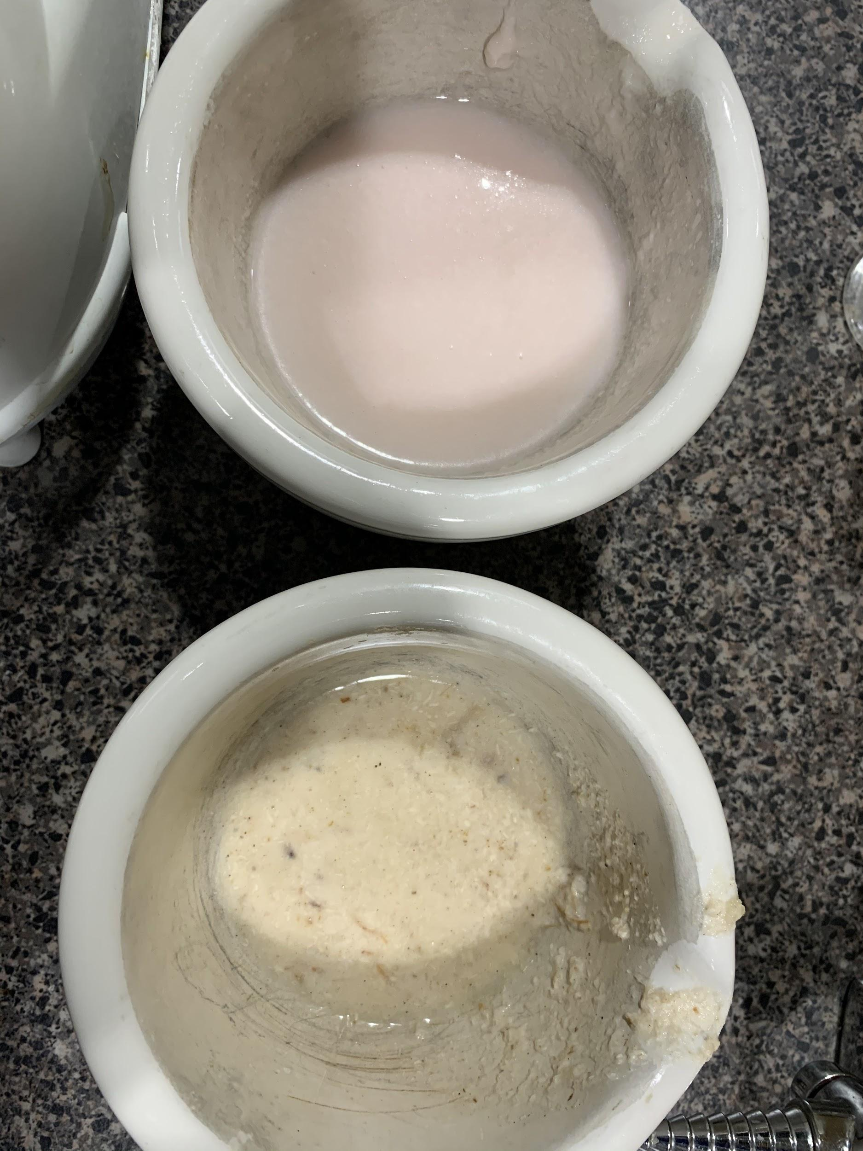
Protein Test: (biuret solution)
Results after 5 minutes after adding biuret solution: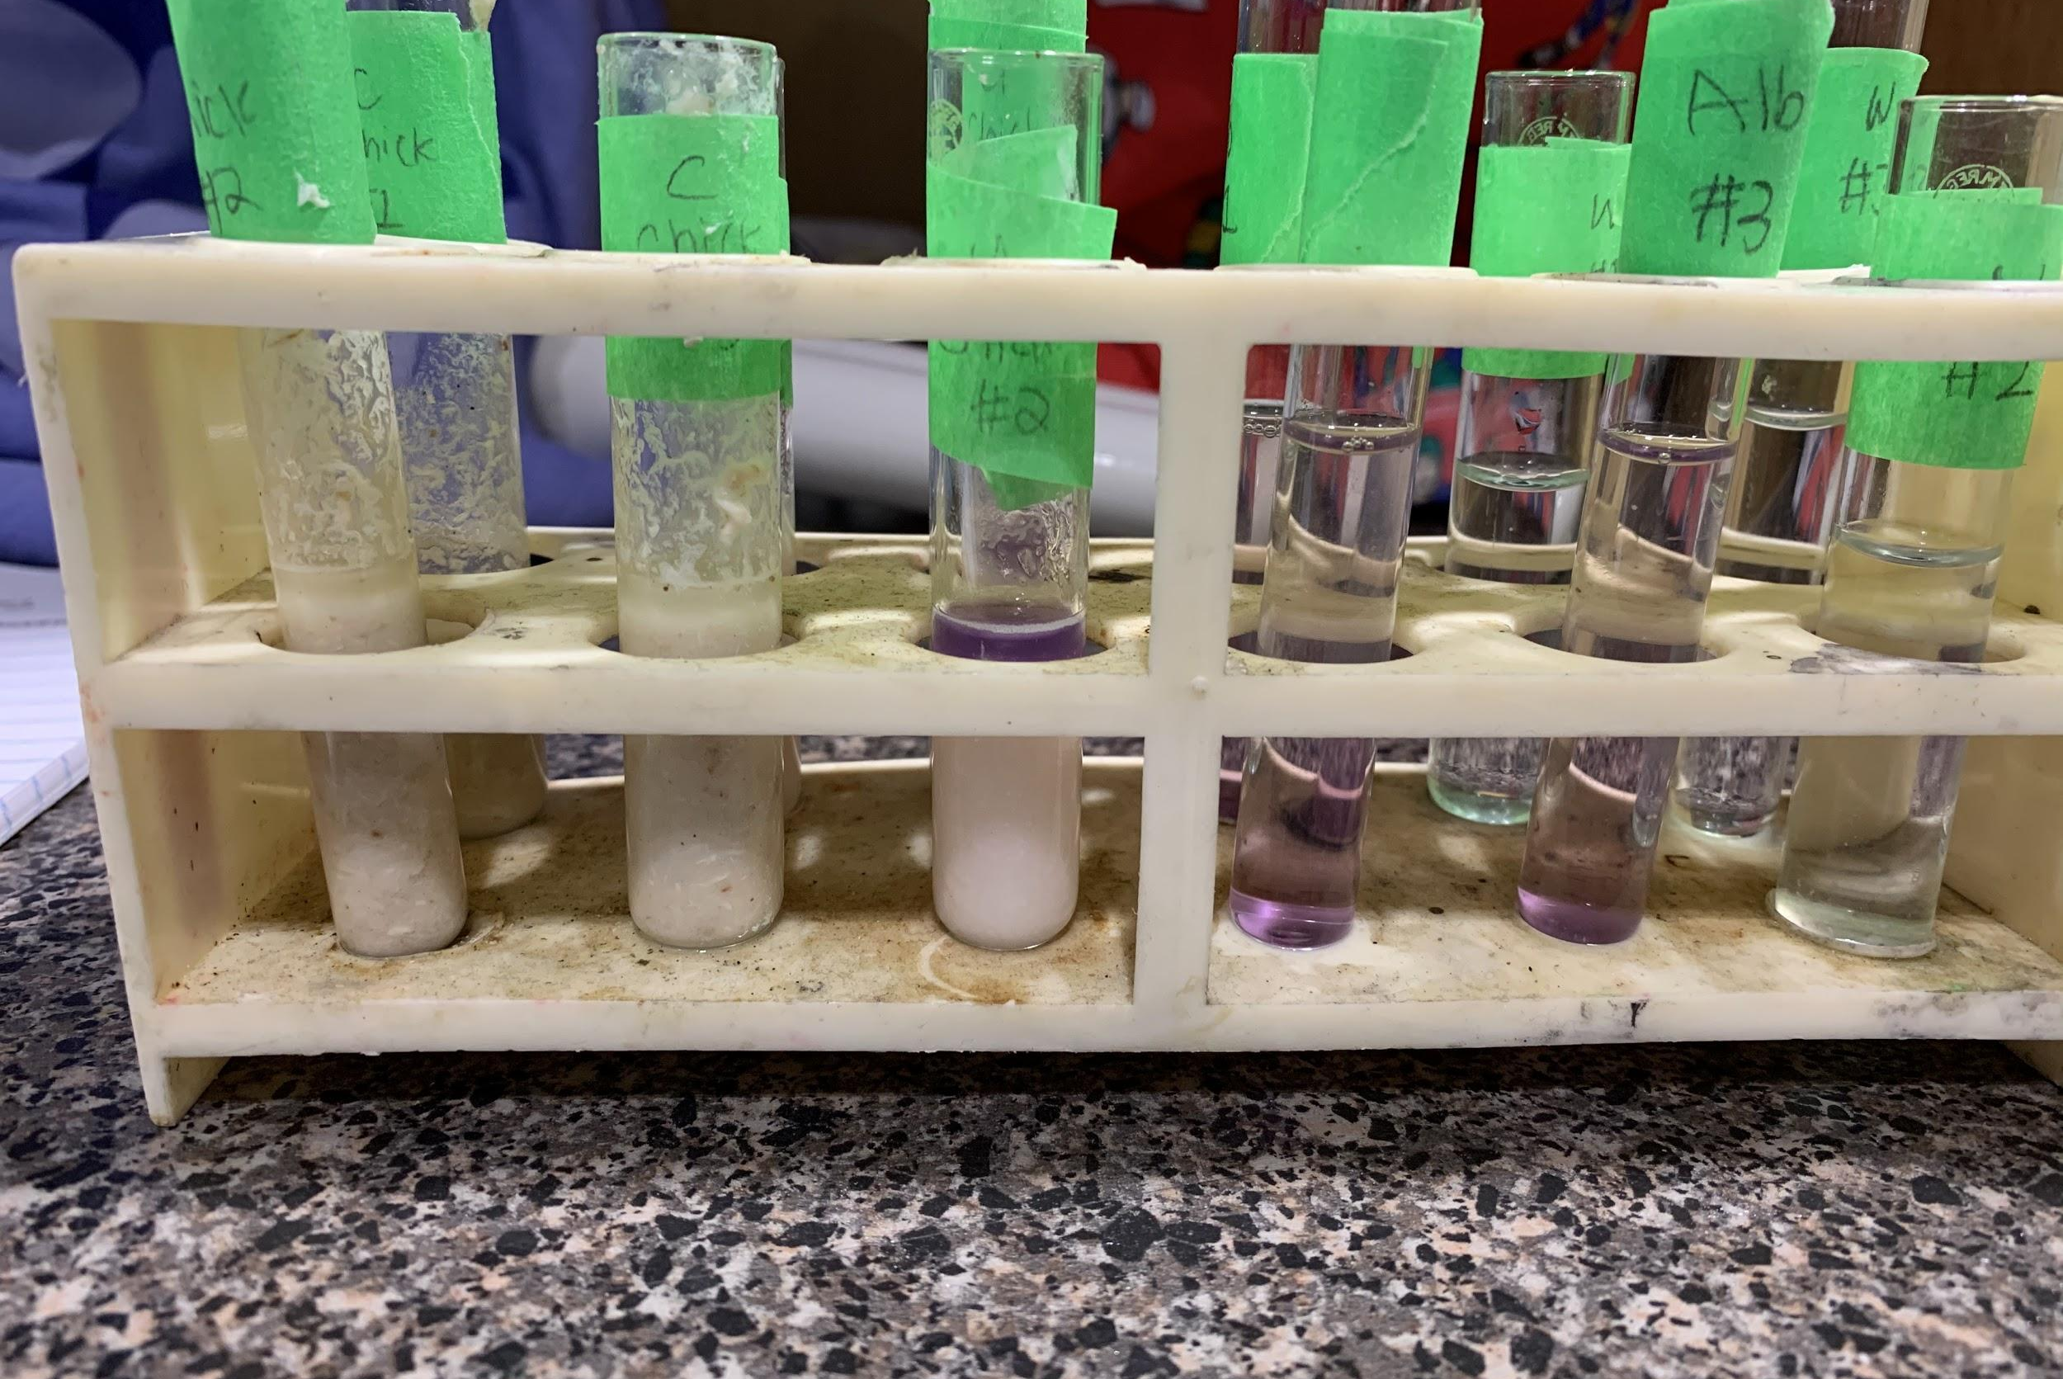
(Left to right) : Cooked chicken, Cooked chicken, Uncooked chicken, Albumin, Albumin, Water.

These results were very difficult to observe because of the density of the liquids and the tints they had to begin with. When the biuret solution was added to the cooked chicken, It instantly turned a bright purple colour on top. Since the liquid was immiscible it only remained on the top. The colour of my positive control; albumin and the colour of my negative control; water, indicates that there was high levels of protein in the uncooked chicken. Since I made the mistake of shaking my cooked chicken test tubes, It was difficult to determine the protein levels. I noticed a light purple, pink colour on the top after letting it sit which indicated protein was present, but in a lesser quantity.

Lipid Test (Sudan IV):
Results after 5 minutes of adding biuret solution:
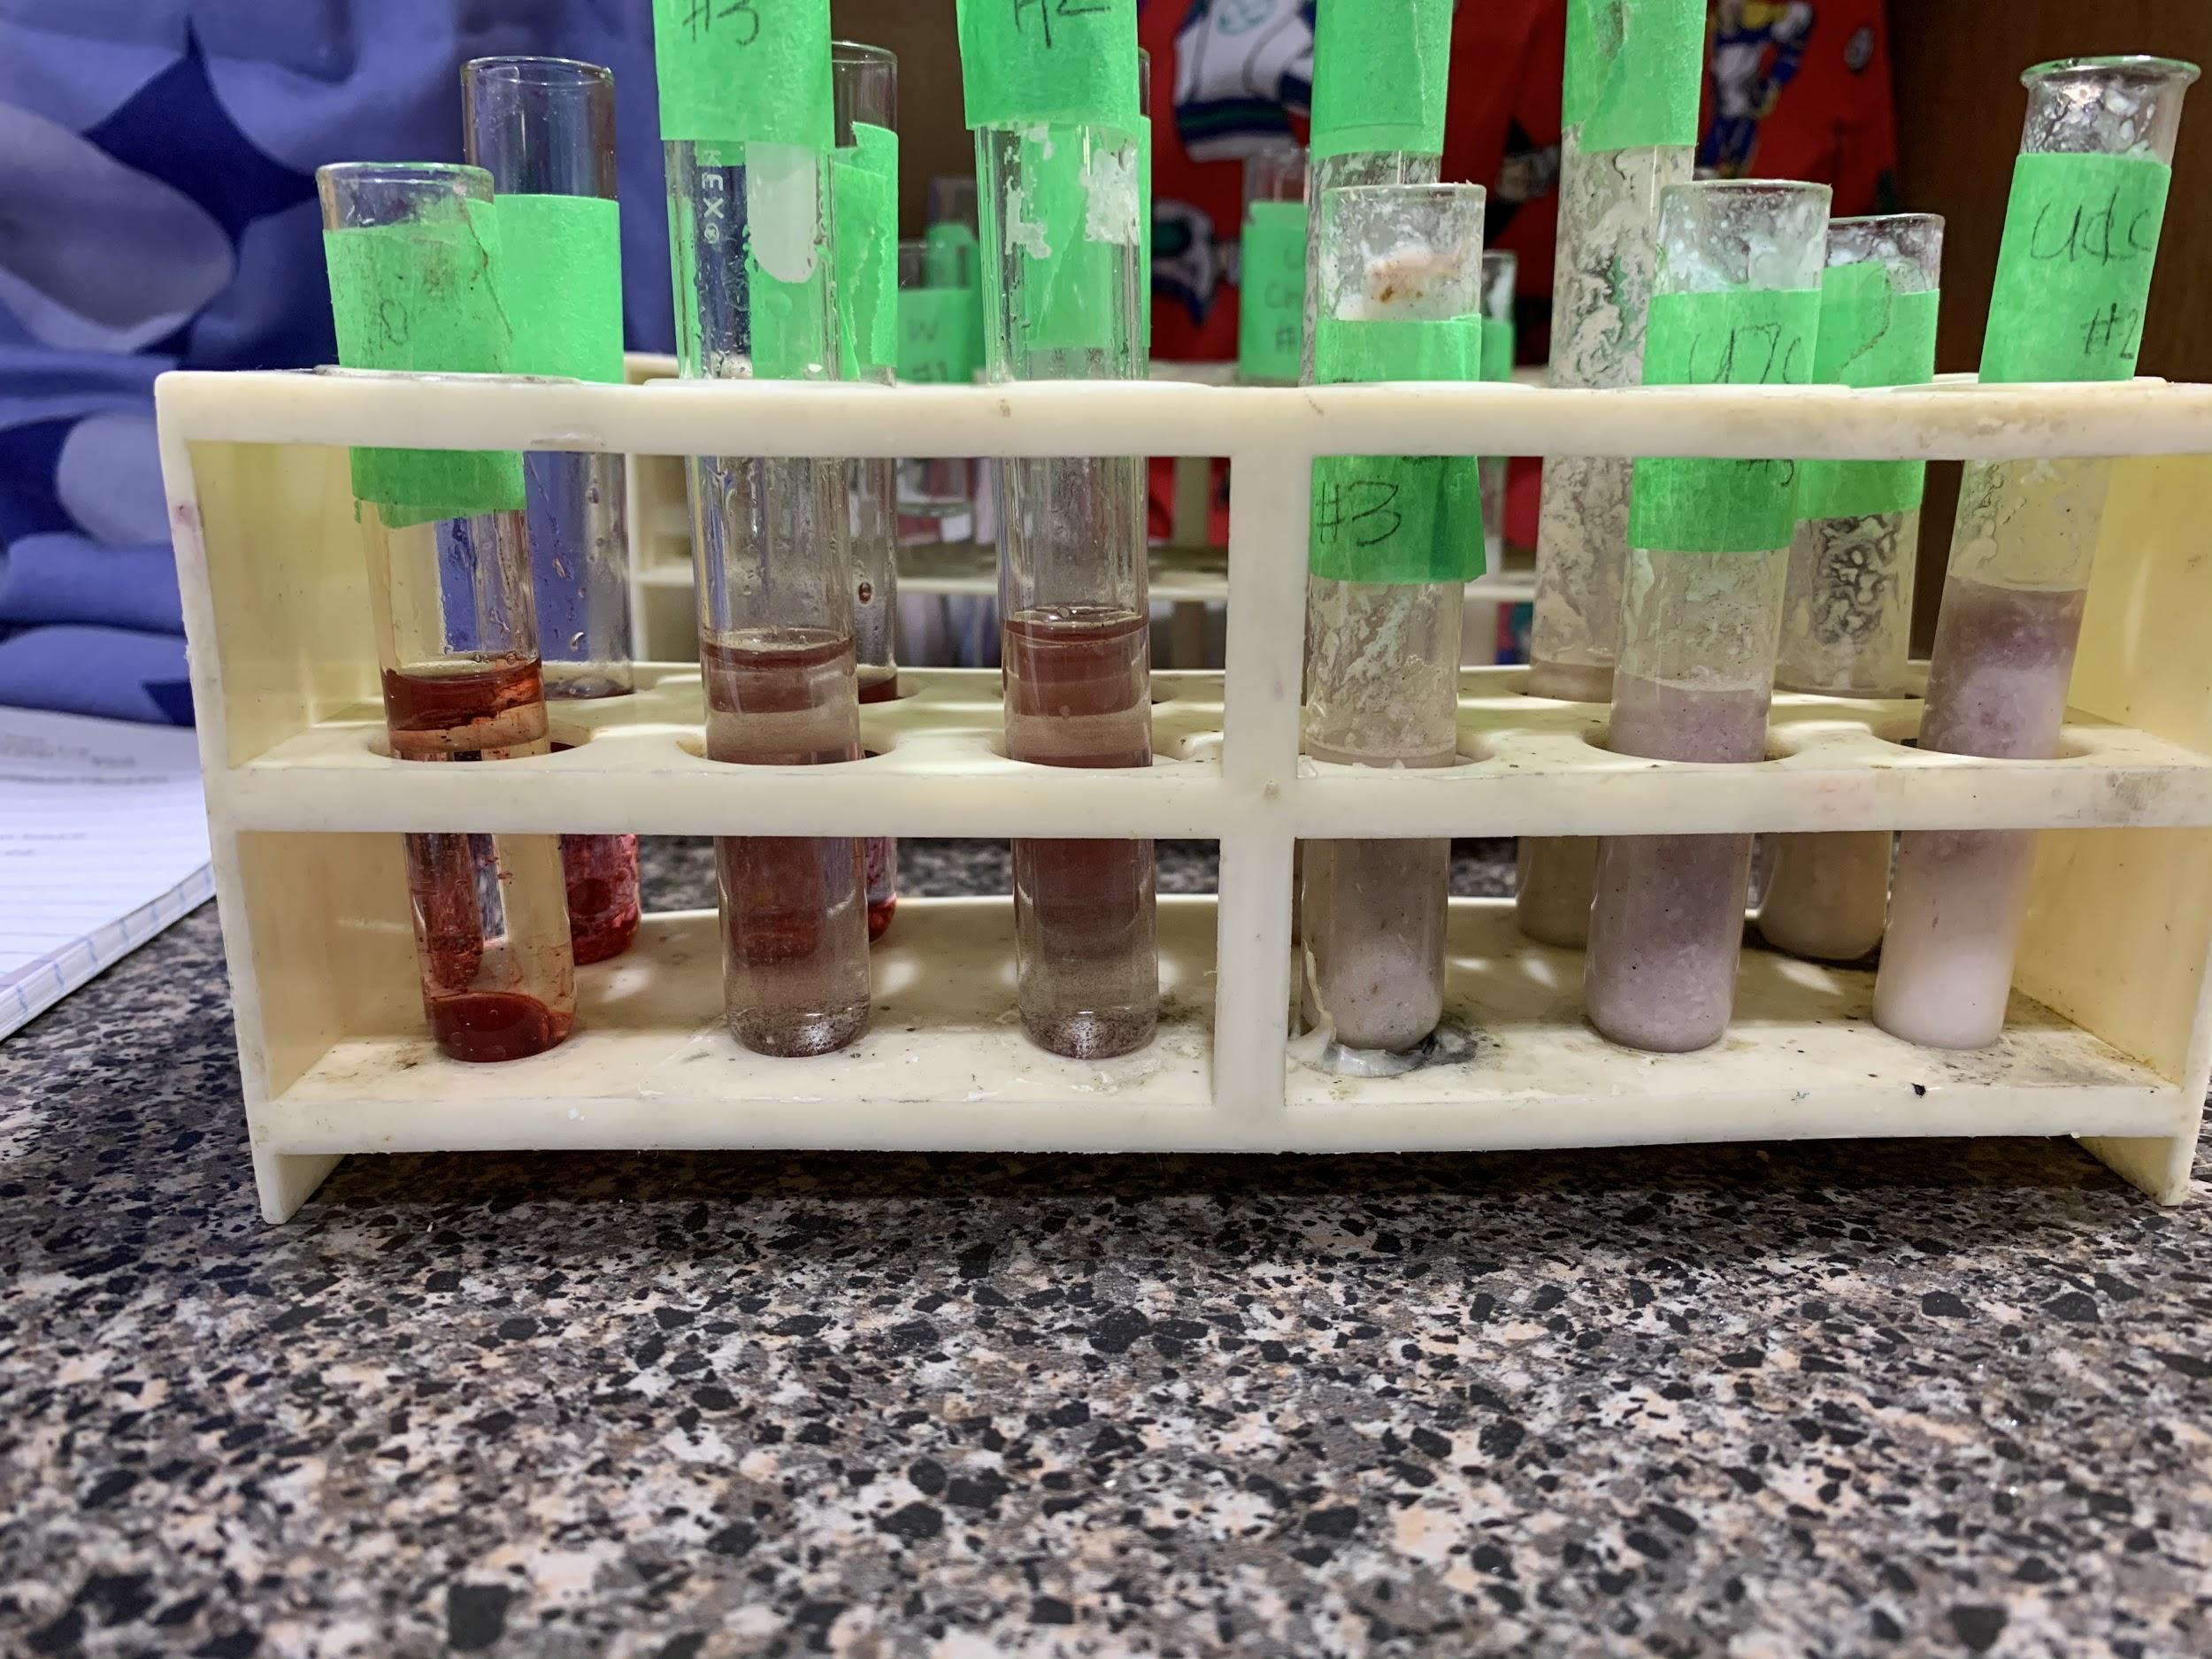
(From left to right): Vegetable oil, Water, Water, Cooked chicken, Uncooked chicken, Uncooked chicken.

These results were very difficult to observe as well, because an indicator of protein when using Sudan IV is that there are two defined layers. Because of the density of my chicken samples, I could not properly observe the different layers since they were immiscible. The positive control, vegetable oil, showed me that if protein was present it would become two separate layers, one being red bubbles. The results of the uncooked chicken were not as evident as they were with the vegetable oil, but there was evidence of a distanced second layer, and a change in colour, making the top layer a deep purple. In the cooked chicken test tube, there was a less distinct layer of a lighter shade of purple. Overall, the amount of lipid in the uncooked chicken is slightly higher than cooked chicken, although they are almost identical in colour.

Data: Protein Test
Food item: | Trial #1 | Trial #2 | Trial #3 | Average
cooked chicken | 2 | 3 | 2 | 2.3
uncooked chicken | 4 | 4 | 5 | 4.3
distilled water | 0 | 0 | 1 | 0.3
albumin | 4 | 5 | 5 | 4.6

Scale: Protein Test
None | Clear/bluish tint | 0
Low | Blue | 1
Medium Low | Green tint | 2
Medium | Light purple | 3
Medium High | Purple | 4
High | Dark Purple | 5

Data: Lipid Test
Food item: | Trial#1 | Trial #2 | Trial #3 | Average
cooked chicken | 2 | 1 | 1 | 1.3
uncooked chicken | 2 | 1 | 2 | 1.6
distilled water | 0 | 0 | 0 | 0
vegetable oil | 3 | 3 | 3 | 3

Scale: Lipid Test
None | one layer, evenly distributed colour | 0
Low | colour isn’t evenly distributed | 1
Medium | 2 layers, top layer pinkish/purple | 2
High | 2 layers, top layer orange/red, visible bubbles. | 3

Conclusion:
In conclusion, the data collected proved the hypothesis correct. The data showed that the amount of lipids was slightly higher in uncooked chicken and that the amount of protein was also higher in uncooked chicken compared to cooked chicken. However, they both had high levels of the macromolecules.

Sources of Error:
During this lab I made a few small mistakes and errors that could have impacted my results. Firstly, an error occurred in my procedure when I did not blend the two types of chicken for long enough, which resulted in the liquid being very chunky and not blending very well with the biuret solution in the protein test. This made my results less accurate because the two liquids did not mix properly, making the results harder to observe and therefore less accurate. Before my lipid test I blended the two bowls of chicken again to become more watery so they could mix better with the Sudan IV solution, all though they were still chunky because of the fibres and muscles in them. Another mistake that I made occurred in my procedure when I started shaking my test tubes filled with cooked chicken after putting biuret solution in them for the protein test. I soon discovered that when one liquid is thicker than the other it's better to not shake the test tube because your results become difficult to observe and record. After realizing my mistake I immediately stopped shaking the test tubes which could have made my cooked chicken data vary and contrast from my other test tubes. The raw chicken has a light pink color and the cooked chicken had a rich brown color which remained once it was blended. This resulted in it being very difficult to determine the exact color for the biuret test while taking into account the color of the dye. For next time, I would definitely include more trials since 3 trials is not the most accurate, but unfortunately that’s all I had time for. I would have definitely learned from more from multiple trials, it could have helped me determine patterns in the results. Generally, when performing an experiment it is vital that multiple tests are taken, including different samples of chicken. I would also add lots more water when blending the chicken so it becomes a thinner liquid. Another thing I would do is try and strain the chicken liquid after blending so that the chunks are not included in the test tubes. I would also try to be more accurate in my measuring and use more precise pipettes, since the one I used was hard to control at times. This could have affected the dye colour and observations of the tests. Moreover, the controls could have been contaminated or diluted when the students were using them. This could have affected the results and observations of this test. In addition, the albumin could have almost reached its expiration date which might have altered the observations by changing the quantity of the protein. Finally, even though all the equipment used was thoroughly cleaned, there could still be remainders and reside from previous experiments which could have changed the colouring and outcome of the results.

Discussion:
People are very worried about their lipid intake nowadays and I think it would be intriguing to discover the levels of unsaturated fatty acids and saturated fatty acids in cooked and uncooked chicken. Saturated fatty acids can cause blockages and lead to atherosclerosis which is when they stick to your artery walls, It could be important to know if their presence is higher than unsaturated fatty acids in uncooked or cooked chicken. Chicken is one of the highest sources of protein, knowing the levels of protein in your diet is extremely important because protein is an essential macromolecule in your body and performs crucial functions. It builds your muscle mass, which will help you protect your bones and prevents conditions like osteoporosis. It also builds your hair and nails. Your body uses it to repair tissues and red blood cells contain a protein compound that carries oxygen throughout your body. This helps supply your body with the nutrients it needs. Protein also regulates your hormones and can help you maintain a healthy weight. Knowing if the food you consume contains lipids is also an important thing to recognize. Lipids, like proteins, are essential macromolecules which perform crucial functions in your body. They are a source of energy in the body and can be stored for future use. This experiment expanded my knowledge of not only lipids and proteins in cooked or uncooked chicken but lipids and proteins in general. I learned that cooking meat will decrease its levels of proteins and depending on how you cook it, fats as well. This information can help consumers monitor their protein and lipid intake resulting in them eating healthier and more aware of what they are putting in their bodies. It is important to perform experiments like mine so people can learn how to properly fuel their bodies and create a diet that works for their needs.

Areas of Further Study:
This was a really interesting lab and I wish I had unlimited resources to make this lab become more reliable. If I wasn't concerned about price and time I would increase the amount of trials from 3 to 9 or 10 which would make my results more accurate. I would love the chance to redo this lab, so I could fix all my errors and see if my conclusion would change, or stay the same. Since chicken is so high in protein, I would like to test how lipids and proteins vary in different types of cooked chicken, or even different types of meats. I also think an interesting idea would be which part of the chicken has the most protein and lipid, the wing, the thighs or the breast. These questions could help further our knowledge of what food would give you the most protein and be best for fueling your body. The results could distinguish what to look for when you are grocery shopping for your family, or looking to cook a well rounded meal. I would also like to test the difference in lipids and proteins between chicken cooked for different amounts of time. Maybe the loss in protein and fat increases the longer you cook the chicken. Perhaps with more trials and types of chicken I could have discovered the best amount of time to cook a chicken so that it doesn’t lose too much protein and fat and is the healthiest it can be.

Bibliography:
https://www.britannica.com/science/protein/Protein-denaturation
https://www.sciencedirect.com/topics/food-science/lipids-in-food
https://www.theatlantic.com/health/archive/2012/03/the-healthiest-way-to-eat-chicken/254844/
http://chemistry.elmhurst.edu/vchembook/568denaturation.html
https://bio.libretexts.org/Bookshelves/Introductory_and_General_Biology/Book%3A_General_Biology_(OpenStax)/1%3A_The_Chemistry_of_Life/3%3A_Biological_Macromolecules/3.3%3A_Lipids

