Environmental Sciences 12
Final Exam
Review Booklet

Tips for Studying:
- Answer each question in this review booklet
- Rewrite your notes
- Attend each lunch time tutorial your teacher holds
- Make cue cards and quiz yourself
- Look at the learning goals that are worth the most marks and MASTER those sections
- Find a study group that BRINGS OUT THE BEST IN YOUR LEARNING
- Teach your parents, relatives, siblings, or pets this information

GOOD LUCK

Continually SELF ASSESS using this learning goal chart

Learning Goals | Beginning  1 | Developing  2 | Proficient  3 | Sophisticated 4
Unit#1: Local Okanagan Ecosystem
- I can connect the roles of species in the local Okanagan ecosystems
- I can explain ecosystem stability and the factors that influence sustainability
- I can explain how humans can be a factor of change within an ecosystem
- I can discuss unsustainable and sustainable human practices
- I can explain First Peoples and traditional ecological knowledge
Unit#2: Earth’s Water
- I can explain bio-indicators of a healthy water system
- I can explain the health factors that contribute to healthy oceans
- I can explain the health factors that contribute to healthy freshwater systems
- I can plan for budgeted water use
Unit #3: Earth’s Air
- I can discuss global changes to Earth’s atmosphere
- I can explain the implications of greenhouse gases
Unit #4: Earth’s Land
- I can explain factors impacting soil quality
- I can discuss global food security issues
- I can explain land management practices
Unit #5: Human Impact and Restoration
- I can discuss human health and environmental impacts of population growth

Learning Goal #1: I can connect the roles of species in the local Okanagan ecosystems
- Define the following terms:
  - Ecosystem Biomass
  - Ecosystem Productivity
  - Ecological niche
  - Trophic cascade
  - Carrying capacity (K)
- Define the following: autotroph, heterotroph, and saprotroph and give an example of each.
- What is the difference between a terrestrial and aquatic biomass pyramids? Explain WHY there is the difference.
- Describe three different trophic cascades situations and how they have impacted the ecosystem. Use the examples that we have explored in our case studies.
- What is an invasive species? What are some examples of invasive species in the Okanagan?
- What is the difference between a native species, non-native species, and invasive species?
- How does predation impact a population?
- What impact do zebra mussels have on a lake system? What are the possibly long term impact?
- What are some examples of symbiotic relationships of organisms in the Okanagan? Explain what they are and define the three main types of symbiosis.
- What are three red listed and three blue listed Okanagan organisms. Explain what is happening in their ecosystems that have led them to their numbers? What is being done about it?
- What are the 7 local ecosystems? What are defining characteristics of each?

Learning Goal #2: I can explain ecosystem stability and the factors that influence sustainability
- What are some of the factors that has led BC to initiate a Wolf Cull starting in 2015? What are they hoping to impact? Why? What are BOTH SIDES of the story?
- What are some of the issues surrounding the Great Bear Rain forest? What is impacting the area? How can we play a role?
- What is the difference between density dependent and density independent limiting factors? Outline some examples of each.
- How does genetic diversity impact sustainability?
- What is a keystone species? Give an example of two that we have learned about. What is the trophic cascade if they were to disappear?

Learning Goal #3: I can explain how humans can be a factor of change within an ecosystem
- What are some examples of biological control that humans have played a role in? Outline four examples of what occurred, what the reasoning was and happened as a result of human involvement?
- What are actions that are currently being done to help improve some of our population of organisms? How are we communicating with our communities to help species at risk?
- What do you think we could do better to help our species at risk? Come up with 5 things we could be doing to help.
- Humans re-introduced wolves into Yellowstone National Park. Why? Has this been a factor of change in the ecosystem? How?
- What is the BC Wildlife Act of 1996 and what does it protect?
- What is SARA? How is the purpose?

Learning Goal #4: I can discuss unsustainable and sustainable human practices
- What are some of the negative impacts of humans on local ecosystem? Explain specifically how this impacts organisms and environments.
- What are some recreation activities that we do that impact organisms? Be specific. What species does it impact and how?
- What are some changes we can make to our choices and behaviours that might positively impact local ecosystems?
- What are some careers that you could go into that would have a positive impact on our environment and sustainable practices?
Learning Goal #5: I can explain First Peoples and traditional ecological knowledge
- What is traditional ecological knowledge (TEK)?
- What are some of the organisms that Okanagan First Nations People have a special connection to? Explain the connection.
- The Okanagan First Nations see all parts of the ecosystem as living (water, soil, etc). How does this differ from the Western perspective of living and nonliving?
- What is the BALANCE of our ecosystem? How does the need for BALANCE impact our actions?

Learning Goal #6: I can explain bio-indicators of a healthy water system
- What was happening in with the population of Alaskan Sea Lions and why? Is this indicating a healthy system? Why or why not?
- What is a trophic cascade that might happen in a water system? Why? What might cause this?
- Why is sewage treatment an issue that impacts our water health?
- What is causing ocean acidification? What are the consequences of it? What can be done? What is being done?

Learning Goal #7: I can explain the health factors that contribute to healthy oceans
- How much of the earth’s surface is covered in ocean water? What does this mean for our water consumption?
- How is ocean acidification impacting aquaculture in BC? Why? What are aqua culturists needing to do?
- What are the issues with overfishing? Use some of the statistics that show how overfishing is impacting our fish population.
- What is bycatch? What is the largest catch species that causes bycatch? What are the statistics on this? What could be done?
- What are some of the issues around salmon farming? What is being done? Give an example of some proactive actions that are trying to solve this issue.

Learning Goal #8: I can explain the health factors that contribute to healthy freshwater systems
- How is water consumption tied to population? Is it always? What are some countries that have low water use per capita? What are some countries that have high use per capita? Use the below graphic.
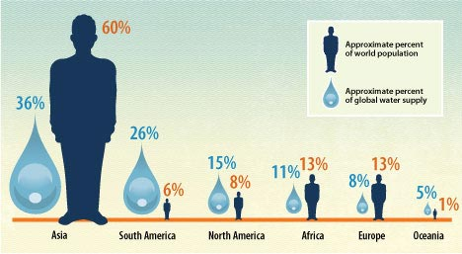

- How is farming and agriculture tied to water use?
- If we as a community decided to reduce our water use by reducing our show time, reducing our use of a dish washer, and sticking to lawn watering restrictions, would that impact our overall global water use? Why or why not? What needs to change?
- What are some of the statistics we use to find the health of a fresh water system? Why?
- How does temperature impact freshwater systems and organisms?
- How does pH impact freshwater systems and organisms?
- How does turbidity impact freshwater systems and organisms?
- How does dissolved oxygen impact freshwater systems and organisms?

Learning Goal #9: I can discuss global changes to Earth’s atmosphere
- Define the following terms:
  - Greenhouse gasses
  - Climate
  - Good ozone
  - Bad ozone
  - Stratosphere
- What changes have occurred on Earth due to global warming?
- What are some of the implications to our organisms due to global warming?
- What are the various layers of Earth’s atmosphere? What are characteristics of each layer?
- What is the difference between good and bad ozone? What can we be doing to help solve both of these issues?
- What is the percent of each gas in our atmosphere?
- What are the three types of UV and what are characteristics of each type? What are the consequences of each?
- How can global warming impact human populations?
- How effective is recycling? What are the positives and the negatives of recycling?

Learning Goal #10: I can explain the implications of greenhouse gases
- Outline the goal and the results of Montreal Protocol. Was it successful at making change? Why or why not?
- Outline the goal and the results of Kyoto Protocol. Was it successful at making change? Why or why not?
- Outline the goal and the results of Paris Protocol. Was it successful at making change? Why or why not?
- What are the consequences of high CO₂ in our atmosphere?
- What are the human actions that are increasing greenhouse gases?
- How can global warming impact our human health?
- What happens can organisms make in order to survive and adapt to the increasing greenhouse gases
- What is carbon sequestering? How does it work? What are some natural sources? What are some of the new technologies?

Learning Goal #11: I can explain factors impacting soil quality
- How might soil be impacted by human activity?
- What are some of the impacts of our forestry industry?
- What are the benefits and negatives of the different types of harvest methods?
- What are important nutrients needed for healthy soil?
- What are some methods we can use to enrich our soil?

Learning Goal #12: I can discuss global food security issues
- What is our current world population?
  - How does this population impact food?
  - What are some solutions?
- What are some issues around food choices? Why are these issues?
- What is the four crop rotation method of agriculture and how has it impacted our food?
- What are the factors that you feel are most important to food security?

Learning Goal #13: I can explain land management practices
- What are the categories of our Summerland recycling depot?
  - What are some of the rules of the waste reduction separations?
  - What can and can’t go in curbside recycling? What can and can’t go in the landfill recycling?
- How does putting food scraps in composting instead of landfill impact the earth?
- What are the rules for what can be composted and what can not be composted?
- What are some of the minerals that are mined in Canada?
- What are some of the benefits and negatives of mining?
- What is the difference between renewable and non-renewable resources? Give three examples of each.
- What are the 3 main companies involved in pipelines in Canada?
  - What are the issues surrounding the Transmountain pipeline?
  - What happened with the Northern Gateway pipepline?
  - What is the current situation in BC and Alberta with the Transmountain pipeline?
- What is fracking? What are the positives and negatives about this practice?
- What are some of the First Nations practices of using the land?
- What are some of the practices that the ONA Hatchery does in order to have such a high success rate of growth of salmonoid?
- What are some of the plants that the En’owkin Centre are trying to grow in order to bring back their populations? What is this important for each species?

Learning Goal #14: I can discuss human health and environmental impacts of population growth
- What have been some moments in history that has impacted the human population growth?
- Do you think that the earth has reached it’s carrying capacity? Why or why not?
  - What are limiting factors that might impact human population as we reach the carrying capacity?
- How does a WASTE water treatment work? Why is it necessary in Summerland?
- How does a Water Treatment Plan work? Why is it necessary in Summerland?

Diagrams to Know:
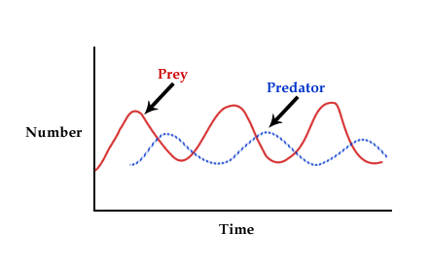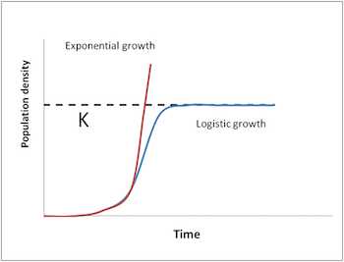
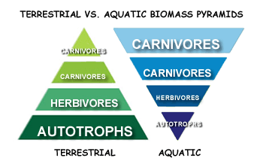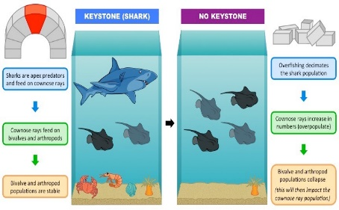

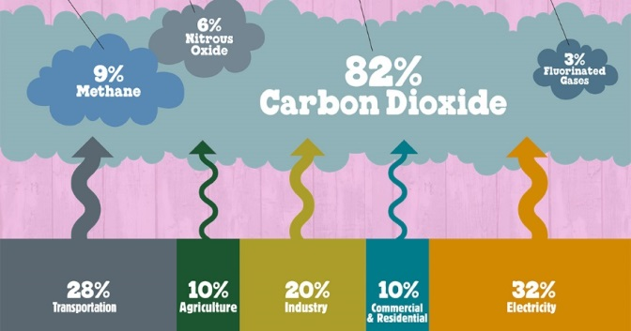

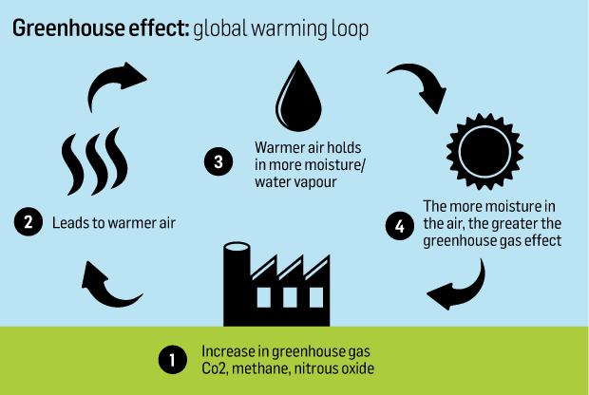

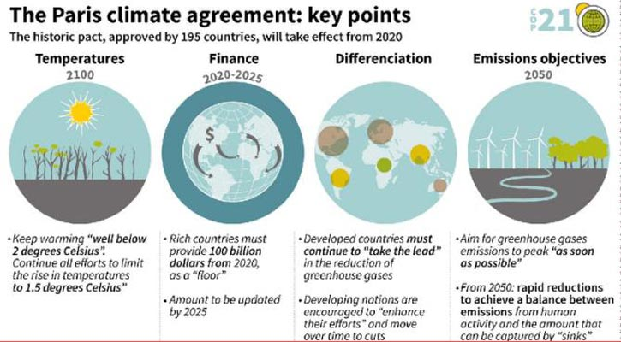
Diagrams to Know
