Foundations of Math 11
Proficiency Levels by Learning Goal

Learning Goal | Emerging | Developing | Proficient | Sophisticated
Reasoning | Using inductive reasoning prove that the sum of three consecutive numbers is divisible by three. | Using deductive reasoning prove that the sum of two even numbers and an odd number is always odd. | Using deductive reasoning prove that the product of an odd integer and an even integer is always even. | Write any two digit number. Reverse the order of the digits and subtract it from the first number. Make a conjecture of the solution. Prove (using deductive reasoning) that the difference is always a multiple of 9.
 | 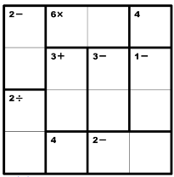 |  | 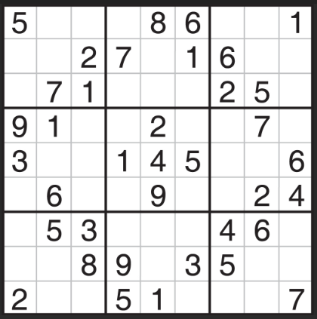
Angles | Define complimentary, supplementary, and vertically opposite angles | Find the value of x:  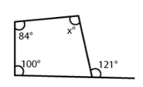 | Find the value of x:  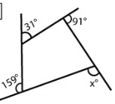 | Find the value of x:  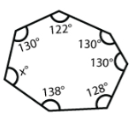
Parallel Lines | Define alternate interior, same side interior, alternate exterior, corresponding angles in parallel lines | Find the value of e and f:  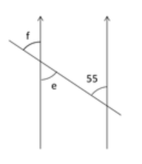 | What is x? What is your proof?  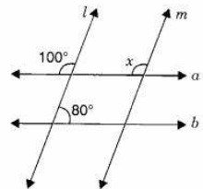 | Prove or disprove that lines l and m are parallel  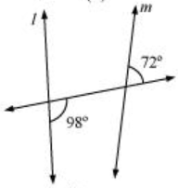
Linear Inequalities | Graph the following inequality  y > $\frac{1}{4}x$ + 1  What is the x and y intercept? | Graph the following inequality  2x – 5y ≤ 10  What is the slope? | Graph the following  system of inequalities:  x + y ≥ 2  4x + y ≥ -1  x ɛ R, y ɛ R | Graph the following  system of inequalities:  2x + 3y < 6  y > 2x – 6  x ɛ I, y ɛ I
Systems of Equations | Graph the following  system:  y = $-\frac{1}{2}x-3$  y = 2x – 3  What is the solution? | Graph the following  system:  y = $(x-1)$² + 3  y = -2(x - 1)² + 3  What is the solution? | Graph the following  system:  y = $-\frac{1}{2}x-3$  y = 2x – 3  What are the solutions? | Graph the following  system:  y = $-\frac{1}{2}x-3$  y = 2x – 3  What are the solutions?
Quadratics | What is the axis of symmetry? Vertex? End behaviour? Direction?  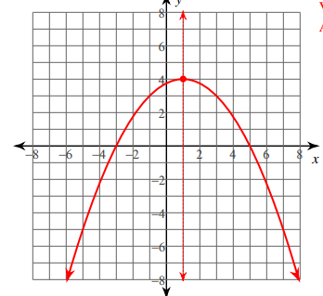 | Graph the following quadratic:  y = $(x+2)$² - 5  What is the axis of symmetry? Vertex? End behaviour? Direction? | Graph the following quadratic:  y = $(x-4)(x+2)$  What is the axis of symmetry? Vertex? End behaviour? Direction? | Graph the following quadratic:  y = x² + 4x - 6  What is the axis of symmetry? Vertex? End behaviour? Y-intercept?
 | Use desmos.  Researchers predict that the world population will peak during the 21st century. In January 2010 the world population was 6.9 billion. The equation for the relationship of year to population is:  Y = -595,000x² + 71,100,000x+ 6,900,000,000  X is the # of years since 2010  Y is the world population  How many years after 2010 will it take for the world population to reach it’s maximum value?  What will be the maximum population? |  | Use desmos.  The cost of car insurance depends on many factors, one of which is the age of the driver. Insurance companies know that younger drivers under the age of 25 and older drivers over the age of 70 are statistically more likely to have accidents. The following data shows the number of accidents per million km driven, by age of driver:  Age 18 30 45 60 75  # accidents 5.2 3.1 2.2 2.8 4.7  Determine the lowest number of accidents per million km.  Who is more likely to have an accident, a 17 yo or a 78 yo?
Optimization | Write an inequality for the below statements:  - The sum of two whole numbers is less than 10  - Person A is no more than 12 years older than person B  - A grocery store sells boxes of apple juice and jars of jam. The store has room for at most a total of 21 kg of these products. | Mary babysits for $4 per hour. She also works as a tutor for $7 per hour. She is only allowed to work 13 hours per week because she needs to focus on her school work. She wants to make at least $65 a week. Write and graph a system of inequalities to represent this situation. | A factory worker take 1.5 hours and 1 kg of raw material to make product X, and half an hour and 1 kg of raw material to make product Y. The worker can not use more than 12 kg of raw material per day and can work a maximum of 9 hours in a day. After paying wages and expenses, product X produced a profit of $40 and produce Y produces a profit of $20. How many of each product should be produced by the factory worker each day for maximum profit? | A company rents busses for tours around the Okanagan. It has 6 vehicles which each seat 28 passengers and 4 buses that each seat 42 passengers. The company arranges a tour for 168 people. Only 8 drivers are available. One driver travels with each 28 seat bus and 2 drivers with the 42 seat bus. The relief driver does not need to occupy a passenger seat. It the running costs to the company are in the ratio of $5 per large bus for every $3.50 per small bus, determine the solution which minimizes the total running cost.
Statistics | For the following groups of numbers, calculate the mean, median and mode for each.  301, 300, 444, 328, 299, 208, 314, 360 | A test was given to 150 students, and the scores approximated a normal distribution. If the mean score was 79% with a standard deviation of 7.5%, approximately what percent of the scores were 94% or higher? | In an apple pie factory, the mean mass of a pie is 89 g. For quality control, the standard deviation is 2.5 g. Pies are rejected if they weigh more than 95 g or less than 86 g. How many pies would you expect to be rejected in a sample of 20,000 pies? | A patient recently diagnosed with Alzheimer’s disease takes a cognitive abilities test and scores a 45. The mean on this test is 52 and the standard deviation is 5. What is the patient’s percentile rank?
Scale Models | If the scale of a map of Canada is 100 km:1 cm, what distance would be represented by 5.2 cm on the map? | Prove whether a rectangular prism that is 3 m by 5 m by 10 m is similar to one that is 5.25 m by 8.75 m by 17.5 m. Explain your reasoning. | Complete the following table to show the relationship between linear scale factor, area scale factor, and volume scale factor:  Linear Scale Factor Area Scale Factor Volume Scale Factor  $$\frac{1}{2}$$  12  0.125  2:5 | The diagram shows two storage jars which are mathematically similar. The volume of the large jar is 3.2L. Find the volume of the smaller jar.  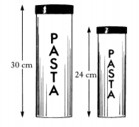
Finance | What are the pro’s and con’s or loans and leases? Outline a detailed list. | (No TVM), you have saved $6540 from your summer job. You put it in your CIBC account, which is a simple interest account at 2.9% per year. You leave the funds in your account for 4 years Calculate the amount in your account at the end of 4 years. | You need a loan to buy a used car for $8,900. You have a down payment of $2000. You take a loan from a bank at 5.6% per annum compounded monthly. If you want to pay off your loan in 4 years, what are your monthly payments? How much would you be paying for this “new to you” car by the end? | You decide you want to lease a new KIA for $29,999. You are going to do a down payment of $5,000. The interest on the lease is set at 5.1% per annum compounded monthly for 5 years. The residual value is $15,975.89. How must is your monthly payment? How much interest do you pay on the car by leasing it in comparison if you were to buy it with cash?

Proficiency Level for Curricular Competencies
 | Emerging | Developing | Proficient | Sophisticated
Reasoning and Modelling
Understanding and Solving
Communicating and Representing
Connecting and Reflecting | I did not notice anything about the problem or patterns in my solution. | I did not notice anything about the problem or patterns in my solution. | I did not notice anything about the problem or patterns in my solution. | I did not notice anything about the problem or patterns in my solution.

