**Biology 12**

**Excretory System Practice Test Name:___________________**



|  |  |  |  |
| --- | --- | --- | --- |
| **Learning Goals** | **Novice** | **Apprentice** | **Expert** |
| I can explain the structure/function of each of the parts of the excretory system |  |  |  |
| I can explain the hormones of the excretory system |  |  |  |

**Learning Goal #1: Explain the structure and function of each of the parts of the excretory system**

1. Draw the various structures of the excretory system. Label each structure. Be sure to include: dorsal aorta, inferior vena cava, renal artery, urethra, renal vein, renal medulla, adrenal gland, renal cortex, minor calyx, major calyx, renal pelvis, ureter, bladder.

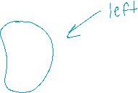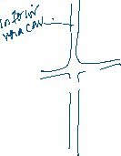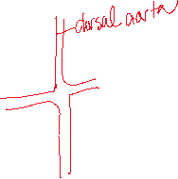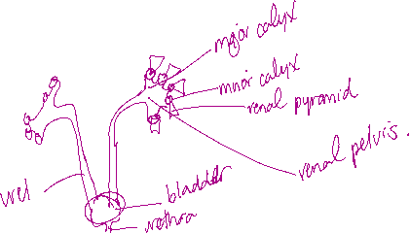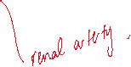

1. Draw a nephron and the circulatory system that surrounds it, in the space below. Label all the structures involved. Be sure to include: descending loop of Henle, ascending loop of Henle, distal convoluted tubule, proximal convoluted tubule, collecting duct, glomerulus, Bowman’s capsule, efferent arteriole, afferent arteriole.

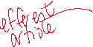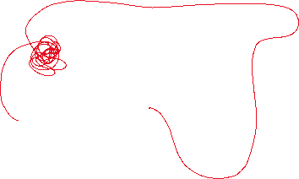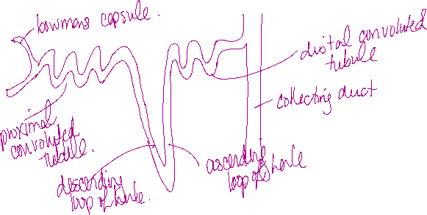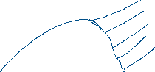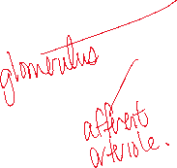

1. Draw another nephron (don’t label the structures). Label what biomolecules are moving where. Be sure to show at the end what biomolecules will come out in the urine.

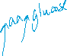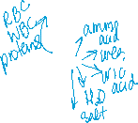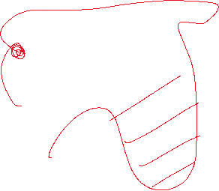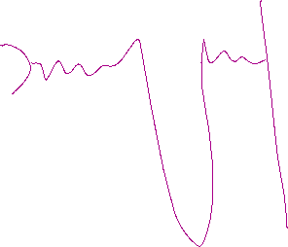

1. What body systems does the kidney interact with? Explain two different systems and **how they interact**?



* 1. ___________________________________________________________________________________________________________________________________________________________________________________________________________________________________________________



* 1. ___________________________________________________________________________________________________________________________________________________________________________________________________________________________________________________



**Learning Goal #2: Explain the hormones of the kidneys and osmoregulation**

1. What is osmoregulation and why is it important for the body? ______________________________________________________________________________________________________________________________________________________________________________________________________________________________________________________________________________



1. If someone were to have 3 cups of coffee to start their day, how would that impact the amount of urine and concentration of urine produced and overall health? Why? ______________________________________________________________________________________________________________________________________________________________________________________________________________________________________________________________________________

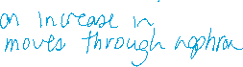

1. The endocrine system monitors the hormones of the body. What three hormones are connected with the excretory system and how do they impact the functioning of the kidneys?

|  |  |  |  |
| --- | --- | --- | --- |
|  | **Hormone Name:**  **_____________________** | **Hormone Name:**  **_____________________** | **Hormone Name:**  **_____________________** |
| Where it is made |  |  |  |
| Where it acts |  |  |  |
| What it does |  |  |  |
| Body system monitoring it’s release |  |  |  |
| Impact on urine concentration |  |  |  |
| Impact on urine volume |  |  |  |

1. Mrs. Becker has very low blood pressure right now. What body systems take action to attempt to reduce her blood pressure? **Explain the process** involved. Be sure to discuss the hormones, sensor cells, and molecules involved. ____________________________________________________________________________________________________________________________________________________________________________________________________________________________________________________________________________________________________________________________________________________________

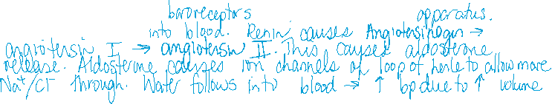

1. How does the excretory system play a role in overall body homeostasis? ________________________________________________________________________________________________________________________________________________________________________________________________________________________________________________________________________________________________________________________________________________________________________

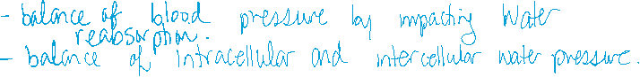

1. You test your urine’s pH and find that it is 3.5. Why might this be? What might cause this? How might you address this? ____________________________________________________________________________________________________________________________________________________________________________________________________________________________________________________________________________________________________________________________________________________________________________________________________________________________________

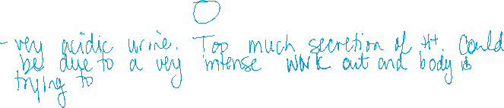

1. Your urine is cloudy. Why might this be? What might be causing this? How might you address this? ________________________________________________________________________________________________________________________________________________________________________________________________________________________________________________________________________________________________________________________________________________

