Environmental Sciences 11/12
Ecology Review
Name: _______________________________
Learning Goal | Novice | Apprentice | Expert
- I can connect the roles of species in the local Okanagan ecosystems
- I can explain ecosystem stability and the factors that influence sustainability
- I can explain how humans can be a factor of change within an ecosystem
- I can discuss unsustainable and sustainable human practices
- I can explain First Peoples and traditional ecological knowledge

Learning Goal #1: I can connect the roles of species in the local Okanagan ecosystems
- Define the following terms:
  - Ecosystem Biomass – the accumulation of organic material in an ecosystem. Can be placed in a pyramid to show the biomass of the various trophic levels
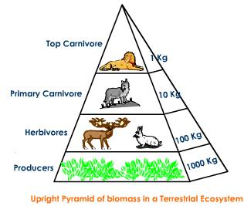
  - Ecosystem Productivity – the rate of generation of biomass
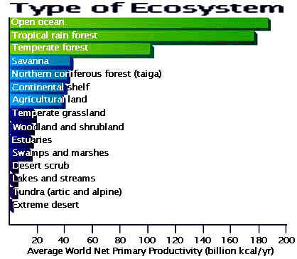

  - Ecological niche – the role of the organism in the ecosystem
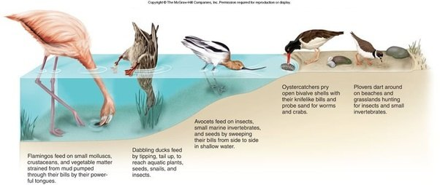

  - Trophic cascade – the downward impact of a removal of species. How are the organisms below in the food pyramid impacted?
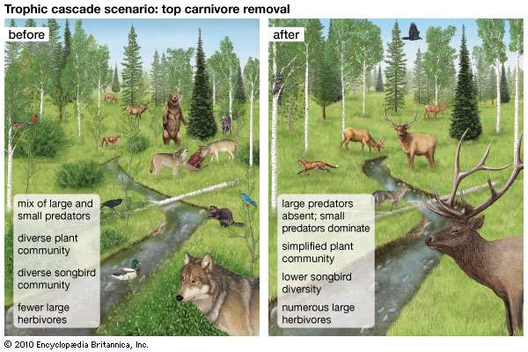
  - Carrying capacity (K) – the limit of a population in a specific area
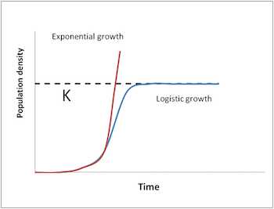

- Define the following: autotroph, heterotroph, and saprotroph and give an example of each.
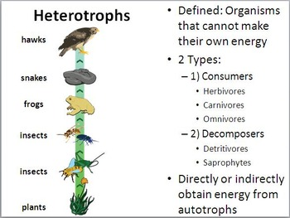
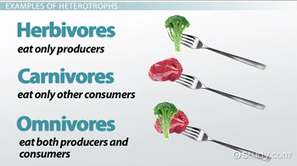
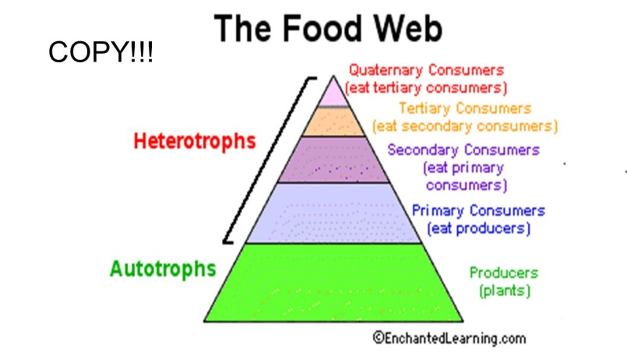

Saprotroph – a specialist heterotroph that eat decomposing and decaying food

- What is the difference between a terrestrial and aquatic biomass pyramids? Explain WHY there is the difference.
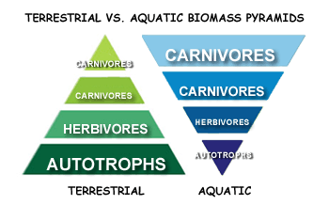
- Describe three different trophic cascades situations and how they have impacted the ecosystem. Use the examples that we have explored in our case studies.
- Yellowstone National Park
  - Wolves removed due to over hunting, which caused the elk population to increase due to decreased predation. Too many elk caused overeating of grasses. Also caused elk to become stationary, which increased the repercussions of elk overeating. This ended up changing the pathways of the creeks and rivers and caused the tree populations in the riparian zones to decrease. This caused a decrease in the bird population as well.

- Wolf and Caribou in BC
  - The caribou population is decreasing to such an extent that the herds are almost extinct. This will impact the lichen population (big food source of caribou). The lichen population will increase which will then be a competitor for the grasses and decrease the grass success. This will impact other ungulates such as deer, as well as smaller rodents which feed and build nests from grasses. This will also impact the beetle and insect populations, which will in turn impact the decomposition rate of organic matter, so there will be a build up of dead and decaying matter.

- Zebra Mussels
  - The mussels will filter feed faster which will make clearer water. The clearer water will allow sunlight to penetrate to the bottom algae better, which means that they will grow taller and bigger. They will eventually grow and cover the top of the pond, which will then block the sunlight to the bottom. All algae will die and rot. This will decrease the oxygen recycling in the water, which will kill off the fish and snails. This will create a “Dead pond” as nothing will be able to survive the low oxygen.
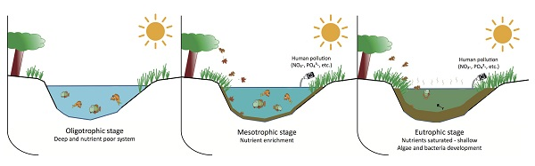
- Sea Otters BC
  - 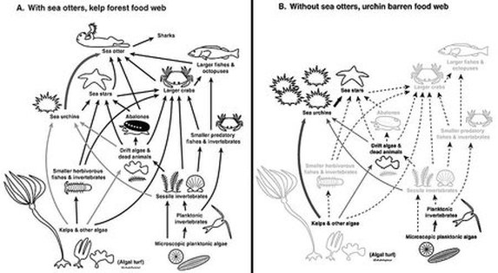

- Sharks (keystone species)

  - 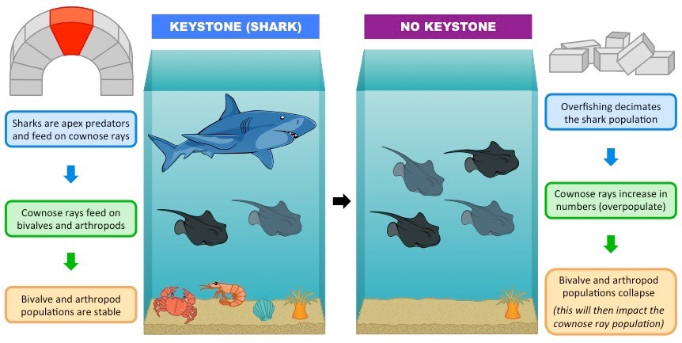

- What is happening to our local pollinators? What are four examples (be specific) of local pollinators?
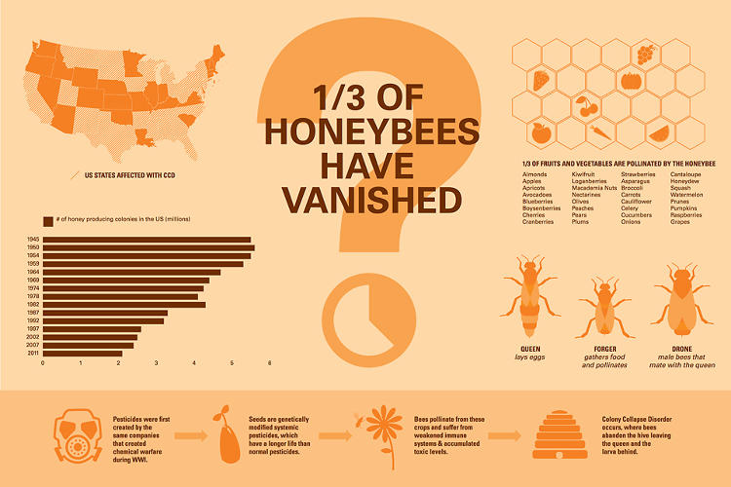

- What is Colony Collapse Disorder? What are four reasons that this might be occurring?
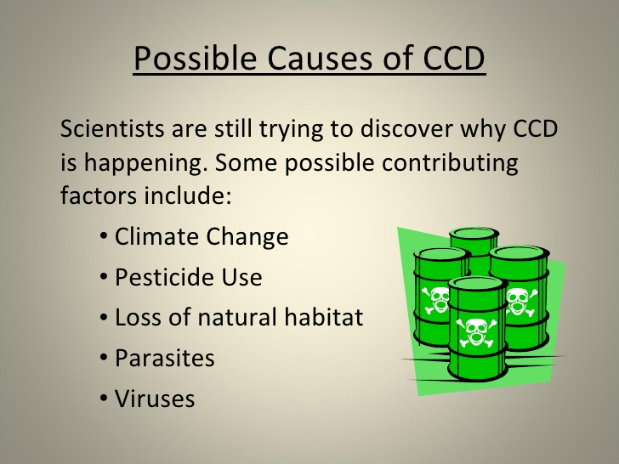

- What is an invasive species? What are some examples of invasive species in the Okanagan?
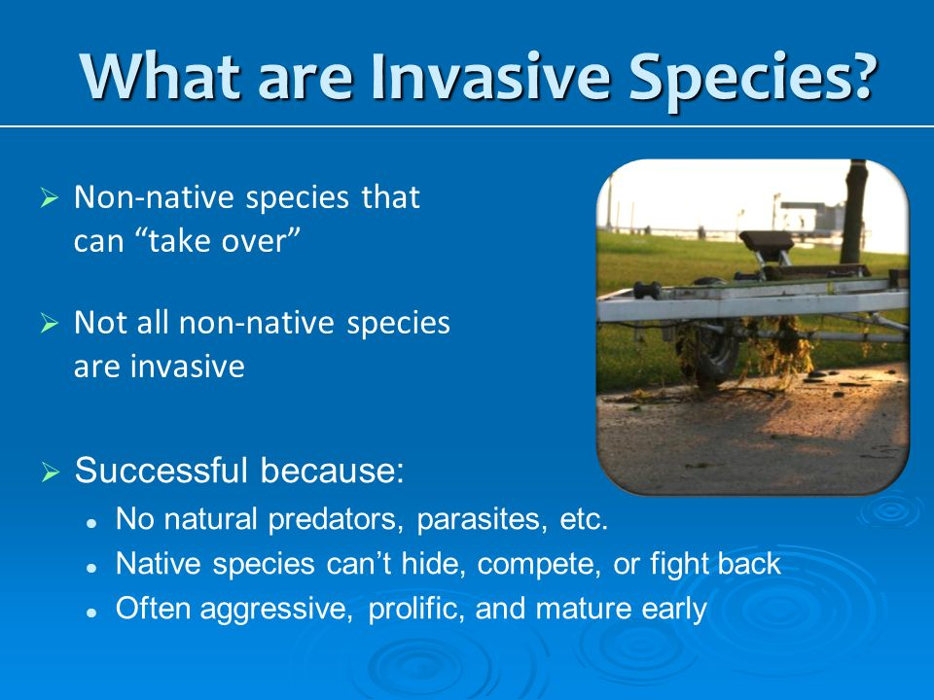

- What is the difference between native, non-native, and invasive species?
Native species are from the area and have natural niches and predators. Non-native species have moved into the area due to habitat change naturally. For example, their population has naturally moved northern and invaded a new space. Predators will usually keep them in check. Invasive species have been artificially introduced into an area and population goes unchecked due to lack of predation.

- How does predation impact a population?
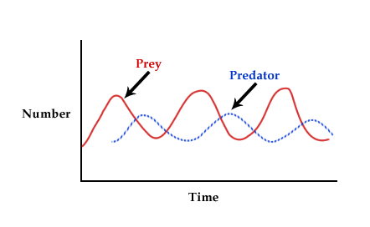
- What impact do zebra mussels have on a lake system? What are the possibly long term impact?

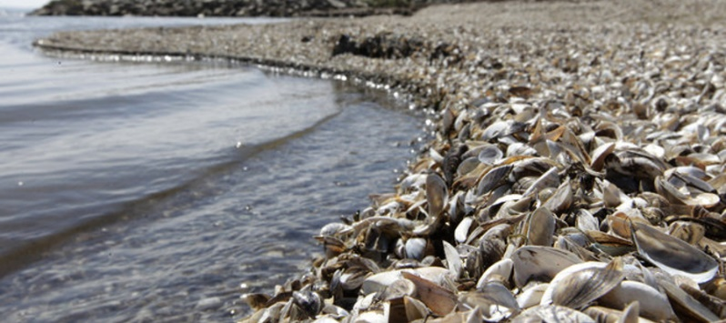
- Increase filter feeding which causes increased visibility
- Sunlight penetrates too deep and changes temperature of water
- Decrease tourism due to beaches
- Increase hydro costs due to penstock damage and cleaning
- What are some examples of symbiotic relationships of organisms in the Okanagan? Explain what they are and define the three main types of symbiosis.
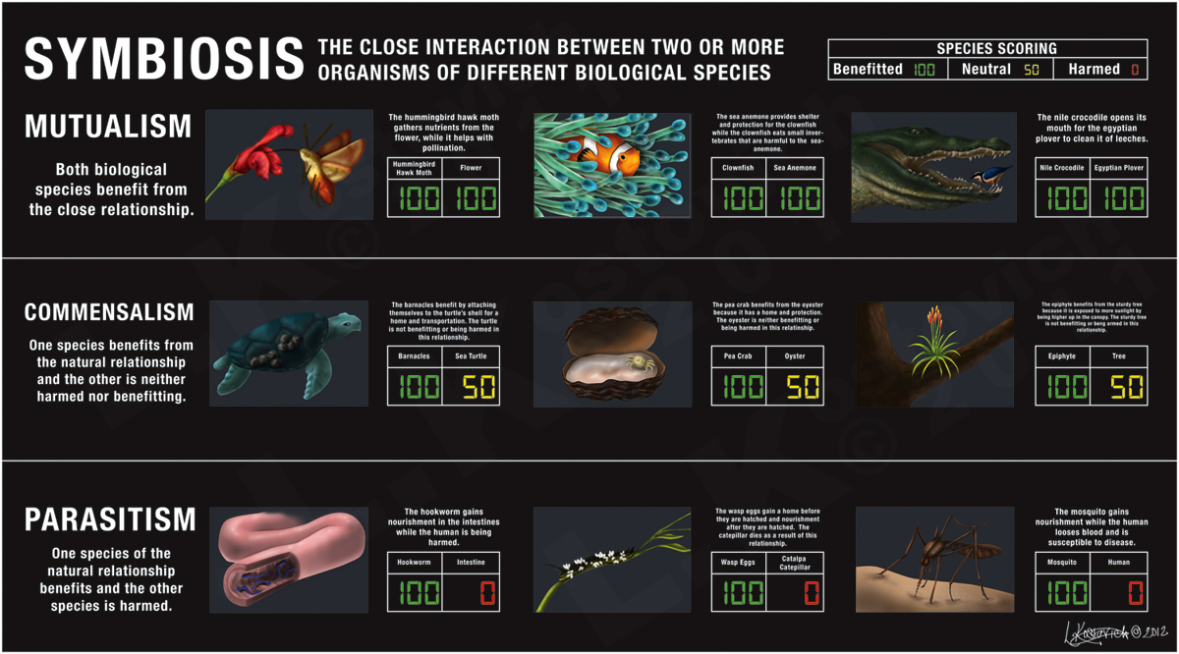
- What are three red listed and three blue listed Okanagan organisms. Explain what is happening in their ecosystems that have led them to their numbers? What is being done about it?
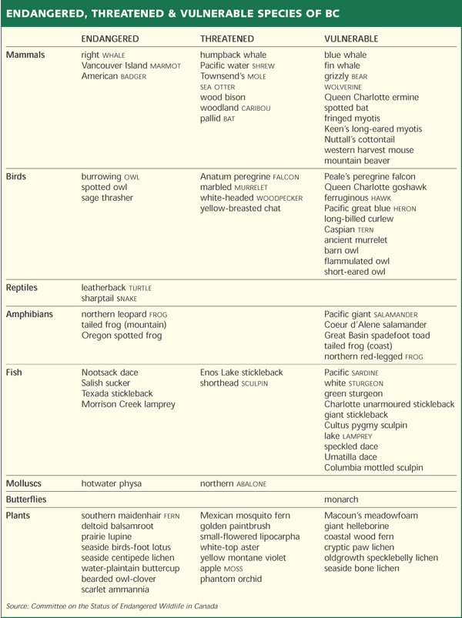

- What are the 7 local ecosystems? What are defining characteristics of each?
Ecosystem | Defining Characteristic
Interior Douglas Fir | Squirrels, dense fir trees
Montane Spruce | High up on montains elevation, spruce trees, birds, and ungulates
Ponderosa Pine | Ponderosa pine trees, not dense forests, owls, etc, lots of pine needle litter
Bunchgrass | Very dry, only blue bunchgrass, no sage, snakes and rodents
Antelope Brush | Very dry, sage and antelope brush, rattle snakes
Interior Hemlock/Cedar | Small hemlock and cedar trees, dark brown soil
Cottonwood Riparian | Along creek or river, lots of birds, yellow cottonwood trees

Learning Goal #2: I can explain ecosystem stability and the factors that influence sustainability
- What are some of the factors that has led BC to initiate a Wolf Cull starting in 2015? What are they hoping to impact? Why? What are BOTH SIDES of the story?
Caribou in Dawson Creek herd are very threatened and down to their last numbers. Biologists and Wildlife Management officers are hoping that removing their predators will help manage their population.
Wolf cull area in BC

- What are some of the issues surrounding the Great Bear Rain forest? What is impacting the area? How can we play a role?
competition with grizzly bears as the habitat of the grizzlies are infringing on the Kermode bear’s habitat
Spirit bear protected by black bears are not
Black bears carry the recessive gene of the white fur

- What is the difference between density dependent and density independent limiting factors? Outline some examples of each.
- How does genetic diversity impact sustainability?
Genetic diversity allows organisms to be adaptive to a change in the environment. When there is low genetic diversity in a population (like in monocultures) you have a much less “flexible” population.

- What is a keystone species? Give an example of two that we have learned about. What is the trophic cascade if they were to disappear?
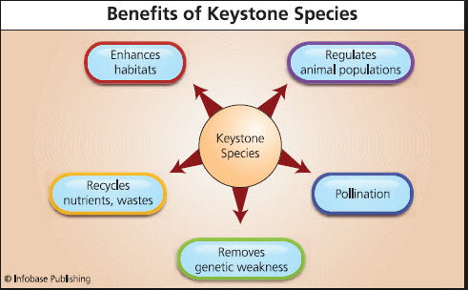

Learning Goal #3: I can explain how humans can be a factor of change within an ecosystem
- What are some examples of biological control that humans have played a role in? Outline what occurred, what the reasoning was and happened as a result of human involvement?
Cane toad
Ontario turkey
Zebra mussels
Prickly pear
Parasitic Wasp
Stink Bug

- Humans re-introduced wolves into Yellowstone National Park. Why? Has this been a factor of change in the ecosystem? How?
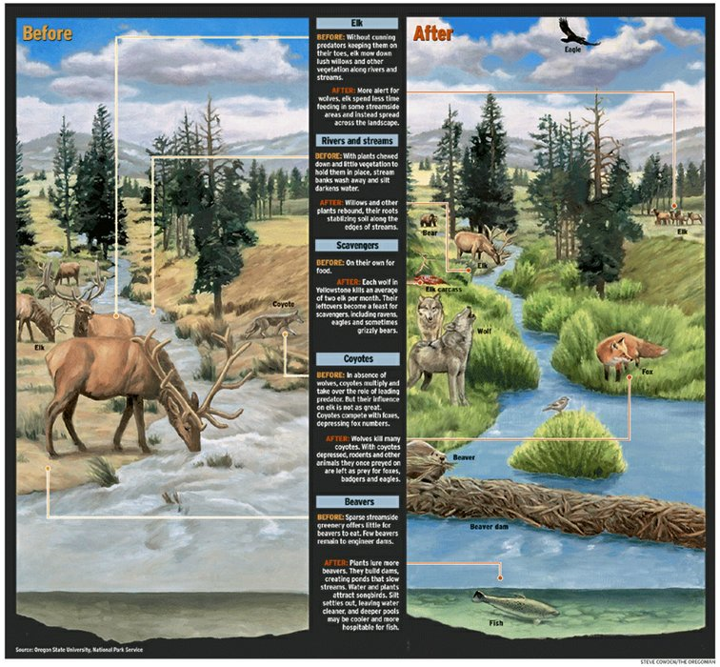
Learning Goal #4: I can discuss unsustainable and sustainable human practices
- What are some of the negative impacts of humans on local ecosystem? Explain specifically how this impacts organisms and environments.
Urbanization
Development
Recreation

- What are some things that we are doing to help our ecosystems and organisms be more sustainable?
Provincial parks, national parks
Breeding programs, aquariums, zoos, education

- What are some changes we can make to our choices and behaviours that might positively impact local ecosystems?
Ethical consumerism, building garden corridors, education among community, buy local, small housing,

- What are some careers that you could go into that would have a positive impact on our environment and sustainable practices?
Conservation officer, wildlife management, fisheries and wildlife biologist, environmental engineer, etc

Learning Goal #5: I can explain First Peoples and traditional ecological knowledge
- What is the traditional ecological knowledge?
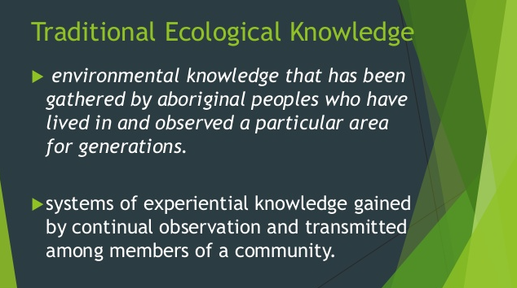

- What are some of the organisms that Okanagan First Nations People have a special connection to? Explain the connection.
Bear, salmon, antelope brush, sage

- The Okanagan First Nations see all parts of the ecosystem as living (water, soil, etc). How does this differ from the Western perspective of living and nonliving?
Abiotic factors are non-living (no reproduction, no breathing) such as soil and rocks and water
Biotic factors are living (reproduce, made of cells, breath) such as animals, plants, fungi, etc

First Nations believe that water and rocks are living and contribute to the energy of the earth. That we are all reliant on each other and feed off each other. If the water is harmed then it will contribute to a trophic cascade. If the rocks and soil is harmed it will also contribute to the trophic cascade.

- What is the BALANCE of our ecosystem? How does the need for BALANCE impact our actions?
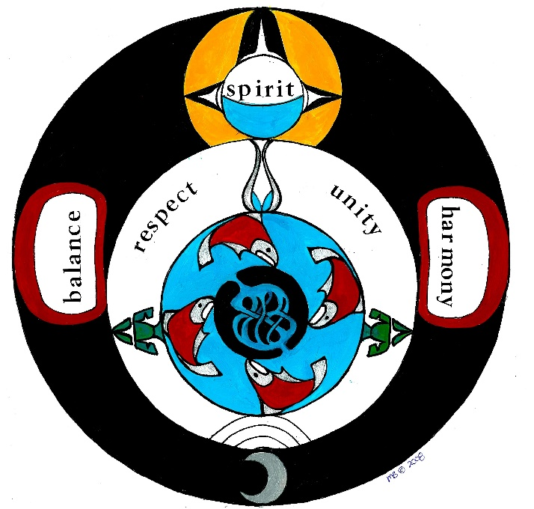
We must balance what we take from the land. Out of balance behaviour is over hunting and over fishing. We must work towards a balance of resources and give back to the earth for decomposition and energy

Diagrams to Know:
