Environmental Sciences 12
Ecology PRACTICE TEST
Name: _______________________________
Learning Goal | Novice | Apprentice | Expert
- I can connect the roles of species in the local Okanagan ecosystems
- I can explain ecosystem stability and the factors that influence sustainability
- I can explain how humans can be a factor of change within an ecosystem
- I can discuss unsustainable and sustainable human practices

Learning Goal #1: I can connect the roles of species in the local Okanagan ecosystems
- Define the following terms:
Vocab Word | Definition | Specific Example
Ecosystem Biomass

Ecosystem Productivity

Niche

Trophic Cascade

Primary Producer

Heterotroph

- What abiotic factors influence a terrestrial population?

- What abiotic factors influence an aquatic population?

- What are these diagrams? Why are they in the shape that they are?
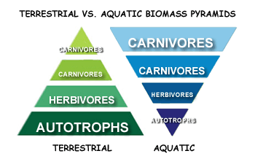
______________________________________________________________________________________________________________________________

- State the Okanagan ecosystem in the picture, explain what organisms can be found there, and where in the Okanagan you might be able to find it.

Ecosystem | Organisms In Ecosystem | Where in Okanagan
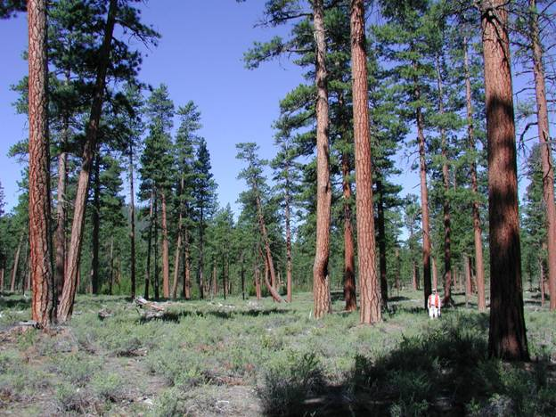
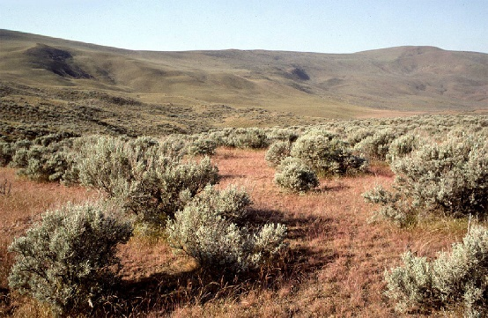

- What are two Okanagan organisms that are either red listed, blue listed, or invasive? Outline some factors that have caused them to be endangered.
Organism | Reason for Endangerment | What is being done

Learning Goal #2: I can explain ecosystem stability and the factors that influence sustainability

- Complete the below chart outlining the 6 Kingdoms and give a unifying characteristic of each
Kingdom | Unifying characteristic | Example organism

- How is the trophic cascade that occurred when the wolves were extirpated from Yellowstone National Park?
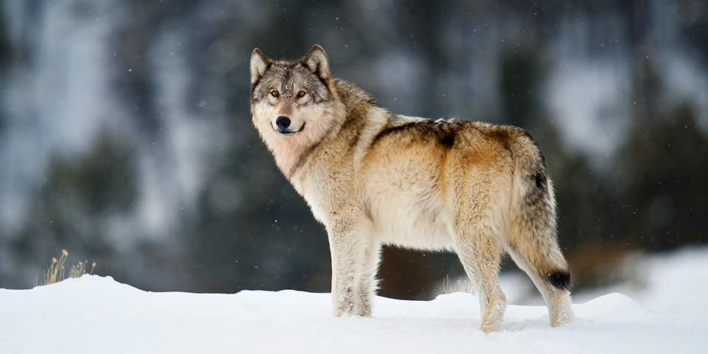
_________________________________________________________________________________________________________________________________________________

- What are the issues occurring for the Spirit Bear? What is impacting their population? __________________________________________________________________________________________________________________________________________________________________________________________________________________________________________________________________________________________________________________________________________________________________________________________________________________________________________________________________________________________________________________________________________________________________________________________

- Define density dependent and density independent limiting factors and give examples of each
Limiting Factor | Definition | Example
Density Dependent

Density Independent

- What is a population’s carrying capacity? How would this impact both the biotic and abiotic fators in a community?
________________________________________________________________________________________________________________________________________________________________________________________________________________________________________________________________________________________________________________________________________________

- Looking at the population trends in the below graph, what would be happening in each of the populations to have this sort of growth?
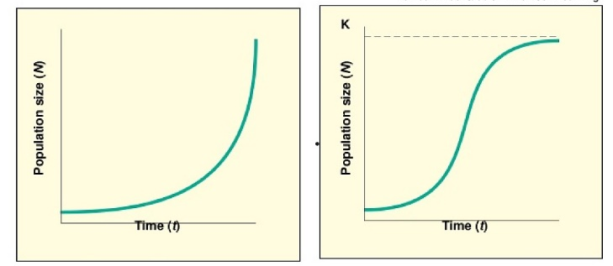
____________________________________________________________________________________________________________________________________________________________________________________________________________________________________________________________

- What is one invasive species in the Okanagan. Outline some of the issues around this invasive species.
Organism | Reason for CONCERN | What is being done

- Outline the 3 main policies or groups that help to manage our organisms at risk
Policy/Group | Main area of focus | How is this managed, sustained over time?
Wildlife Act of BC

Species at Risk Act

COSEWIC

- What is ecological succession? Explain the process involved. Outline the similarities and differences between the two types of succession.
__________________________________________________________________________________________________________________________________________________________________________________________________________________________________________________________________________________________________________________________________________________________________________________________________________________________________________________________________________________________________________________________________________________________________

Learning Goal #3: I can explain how humans can be a factor of change within an ecosystem
- What is happening in northern BC with the current wolf cull? Why does the BC Wildlife Management feel this is a necessary action? ____________________________________________________________________________________________________________________________________________________________________________________________________________________________________________________________________________________________________________________________________________________________________________

- Humans are causing urbanization. Explain what this is and how this is impacting our local plants and animals? ____________________________________________________________________________________________________________________________________________________________________________________________________________________________________________________________________________________________________________________________________________________________________________

- What is one example of biological management? State the organism involved, the reason, and any unforeseen consequence of the action.
Organism | Reason for Biological Control | Consequence

- How is human behaviour impacting pollinator populations, specifically bees? What are 6 factors that are contributing to Colony Collapse Disorder?
____________________________________________________________________________________________________________________________________________________________________________________________________________________________________________________________________________________________________________________________________________________________________________________________________________________________________________________________________________________________________________________________________________________________________________________________________________

Learning Goal #4: I can discuss unsustainable and sustainable human practices
- Are we an invasive species?
____________________________________________________________________________________________________________________________

- What are some of the human practices and behaviours that have negatively impacted Earth’s organisms? _________________________________________________________________________________________________________________________________________________________________________________________________________________________________________________________________________________

- What are some of the human practices and behaviours that have positively impacted Earth’s organisms? _________________________________________________________________________________________________________________________________________________________________________________________________________________________________________________________________________________

- What is the difference between First Nations and Western perspectives as far as what is considered living? How might this impact our view of ecosystems? ____________________________________________________________________________________________________________________________________________________________________________________________________________________________________________________________________________________________________________________________________________________________________________

