DNA Replication

**Single Stranded Binding Proteins**



**Helicase**



**Topoisomerase (also known as DNA Gyrase)**



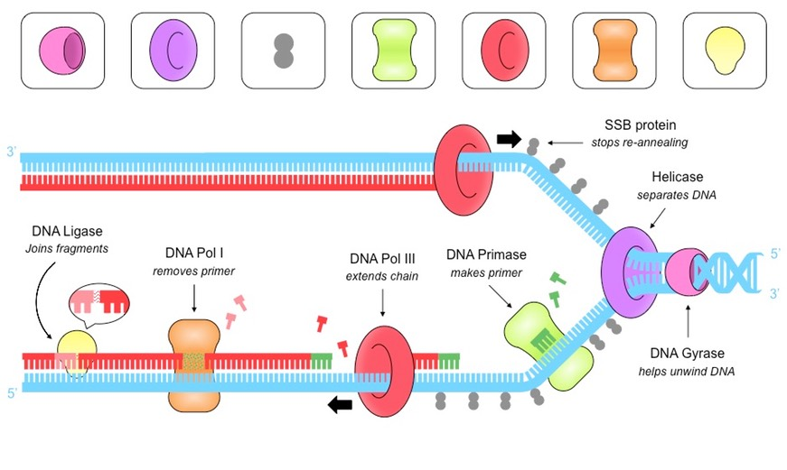

**DNA Ligase**



**DNA Polymerase III (3)**



**DNA Polymerase I (1)**



**DNA Primase**

