Enzymes, Tissues & Digestive System
Unit Review 2020

Test Date: _______________________________

Learning Goals:

- I can explain the functioning of an enzyme
- I can explain the various types of tissues that make up the human body
- I will be able to the structures and functions of the organs of the digestive system
- I will be able to explain the roles of the various enzymes of the digestive system
Learning Goal #1 I can explain the functioning of an enzyme
- Draw and label the various parts of an enzyme (enzyme, active site, substrate)

- Why does the pH of the environment matter when it comes to functioning enzymes?

- What are the six factors that impact enzyme functioning?

- Explain the difference between the lock and key and induced fit theories of enzyme functioning.

Learning Goal #2 I will explain the 4 types of tissues in the human body
- What are the four types of tissues?

- Where in the digestive system would you find each of the tissue types

Learning Goal #3 I will be able to identify the structure and function of the following parts of the digestive system
- Complete the function of the below structures:

  - Salivary glands

  - Esophagus

  - Stomach

  - Duodenum

  - Liver

  - Gallbladder

  - Pancreas

  - Small intestine

  - Large intestine

  - Epiglottis

  - villi

- Draw and label the 3 main parts of the small intestine

- What is the order of the sphincters from mouth to anus?

- Why do we have E. coli in our large intestine?

- What is mechanical digestion and where does it occur?

- How does the bolus of food travel down to your stomach?

- What happens when someone has peristalsis impacted?

- Are there any other structures other than the esophagus that might have some level of peristalsis as well? Why?

- What are the 6 major functions of the liver?

- What other structures of the digestive system work with or contribute to the liver?

Learning Goal #4 I can explain the roles of the various digestive enzymes
- What are the 3 main enzymes that help in the hydrolysis of starch? What do they make? What pH does each function best at?

- What are the 3 main enzymes that help in the hydrolysis of proteins? What do they make? What pH does each function best at?

- What is the 1 main enzyme that help in the hydrolysis of fat? What do they make? What pH does each function best at?

- What are some disorders that can negatively impact our enzyme functioning of our digestive system?

- What type of food items would still NOT be digested after passing through the mouth and stomach? Why?

- Compare the chemical composition of the CONTENTS of the stomach when you have eaten a meal consisting of protein, carbohydrates, and fats to that of the small intestine an hour later?

- What structures produce or assist bile? How?

- What happens to fat as bile “digests” it? What does it get formed into? What happens next?

- What is the role of the small intestine? Where does it do this?

- What is the difference between physical and mechanical digestion?

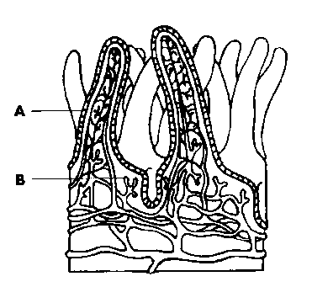
- Where do the nutrients go? What happens next to them? Why is this important?

- Label the parts of the below structure

- Why are these villi “fingers” part of the structure of the small intestine?

- What would happen if some of the villi of the small intestine were not working properly?

- What is in the pancreatic juice?

- What does each molecule in the pancreatic juice do?

- How does the functioning or non-functioning of the pancreas impact diabetes?

- What would happen if the pancreas DID NOT release sodium bicarbonate?

- What is the difference between an enzyme and a hormone?

- What is gastrin? Where is it made? What does it do?

- What is CCK? Where is it made? What does it do?

- What is secretin? Where is it made? What does it do?

- What is Gastric Inhibitory Peptide? Where is it made? What does it do?

- What is an enzyme?

