Circulatory & Respiratory Lab Inquiry
Biology 12 Name: ____________________________
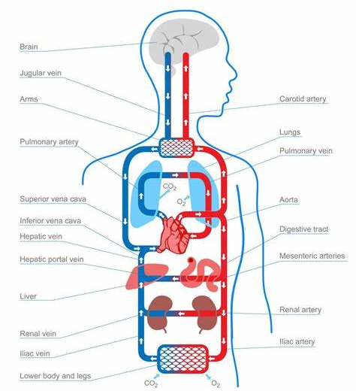
Due date: ________Wednesday, Dec8th____________

Your Mission You are to ask a TAKE ACTION question to explore how the circulatory and respiratory systems work together. You are to ask a question that looks at both breathing rates and pulse/blood pressure.

What activities are you interested in finding out more about how your body responds? Exercise? Calming down? Studying? Sleeping? Responding to stimuli?

For this Take Action Inquiry you are needing to:
- Find an Essential question that interests you
- Collect data on BOTH respiratory system and circulatory system
- Collect data from 10 different people
- Collate data (mean and standard deviation)
  - Include data table of trials and means
  - Include a graph of the means of data
- Type up your lab report following the scientific lab report sections

Marking Criteria
Learning Goals | Take Action  Experiment
I can pose questions | Did your 4 guiding questions for your background research help dive into your topic?
I can plan an inquiry and/or science experiment | Did you bring all necessary equipment when needed? Did you have parent permission form for any students participating in your experiment?
I can act safely (only if doing experiment) | Did you act safely as to not put stress on any of your subjects? Were you ethical in your experimentation?
I can analyze data and graphs | Did you create data tables and graphs of your findings? Did you collect multiple trials (10) and calculate means (and standard deviation or standard error)
I can explain the societal impacts of my big question | Did you explain in your discussion and further investigation section the societal impacts of your big question? Why is if your experiment important for society?
I can communicate my findings | Did you follow the expectations for a scientific write up?
I can reference my research and provide a proper summary of my sources (only research) | Did you follow proper citing protocol and source all research material?

Circulatory Inquiry
Proposal
Name: _____________________________________
Step#1: My Big Question
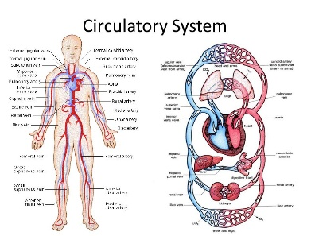

What do you want to find out more about??

What is your big question?
- ______________________________________________________________________________________________________________________________________________________________________________________

Supporting Questions:
- ______________________________________________________________________________________________________________________________________________________________________________________
- ______________________________________________________________________________________________________________________________________________________________________________________
- ______________________________________________________________________________________________________________________________________________________________________________________
- ______________________________________________________________________________________________________________________________________________________________________________________

What type of data could you collect about the circulatory and respiratory system? (possible dependent variables)
- _____________________________________________________________________
- _____________________________________________________________________
- _____________________________________________________________________

Possible independent variables (what could you change)
Situation #1: _______________________________ vs Situation #2: _______________________________
Step#2: Getting Prepared

Materials to bring Thursday, Dec 2nd
________________________________________________________________________________________________________________________________________________________________________________________________________________________________________________________________________________________________________________________________________________________________________________________________________

Participation Permission Forms
When people are part of a research experiment they MUST give consent to be involved. Because many of your participants are under the age of 19, they will need parent permission. Who are you going to have involved? Hand them a permission form. You MUST have it returned prior to action day.
Participants (minimum of 5 different people done 3 trials each) | Permission Form Received

Variables:
Independent variable: _________________________________________
Dependent variable: __________________________________________
Controls: ______________________________________________________

Safety
How are you going to stay safe in your experiment?
______________________________________________________________________________________________________________________________________________________________________________________________________________________________________________________________________________________________________

Your To Do List:
- Research the topic of your study.
- Hand out permission forms
- Collect your permission forms
- Assemble all necessary items for Monday (food, pictures, materials, etc)

