Biology 12
Cell Practice Test (Dec 2020)
Name: ____________________________________

Learning Goals | No Evidence  0 | Beginning  1 | Developing  2 | Proficient  3 | Sophisticated  4
I can explain the role of enzymes in the body
I can explain the structures and functions of the various parts of the cell and membrane
I can explain the process of DNA Replication
I can explain the process of protein synthesis and how it leads to mutations

Learning Goal #1: I can explain the role of enzymes in the body
- Which of the factors that can impact enzyme functioning is displayed in the graph below? Justify your answer.
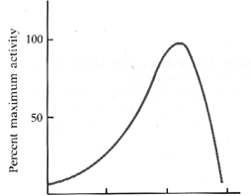
_______________________________________________________________________________________________________________________________________________________________________________
- Which of the factors that can impact enzyme functioning is displayed in the graph below? Justify your answer.
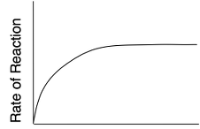
_______________________________________________________________________________________________________________________________________________________________________________

- Why is a fever of 105 degrees too high? Why is it dangerous? _____________________________________________________________________________________________________________________________________________________________________________________________________________________________________________________________________________________________

- There is an enzyme pepsin that works in the stomach (pH 2) but not in the small intestine (pH 8). Why? _____________________________________________________________________________________________________________________________________________________________________________________________________________________________________________________________________________________________

- Draw and label an enzyme and substrate. What are the various parts on an enzyme? What lands on an enzyme?

- What are the two ways that vitamins and minerals impact an enzyme. Draw and explain this.

Learning Goal #2: I will be able to label the various cell structures and their functions

      - Label the following organelles:
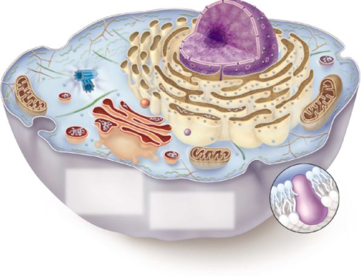

3. Match the organelle name with the function
Organelle matching letter | Function of organelle | Organelles
 | The uncoiled genetic material in the nucleus | A = nucleus
 | The site of packaging of proteins for export of the cell | B = chromatin
 | The main control centre of the cell, because it holds the genetic material (DNA) | C = golgi body
 | The membrane bound organelle that holds water for the cell. It is a very large part of the plant cell | D = vacuole
 | The inner jelly of the cell that suspends the organelles inside the cell | E = cytoplasm

- Draw a phospholipid bilayer of the cell membrane, including all important structures. Label all parts.

- What are the five ways that a material can move across the cell membrane? Describe the various methods and give an example of what type of molecule needs to move in that method:

Type of Movement | Description | Example molecule

Learning Goal #3: I can explain the structure, role, and replication of DNA
- Draw the backbone of DNA with a series of 5 nitrogen base pairs with the proper complimentary pairings

- Draw an mRNA strand that is complementary to the DNA strand below.
3’ ACGCGATTATATCCTACGGCGAATCGTATCATTGGTCAA 5’

- Draw and label the process of DNA replication. Be sure to label:

- Leading strand
- Lagging strand
- Okazaki fragments
- Helicase
- DNA polymerase III
- DNA polymerase I
- Single stranded binding proteins
- Ligase
- Nitrogen base pairs
- 3’ and 5’ ends
- topoisomerase

Learning Goal #4: I will be able to explain the process of protein synthesis and mutations
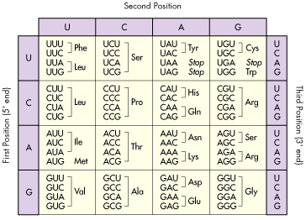
- Below is a “normal” gene and a mutated gene. Write out the mRNA strand and predict the polypeptide that is formed (5 marks). Use the chart on the back page.

a) “Normal” Gene

DNA Strand ^{3’}CTATACGTACATAAGCCTGACTGG^{5’}
mRNA Strand ^{5’} ^{3’}
Amino acid chain =

b) “Mutated” Gene

DNA Strand ^{3’}CTATACGTACATAAGCCTGACAGG^{5’}
mRNA Strand ^{5’} ^{3’}
Amino acid chain =

What type of mutation was shown here? What is the repercussion of a mutation like this? ______________________________________________________________________________________________________________________________________________________________________________________________________________________________________________________________________________________________________

