Unit #1 REVIEW Biochemistry KEY

Name: ____________________________________
Learning Goals:
- I will be able to come up with a testable hypothesis to investigate a scientific problem
- I will be able to describe the unique properties of water
- I will be able to show examples of hydrolysis and dehydration synthesis
- I will be able to recognize the difference between carbohydrates, lipids, proteins, and nucleic acids
- I will be able to recognize the difference between saturated and unsaturated fats
- I will be able to draw the general structure of an amino acid
- I will be able to differentiate between primary, secondary, tertiary, and quaternary protein structures
- I will be able to list the main functions of nucleic acids (DNA, RNA)
- I will be able to draw the main structure of DNA and RNA (including nitrogenous bases

Using a separate piece of paper, answer the question to each of the learning goals. Use your notes, the videos, a textbook, and the internet as possible sources of information.

I will be able to come up with a testable hypothesis to investigate a scientific problem
      - While out and about, you notice people blowing bubbles with their gum. You reminisce about the days you used to chew gum, stick it to your night table and continue chewing it and blowing bubbles the next day. This gets you wondering if there is an ideal bubble blowing time with gum. Are the best bubbles blown after 5 minutes of chewing, 10 minutes, 30 minutes? Come up with a testable hypothesis to test this question.
Independent variable is chewing time (what you change)
Dependent variable is what you measure (diameter of bubble)

Hypothesis – if you chew gum for a longer time then you will have smaller diameter bubbles. This is because as you chew the gum, there is less space between the molecules for air, so the gum is more dense, and less able to blow bubbles.

I will be able to describe the unique properties of water

Explain why water is considered a polar molecule.
Water has a negative pull from hydrogen and a positive pull from oxygen molecule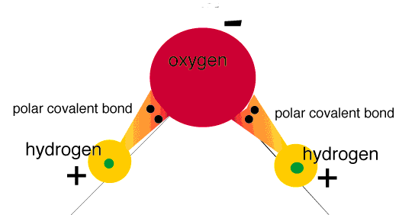

What holds a water molecule together? What type of bond holds several water molecules together? Where will this bond form? How would you describe this type of bond?
It is a covalent bond that hold the oxygen and hydrogen together. It is a a weak hydrogen bond that pulls other water molecules towards each other. That is why it is easily breakable, but still cohesive.

List 4 functions of water in the body. Give an example of each function.

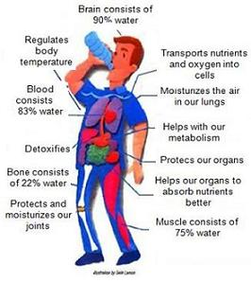

I will be able to show examples of hydrolysis and dehydration synthesis
      - Draw dehydration synthesis of amino acids into proteins
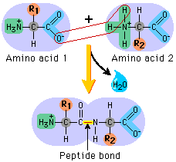
      - Draw hydrolysis of sucrose into monosaccharides
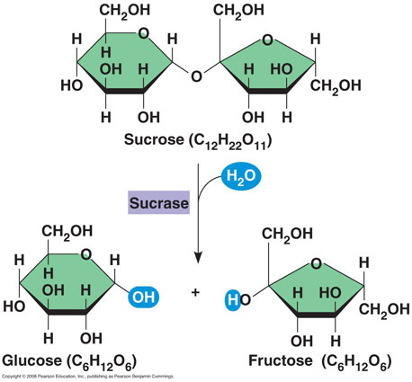

I will be able to recognize the difference between carbohydrates, lipids, proteins, and nucleic acids
      - Name the following molecules (2 marks)

A) __starch____________________ B) ___cellulose__________________________
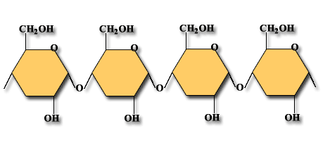

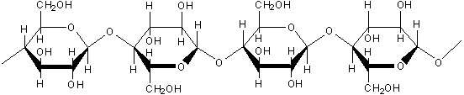

      - Name the following reaction and explain the 2 roles water has in the reaction (3 marks)

This is hydrolysis. This is when water will help break apart a polymer to form two monomers. It helps break apart the glycosidic bond between the two polymers.

      - Draw the structure for a monosaccharaide, a disaccharide, and a polysaccharide
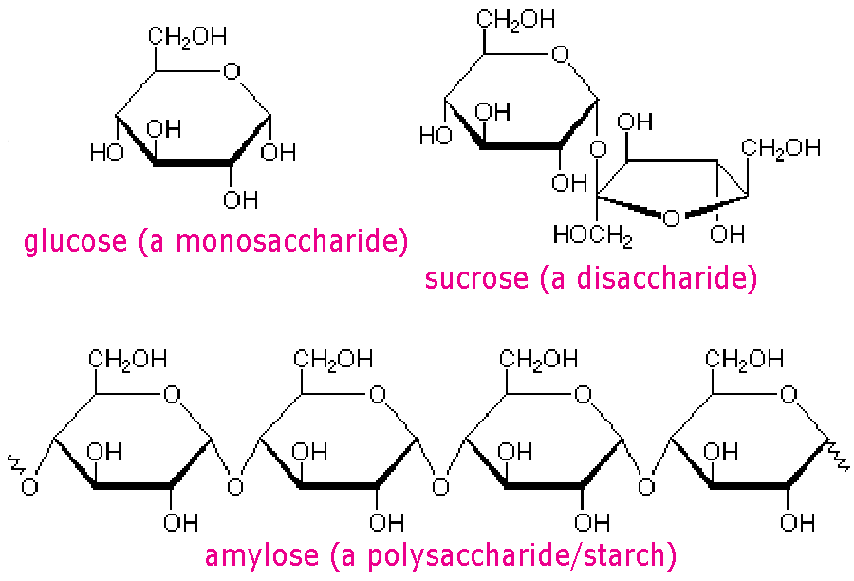

      - What are the similarities and differences between a sugar and a starch?
Sugar is either a monosaccharide or a disaccharide. It is relatively easy for the body to break apart into monomers. It is referred to as a simple carboyhydrate. Whereas a starch is a polysaccharide and is much harder for us to break apart. There are long starches that we use, but it requires a lot of energy to rip apart the bonds.

      - Draw the structure for a nucleic acid (DNA or RNA)
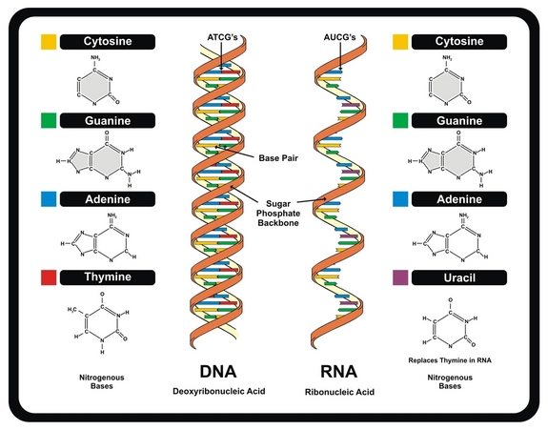
      - What are the similarities and difference between a steroid and a hydrocarbon chain?
Hydrocarbon chain

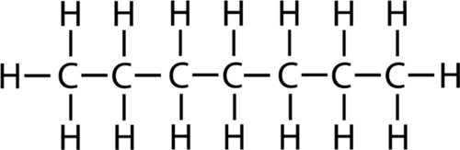

Steroid

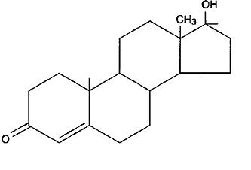

      - What would an example of a balanced meal be if your goal was to have a balance of macromolecules in your diet each meal?
You need to make sure that you include a protein (meat, nuts)
You need to include a fat (avocado, olive oil, fish)
You need to include carbohydrates (sugars to add to your energy source)

I will be able to recognize the difference between saturated and unsaturated fats
      - Draw an example of a saturated fat
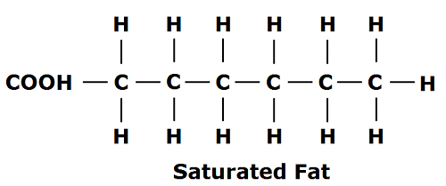
      - Draw an example of an unsaturated fat
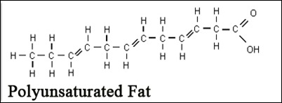

      - Why are some unsaturated fats bad for us? What is a trans-fat and what is it’s general shape? Why is this unhealthy?
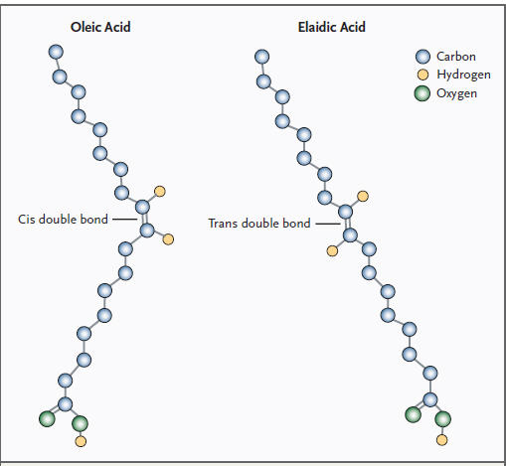
Trans fats are a type of unsaturated fats with a special trans (opposite sides) type of double bond. The double bond causes a kink in the hydrocarbon chair, which causes the fat to take up more room. Trans fats are unhealthy for us as they raise our cholesterol and block our arteries due to their size. Industry adds trans fats bonds into our foods because it helps food last a very long time. Eating trans fats causes an increase in your heart attack risk.
      - What are some examples of healthy fats? Why are they healthy?
Olive oil
Avocado
Fish (Oemgas)

I will be able to draw the general structure of an amino acid
      - Draw the structure for an amino acid (using R for Reactive Grp)
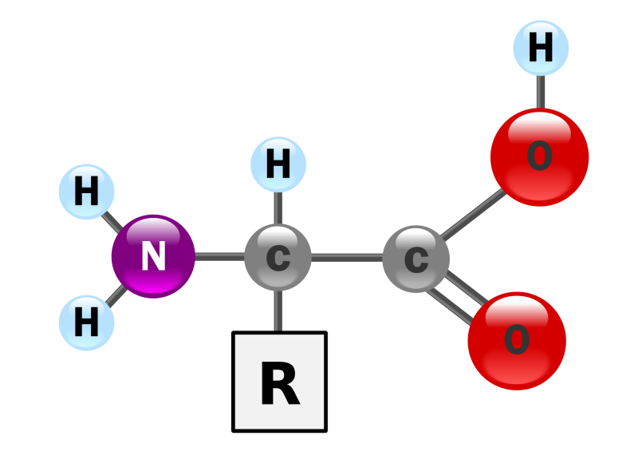

      - Draw hydrolysis of a protein

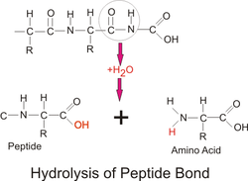
      - Draw dehydration synthesis of an amino acid
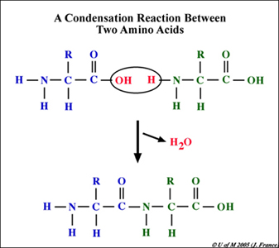

I will be able to differentiate between primary, secondary, tertiary, and quaternary protein structures
      - Draw and explain the process of protein folding, starting with a primary protein, secondary alpha helix, folding over, and in the case of haemoglobin, quaternary structure
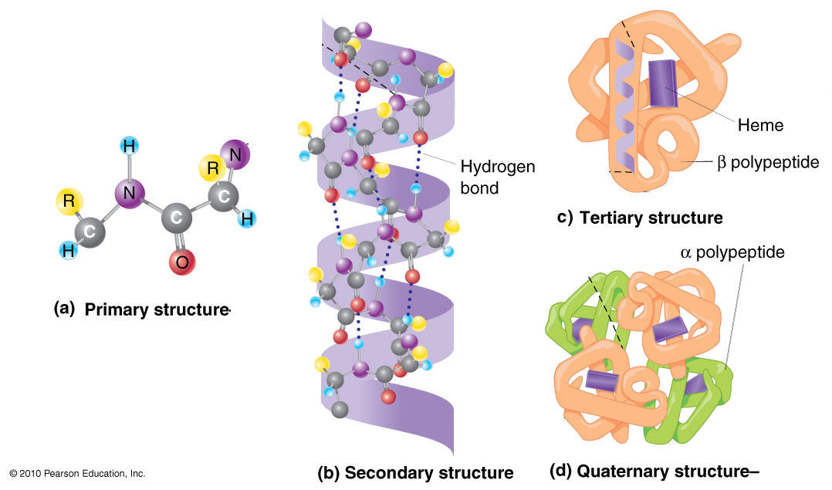

I will be able to list the main functions of nucleic acids (DNA, RNA)
      - What is DNA and what role does it play in organisms?
Our genetic code. DNA must stay in the nucleus of the cell as it is a double helix and too large to leave through the nuclear pore. Codes for all parts of the genes, proteins, etc.
      - What is RNA and what role does it play in protein production?
RNA is the smaller single helix code made from DNA and that has the ability to leave the nucleus to go to the ribosome to make proteins.
      - What are the similarities and differences between RNA and DNA?
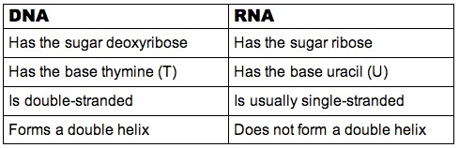
      - What is ATP? Draw a basic ATP molecule using symbols for the general parts.
ATP is a type of nucleic acid. It is Adenine triphosphate. It is the energy currency of the cell. Because of the 3 phosphate groups, each with a negative charge, the breaking of those bonds create a large amount of energy that your body can use for all the things it needs to do.
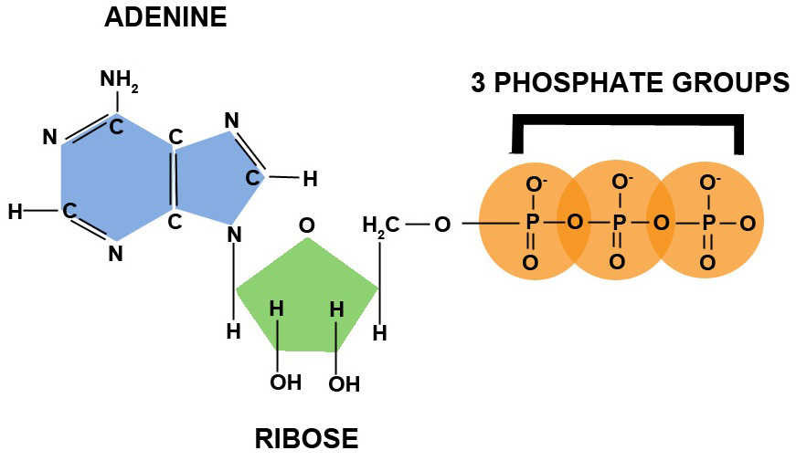

I will be able to draw the main structure of DNA and RNA (including nitrogenous bases)
      - Draw the backbone of DNA with four different nitrogen base pairs
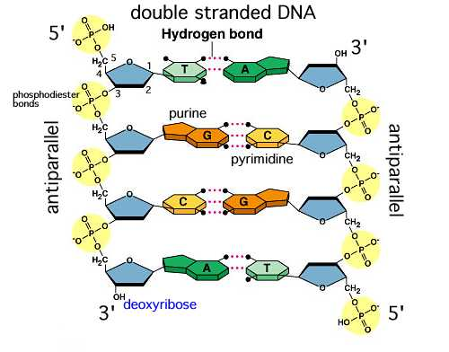
      - Draw a RNA strand that is complementary to your above DNA strand
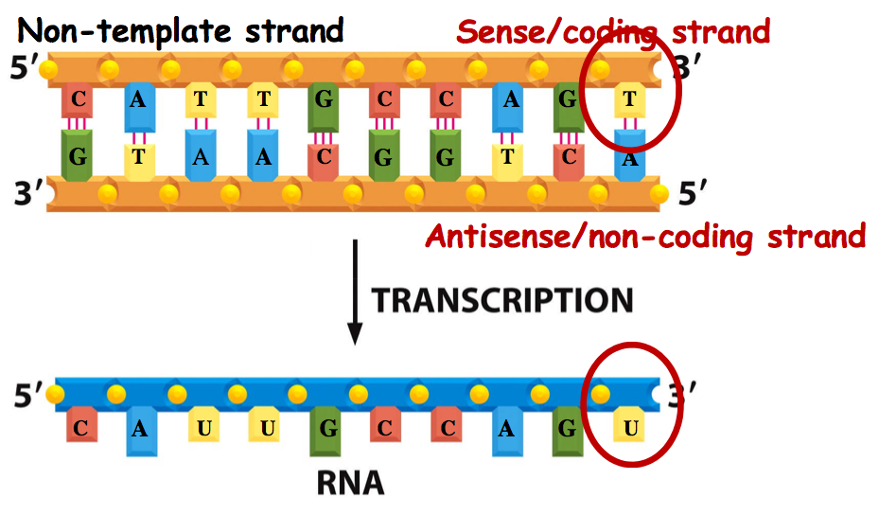
      - What are the differences and similarities of DNA and RNA?
