Unit #1 REVIEW Biochemistry

Name: ____________________________________

Test Date: ____________________________________

Learning Goals:
- I will be able to come up with a testable hypothesis to investigate a scientific problem
- I will be able to describe the unique properties of water
- I will be able to show examples of hydrolysis and dehydration synthesis
- I will be able to recognize the difference between carbohydrates, lipids, proteins, and nucleic acids
Using a separate piece of paper, answer the question to each of the learning goals. Use your notes, the videos, a textbook, and the internet as possible sources of information.

I will be able to come up with a testable hypothesis to investigate a scientific problem
      - While out and about, you notice people blowing bubbles with their gum. You reminisce about the days you used to chew gum, stick it to your night table and continue chewing it and blowing bubbles the next day. This gets you wondering if there is an ideal bubble blowing time with gum. Are the best bubbles blown after 5 minutes of chewing, 10 minutes, 30 minutes? Come up with a testable hypothesis to test this question.

I will be able to describe the unique properties of water

Explain why water is considered a polar molecule.

What holds a water molecule together? What type of bond holds several water molecules together? Where will this bond form? How would you describe this type of bond?

List 5 functions of water in the body. Give an example of each function.
- List 4 characteristics of the water as a molecule.

I will be able to show examples of hydrolysis and dehydration synthesis
- Draw dehydration synthesis of amino acids into proteins
- Draw hydrolysis of sucrose into monosaccharides
- When would the body use dehydration synthesis? Why?
- When would the body use hydrolysis? Why?

I will be able to recognize the difference between carbohydrates, lipids, proteins, and nucleic acids
      - Name the following molecules (2 marks)

A) ______________________ B) _____________________________
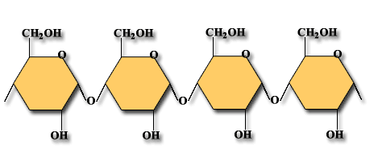

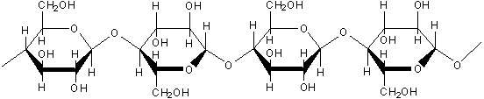

      - Name the following reaction and explain the 2 roles water has in the reaction (3 marks)
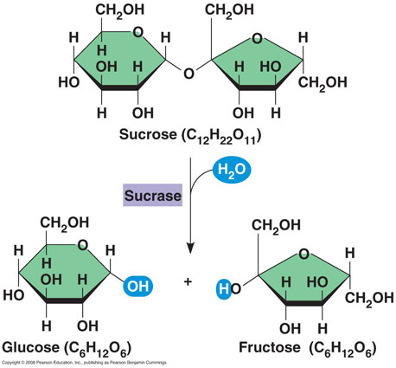

      - Draw the structure for a monosaccharaide, a disaccharide, and a polysaccharide
      - What are the similarities and differences between a sugar and a starch? Between starch and cellulose?
      - What is the monomer for a carbohydrate, lipid, protein, and nucleic acid. Draw an example of each.
      - Draw the structure for a nucleic acid (DNA or RNA)
      - What type of bonds are in a primary, secondary, tertiary, quaternary protein?
      - What are the similarities and difference between a steroid and a hydrocarbon chain?
      - What would an example of a balanced meal be if your goal was to have a balance of macromolecules in your diet each meal?
      - Why do we eat each of the macromolecules? What do they do for our bodies?
      - Draw an example of a saturated fat
      - Draw an example of an unsaturated fat
      - Why are some unsaturated fats bad for us? What is a trans-fat and what is it’s general shape? Why is this unhealthy?
      - What are some examples of healthy fats? Why are they healthy?
      - Whar are some of the issues that surround lipids that have strong backing in both sides of the argument?
      - Draw the structure for an amino acid (using R for Reactive Grp)
      - Draw and explain the process of protein folding, starting with a primary protein, secondary alpha helix, folding over, and in the case of haemoglobin, quaternary structure.
      - What is DNA and what role does it play in organisms?
      - What is RNA and what role does it play in protein production?
      - What are the similarities and differences between RNA and DNA?
      - What is ATP? Draw a basic ATP molecule using symbols for the general parts.

