Biology 12
Unit #1 PRACTICE Test Biochemistry
Name: ____________________________________

Learning Goals | No Evidence  0 | Beginning  1 | Developing  2 | Proficient  3 | Sophisticated  4
I will be able to describe the characteristics of water and its role in the body
I will be able to explain dehydration synthesis and hydrolysis
I will be able to recognize the difference between carbohydrates, lipids, proteins, and nucleic acids

Learning Goal #1: I will be able to describe the characteristics of water and its role in the body
- In terms of the properties of water, what makes it a good transport medium? Explain 2 properties.
________________________________________________________________________________________________________________________________________________________________________________________________________________________________________________________________________________________________________________________________________________
2. The bond formed when two atoms share a pair of electrons is called a(n)
a. | hydrogen bond. | c. | covalent bond.
b. | ionic bond. | d. | water bond.

- List three reasons why water is important for the human body. Be specific.
  - _________________________________________________________________________________
  - _________________________________________________________________________________
  - _________________________________________________________________________________

- You notice that the top end of a paper towel is wet, even though only the bottom is immersed in water. Why is that? _____________________________________________________________________________________________________________________________________________________________________________________________________________________________________________________________________

- Your best friend refuses to drink water as she says that she doesn’t like the taste. You see this sticker and you put it on her binder. Why is drinking water so important for her learning?
________________________________________________________________________________________________________________________________________________________________________________________________________________________
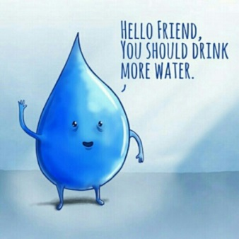
Learning Goal #2: I will be able to show examples of hydrolysis and dehydration synthesis
1. When does your body use the process of dehydration synthesis? ______________________________________________________________________________________________________________________________________________________________________________________________________________________________________________________________________________

2. When does your body use the process of hydrolysis? ______________________________________________________________________________________________________________________________________________________________________________________________________________________________________________________________________________

3. Sketch both the process of hydrolysis and dehydration synthesis using one equation to explain both processes. (use either protein or carbs as an example):

Learning Goal #3: I will be able to recognize the difference between carbohydrates, lipids, proteins, and nucleic acids
1. Polysaccharides are:
a. | carbohydrates. | c. | proteins.
b. | lipids. | d. | unsaturated fats.

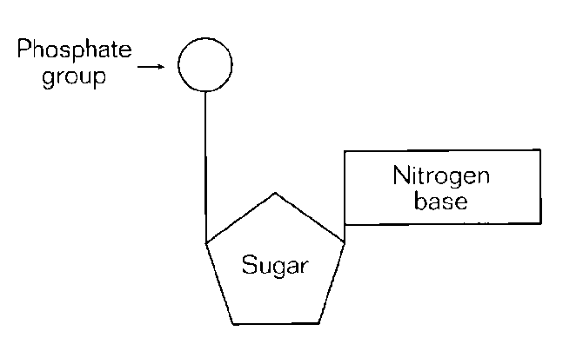
2. The entire molecule shown in the diagram above is called a(n)
a. | amino acid. | c. | polysaccharide.
b. | nucleotide. | d. | pyrimidine.

3. Lipids that are polar and help form the plasma membrane are
a. | triglycerides | c. | phospholipids
b. | saturated | d. | all of the above

4. Label the below molecules:

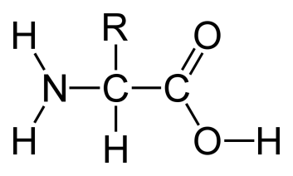
This molecule is a : ______________________________________
This is a type of (macromolecule)_________________________________________

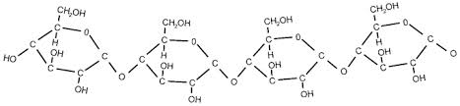
This molecule is a : ______________________________________
This is a type of (macromolecule)_________________________________________
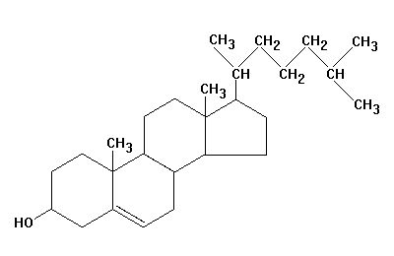
This molecule is a : ______________________________________
This is a type of (macromolecule)_________________________________________

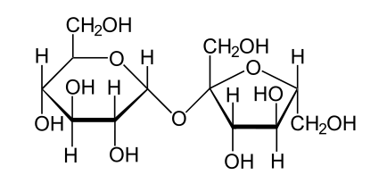
This molecule is a : ______________________________________
This is a type of (macromolecule)_________________________________________

5. The difference between a saturated and unsaturated fat is
a. the size of molecule | c. | the double bond in the saturated fat
b. the R group | d. | the double bond in the unsaturated fat
6. What type of bond goes between each amino acid to make a protein? _________________________

- What is an essential amino acid? ________________________________________________________________________________________________________________________________________________________________________

- What are three examples of nucleic acids?
  - ____________________________________
  - ____________________________________
  - ____________________________________

- Your mom made a wonderful meal to help you prepare for the Freakin’ Farmer last weekend. She said it would help you carbo load. You disagree that it has the macromolecule that you need. How would you test this?
  - What macromolecule do you need? Why? ___________________________________________________________________________________________________________________________________________________________________________________________________________________________________________________

  - How would you test this? _____________________________________________________________________________________________________________________________________________________________________________________________________________________________________________________________________________________________________________________________________________________________________________________________________________________

- What is this cartoon referring to? Why is this ironic?



