Environmental Sciences 12
Atmosphere Unit PRACTICE TEST
Name: _______________________________
Learning Goal | Beginning | Developing | Proficient | Sophisticated
- I can discuss global changes to Earth’s atmosphere
- I can explain the implications of greenhouse gases

Learning Goal #1: I can discuss global changes to Earth’s atmosphere
- Match the below vocab words with the correct definition. Draw a line connecting the matching pair.

Greenhouse Gasses | The recapture of carbon dioxide and the storage of carbon in a liquid or solid form
Climate Change | The process used by plants and other organisms to convert light energy into chemical energy that can later be released to fuel the organisms' activities (energy transformation)
Bad Ozone | Molecules that absorb and re-emit thermal energy from and into our atmosphere
Good Ozone | A gas that is in the troposphere and it attracts and clings to smog and pollution
Carbon Sequestration | The change in Earth’s weather patterns that lasts a long period of time
Photosynthesis | A gas that is in the stratosphere and it absorbs most of UV-C energy

- Complete the chart below that outlines the layers of Earth’s atmosphere. Give a characteristic of each layer.
Layer | Characteristic

- What is the difference between the phrases “global warming” and “climate change”? ____________________________________________________________________________________________________________________________________________________________________________________________________________________________________________________________________________________________________________________________________________________________________________________________________________________________________

- What is this graph showing and what might be causing the trend seen here?
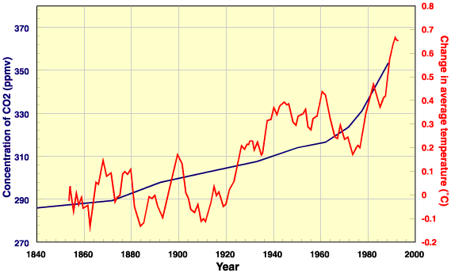
________________________________________________________________________________________________________________________________________________________________________________________

Learning Goal #2: I can explain the implications of greenhouse gases
- Complete the below chart outlining the 3 environmental protocols that have been made since 1980’s. Be sure to add as much detail as you can.
Protocol | Year it was ratified | Goals/Focus | Was it Successful?

- What are the 3 main greenhouse gases that are impacting our atmosphere? Complete the chart below.
Greenhouse Gas | What actions are causing it? | What can we do to help this?

- What is this cartoon referring to? What is happening? Why? How is this impacting our atmosphere?
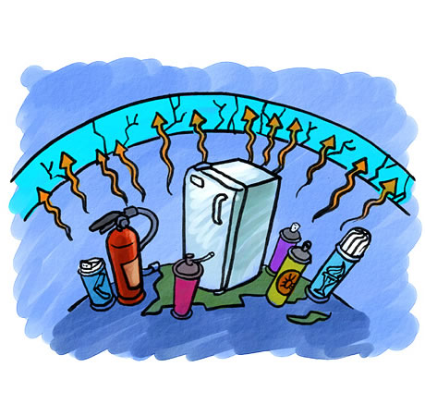
________________________________________________________________________________________________________________________________________________________________________________________
- How are an actual greenhouse and greenhouse gasses connected?



